**NEW FEATURES vsphere 6.x**

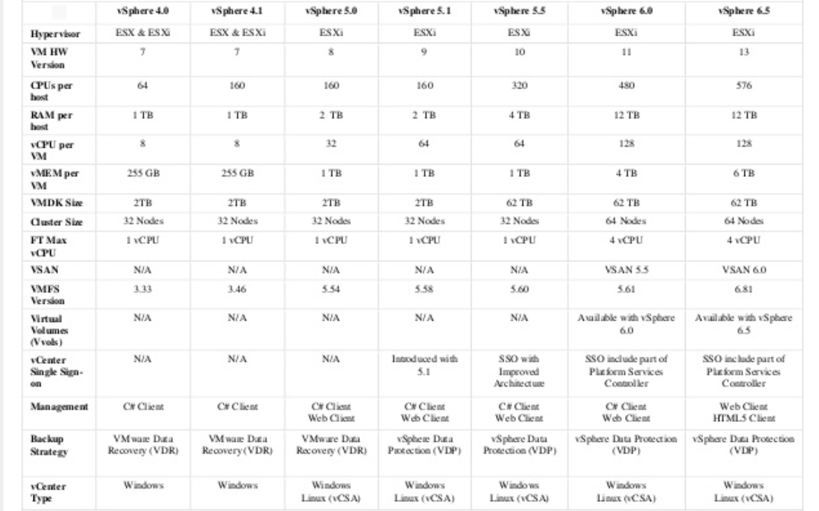

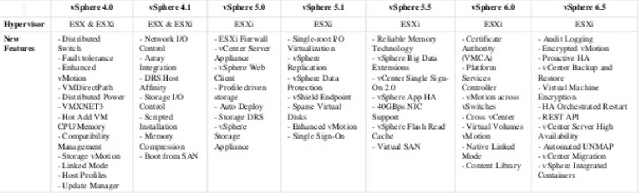

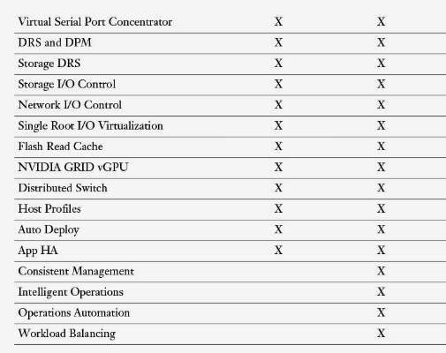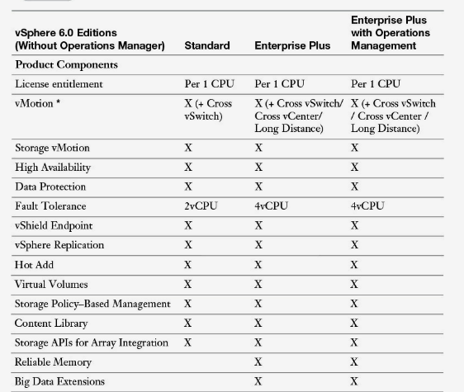**Edition features**

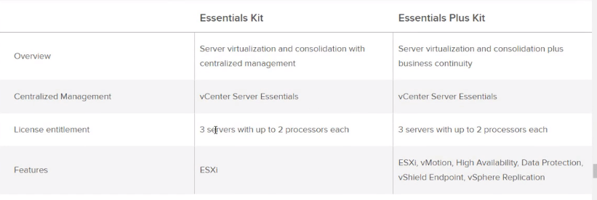

* Host Client Auto-Refresh

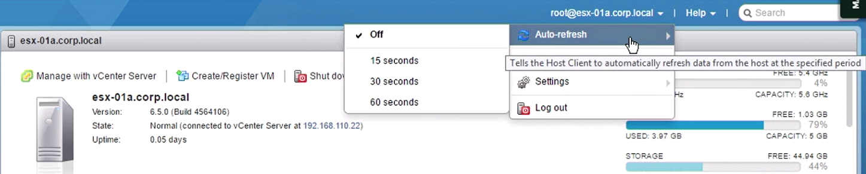

* Showing update-time

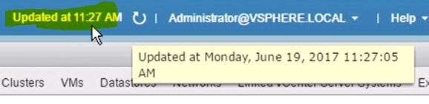

* vsphere Client

html based

host client connects vcsa

https://<fqdnvcsa>/ui

* Strict lockdown (lockdown mode)
* Secure boot of VMs

changing

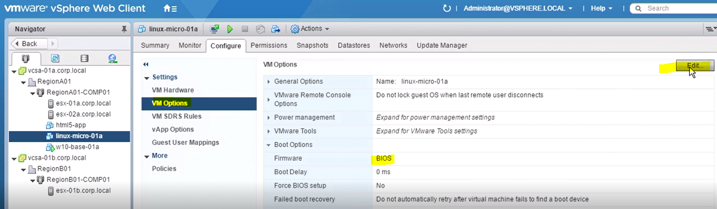

* VM Encryption

From storage policy

Vcenter server stores KMS credential information

Cryptography administrator role

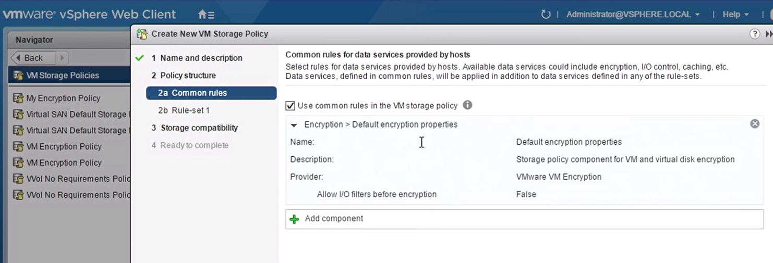

* Computing enhancements

64 hosts/cluster>> total 1000host supported (without external database)

Usb 3.0 support

FT with 4vCPUs

* Host Profile enhancements

Parallel remediation

* Vsphere6.5>> VMFS6

Supports 512 devices and 2000 paths

Storage vmotion is supported vmfs5 to vmfs 6

* Vsphere6.5 and 6 >>NFS4.1

Session multipathing

Kerberos authentication

Storage drs not supported

Storage i/o control not supported

Nfs 4.1 and nfs 3.0 not compatible>> choose one or other for entire storage array

* vSAN

all flash (all SDD)

fault domains

* Storage I/O control

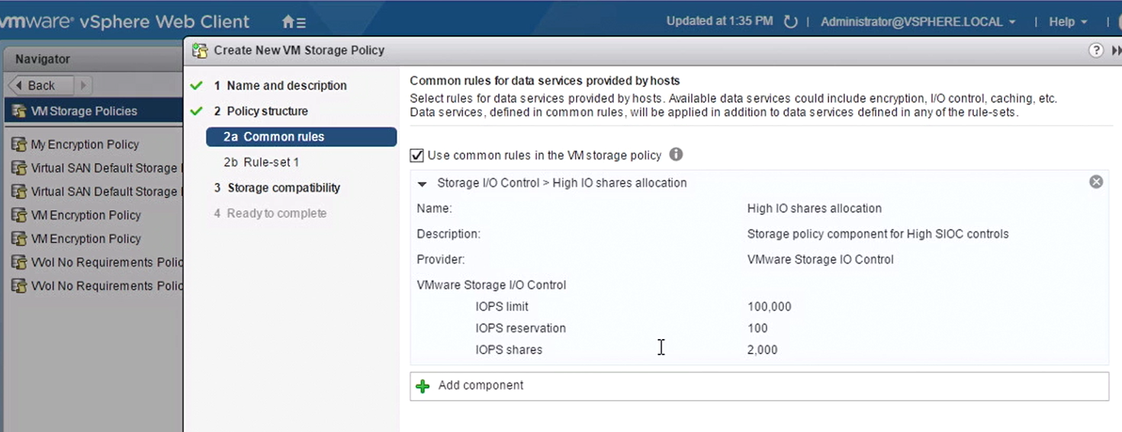

* Network I/0 control v3 (on distributed switch)

Control percantage total BW that a VM can get from distributed switch

Load based nic teaming is disabled

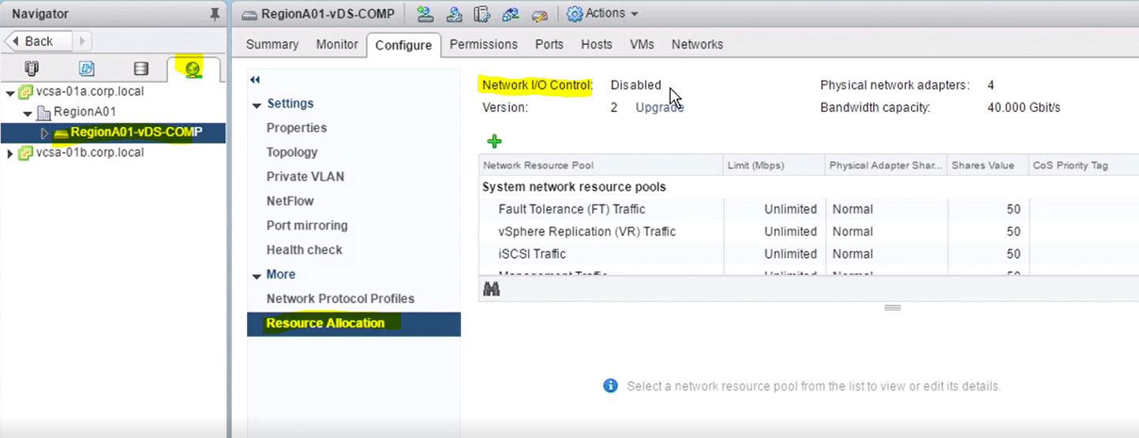

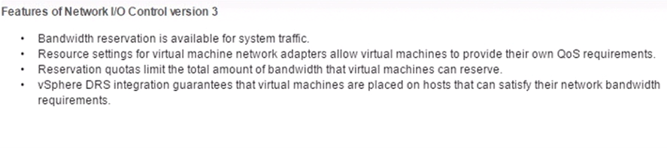

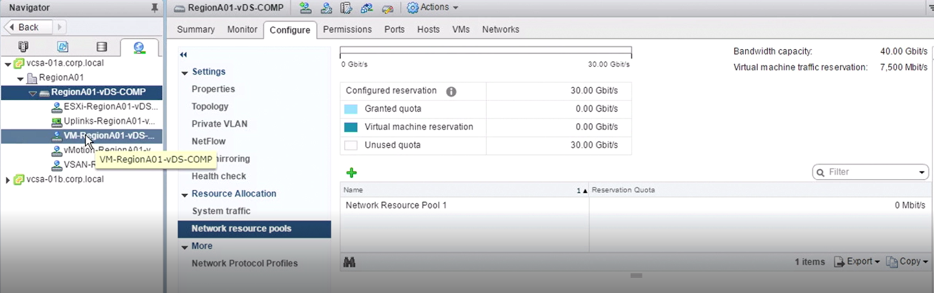

On VM level

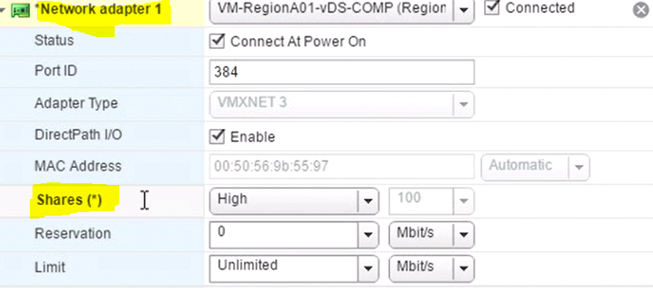

* Vsphere 6.0 >> platform services controller

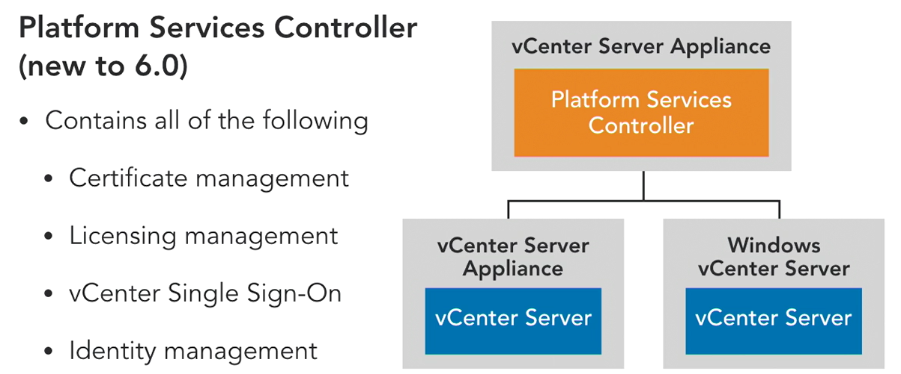

* Vcenter HA

VCSA only

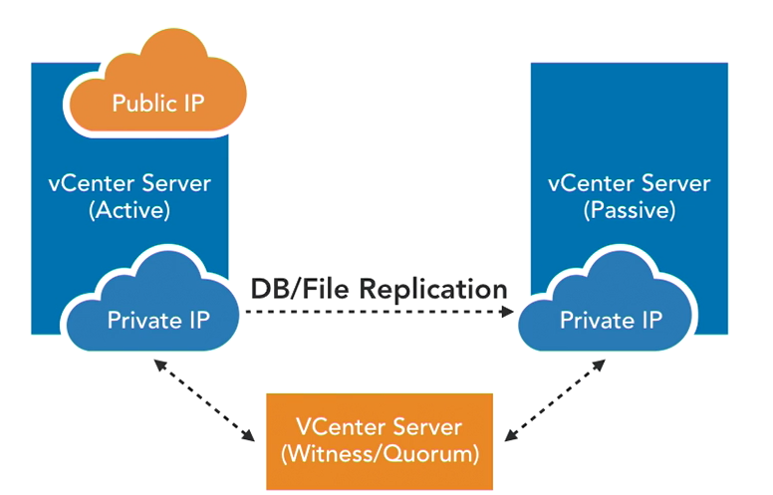

* Proactive HA >> move VMs to another host before host fails (predictive)

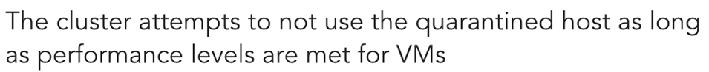

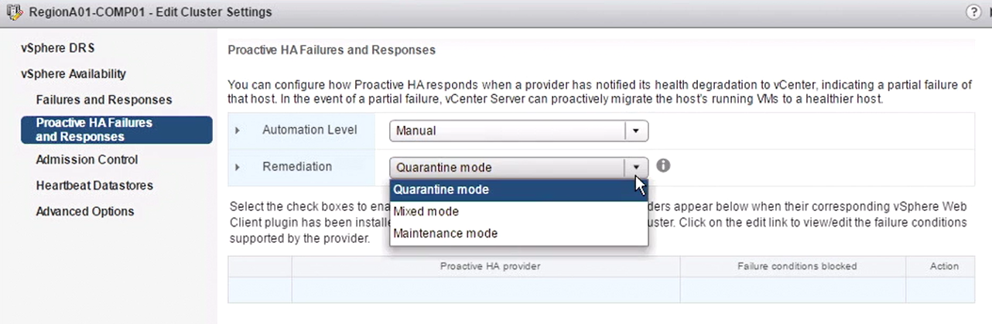

* VM maximums

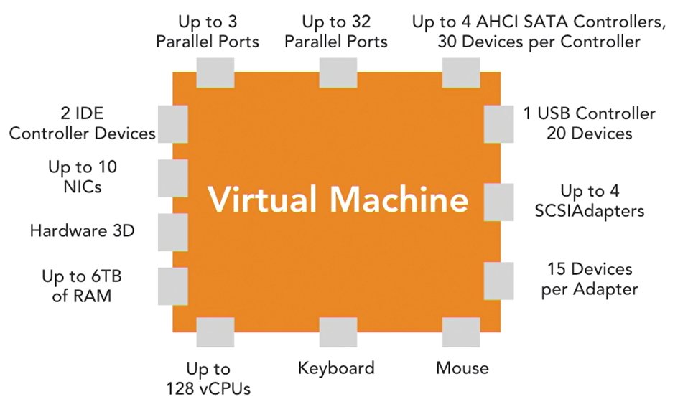

Common topology

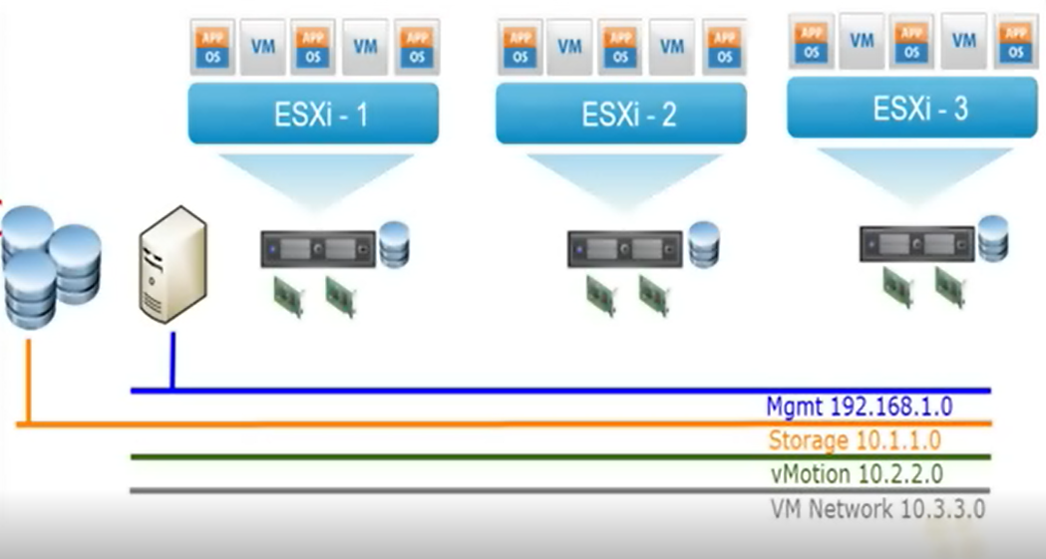

**Elements**

* ESXi host
* Storage e.x Network attached storage (iscsi,nfs)
* vCenter devicename vCSA (vCenter Server Appliance to connect esxi hosts) (microsoft or linux based)
* Active Directory (microsoft) auth.
* Networking (management network+

**Hypervisor names and types**

**Type1>>** (bare metal) host+hypervisor+VM (ESXi)

**Type2>>**host os+hypervisor+VM e.x Vmware Workstation(on microsoft OS) or Vmware Fusion (on MacOs)

**ESXi hosts**

Hardware requirements

* Supported server platform
* Two CPU cores
* NX/XD bit enabled for the CPU in host BIOS
* 4 GB physical RAM
* Hardware virtualization Intel VT-x or AMD RVI to support 64-bit VMs
* One or more gigabits of faster Ethernet controllers
* SCSI disk or a local, nonnetwork RAID LUN with unpartitioned space
* Static IP
* Hardware virtualization is required only to support 64-bit VMs.

(interactive installation)>CD/DVD,USB,PXE

(script installation)> location https,ftp,nfs

Esxi security settings

Host>Manage>Settings>System>Security profile

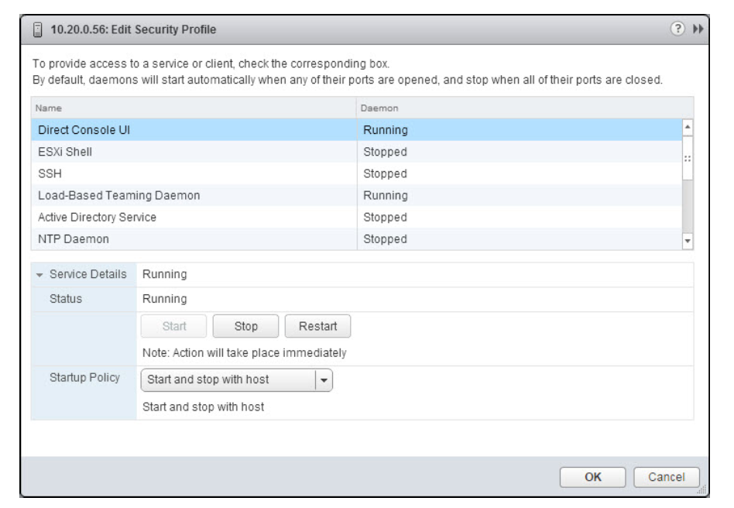

Start up policies

* Start and stop with host
* Start and stop manually
* Start and stop with port usage

SSH enable

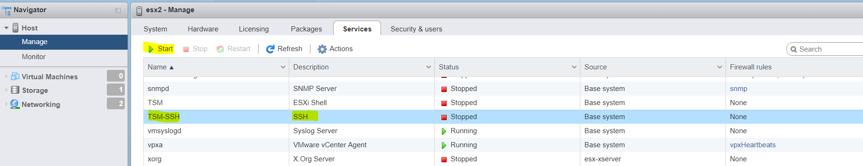

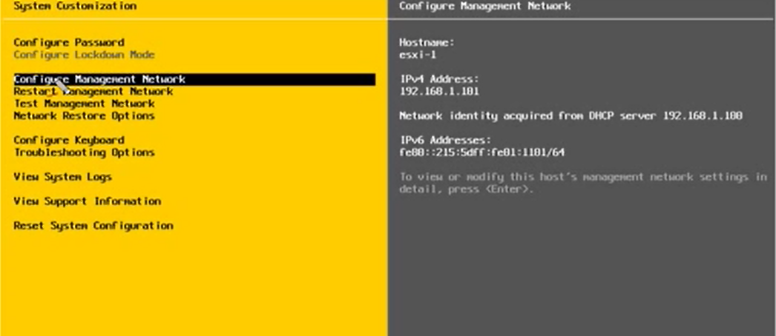

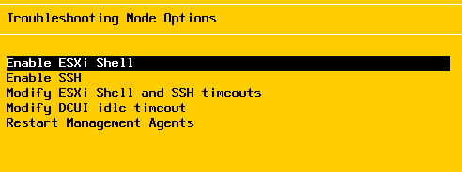

Management agent> esxi host’un vcenter ile konuşmasını saglar

Timeout>

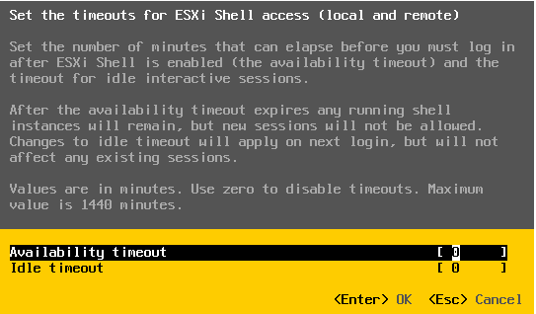

Test Management Network pings DNS servers,default gateway and NTP server

ESXİ LOGs with explanations

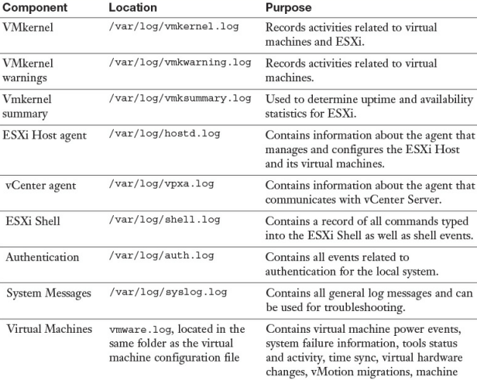

ESX FIREWALL PROFILE

Esxcli network firewall ruleset list

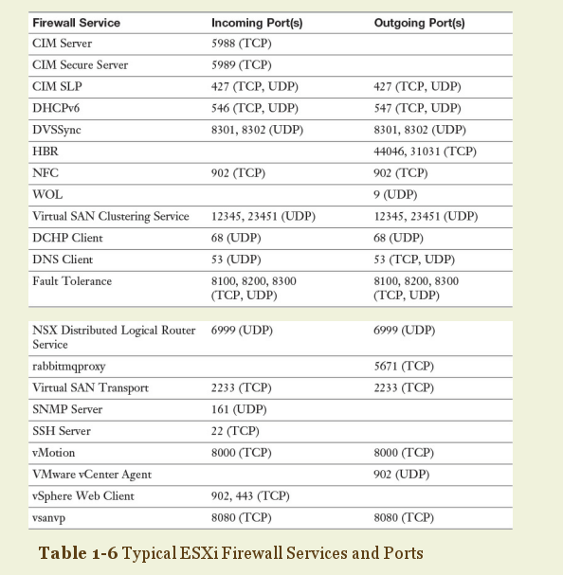

ESX Management Services

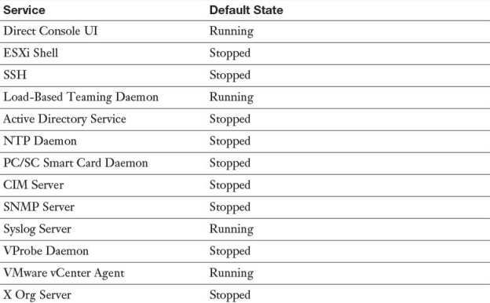

ESX Host Diagnostics

Vm-support

Command to manage esxi host from SSH session

**Identify Common Command Line Interface (CLI) Commands**

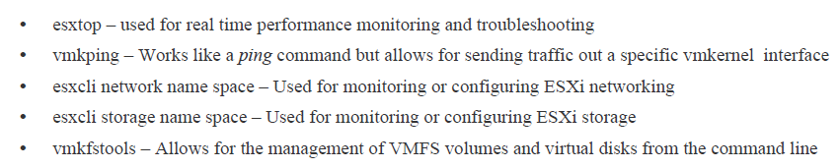

Esxtop> cpu utilization of services or VMs refresh rate 5sec

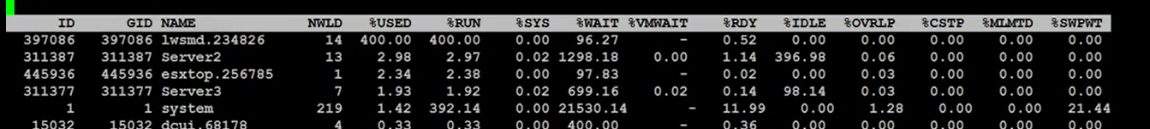

%used> cpu usage

%rdy> ready time.. amount of vm wait for resources

**Performance Metrics**

**Memory**

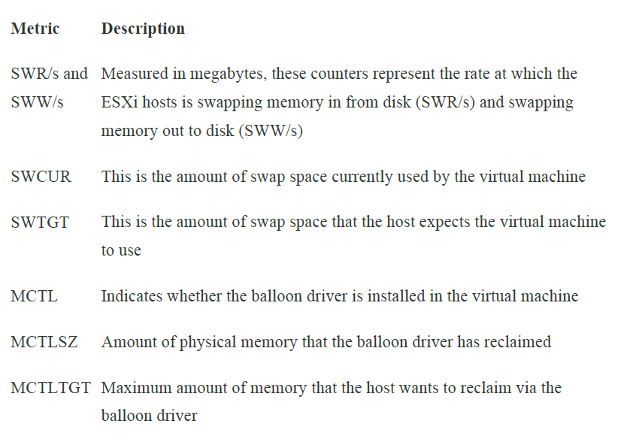

**CPU**

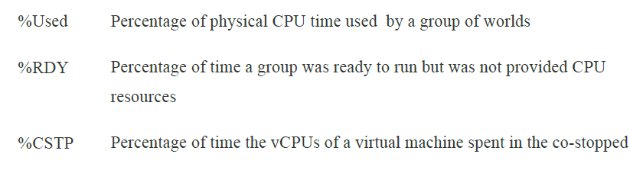

%MLMTD >> The percentage of time the vCPU was ready to run but deliberately wasn’t scheduled because that would violate the “CPU limit” settings.

High ready time> VM is competing for resources. (reduce workload on host, reserve CPU resources with VM, migrate VM to a host with more resources)

High co-stop time> one of vCPU is waiting for another one to be scheduled > reduce number of virtual CPUs

High swap time> VM is spending time waiting on memory to be swapped into virtual machine > reduce workload on host

**Network**

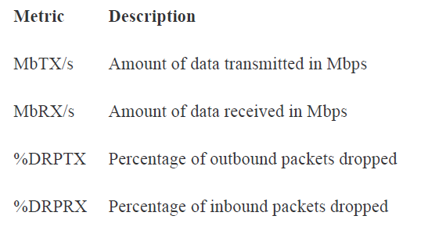

**Storage**

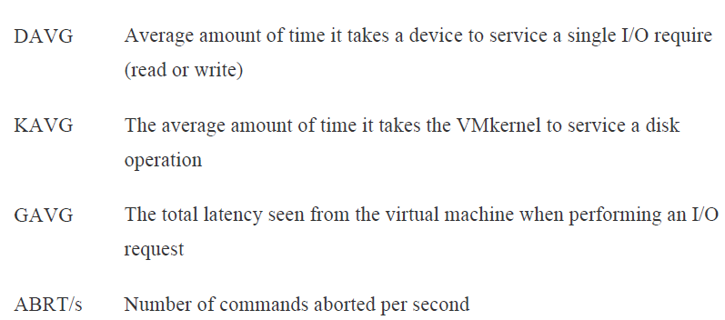

Esxtop n> network utilization

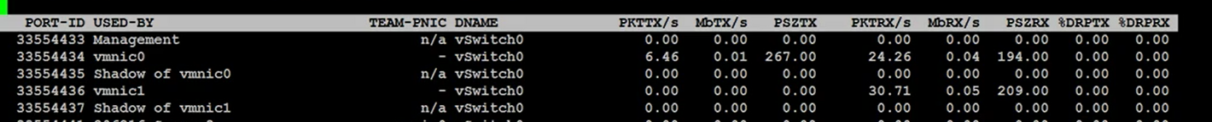

Esxtop switches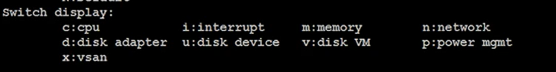

Esxcli>> get info about esxi host

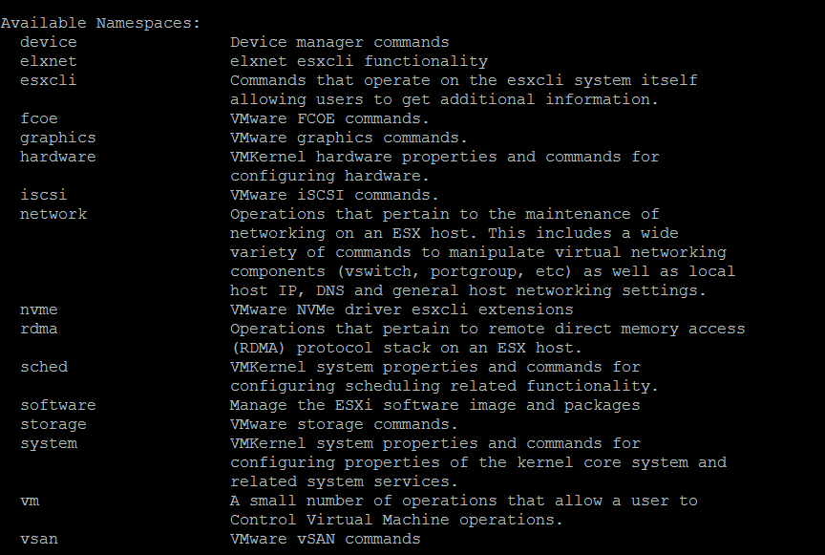

Performance monitoring

Esxi host name>monitor>performance>advanced

CPU(overall usage per cpus),datastore,disk(read&write,latency),memory,network(network rate&network packet by vmnic), power,system,virtual disk

Logs and Events

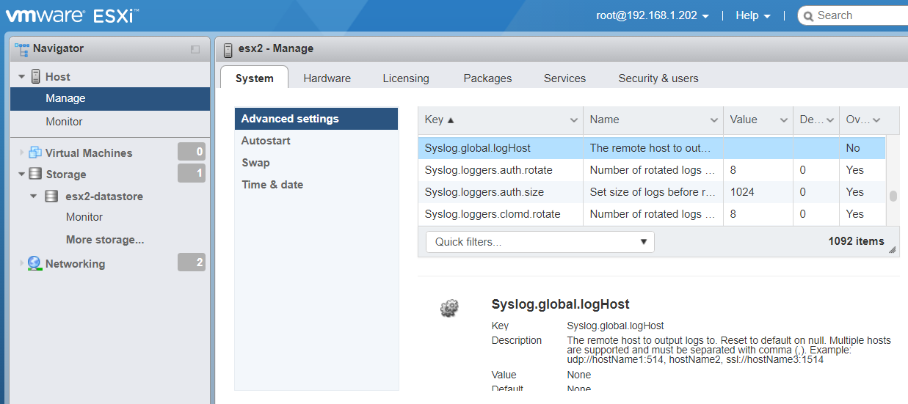

Creating Custom Welcome screen for DCUI

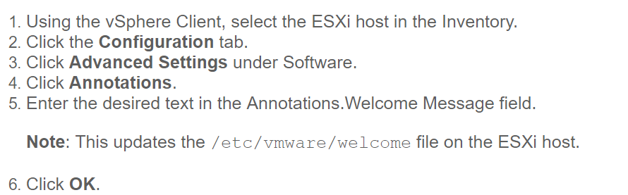

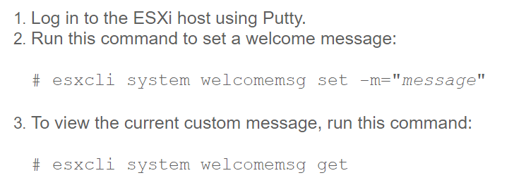

**Vmware Host Clients**

* Vmware Host Client (windows computer)

Connection to esxi host > https://<fqdnesxihost>/ui

Username(root) +password

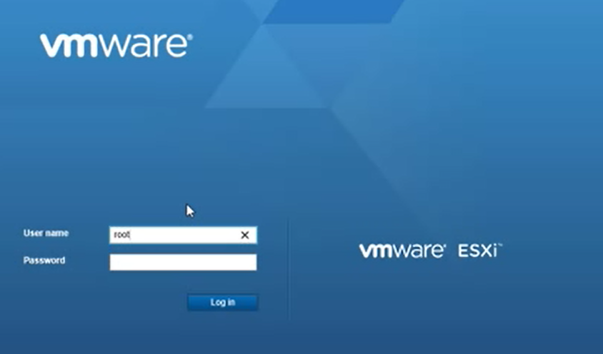

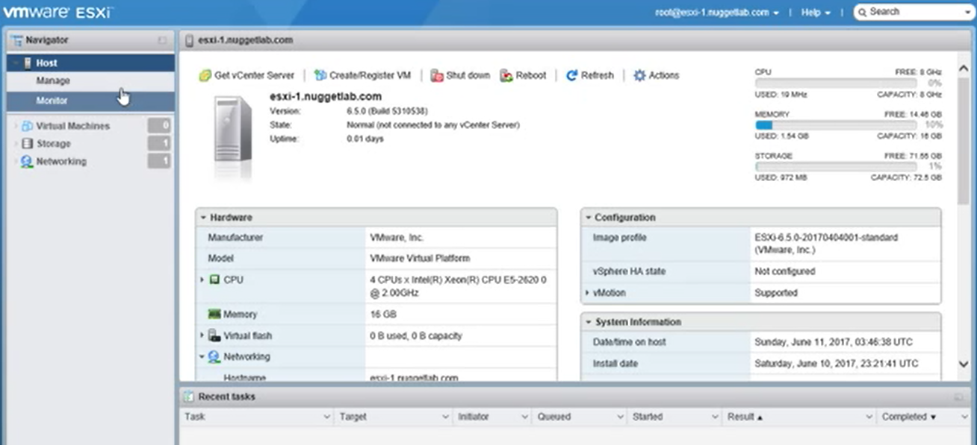

* vSphere Web Client

host client connects vcsa

https://<fqdnvcsa>:443/vsphere-client

and vcsa connects esxi hosts

cont’d

* vsphere Client

html based

host client connects vcsa

https://<fqdnvcsa>/ui

and vcenter connects esxi hosts

**vCenter Deployment Types**

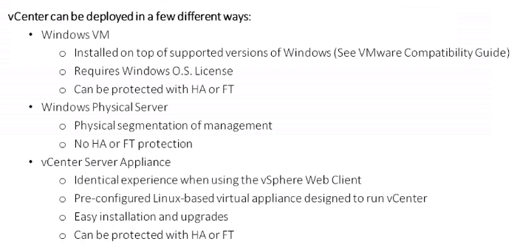

vcenter server windows requirements

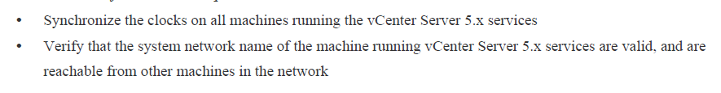

Operating system 64bit

Min Windows Server 2008 SP2

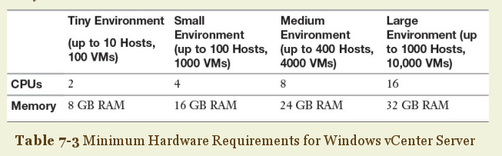

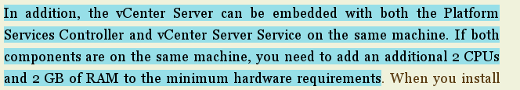

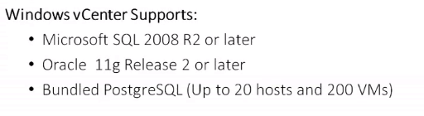

VCenter Related Ports

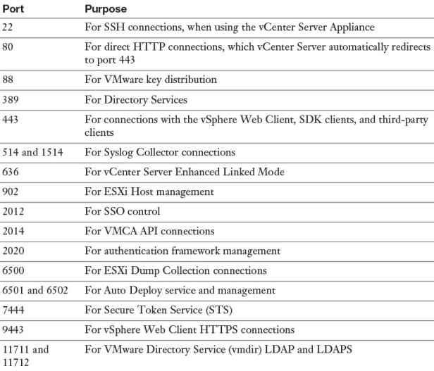

**DEPLOYING VCENTER SERVER APPLIANCE(vCSA)**

Vcenter server appliance requirements

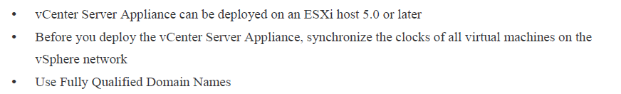

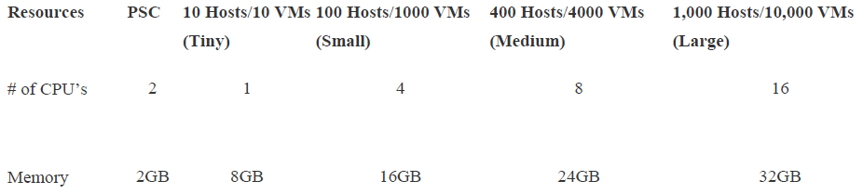

Supported databases>> postgresql (supports more host and vm comparing to database on vcenter without server appliance), oracle

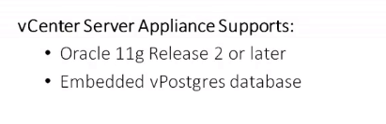

**Architecture**

Platform services controller

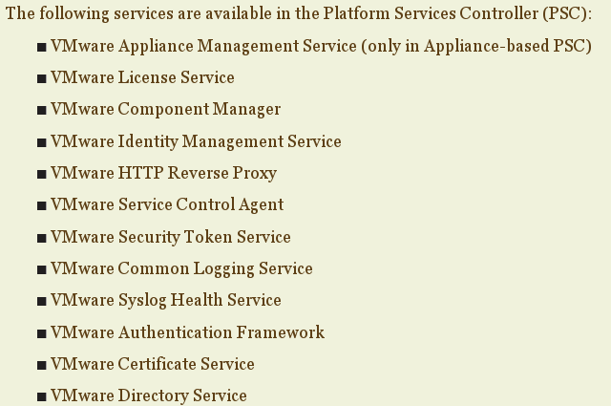

vCenter services

The vCenter Services server provides for the vCenter Server, as well as the vSphere Web Client, vCenter Inventory Service, vSphere Auto Deploy, vSphere ESXi Dump Collector, and vSphere Syslog Collector.

options

Embedded= vcenter services+platform services controller

Linked= vcenter services (seperated) platform services controller

Enhanced linked mode= 1 platform services controller + 2vcenter services below

Vcsa (linux based) connected to Platform Services Controller

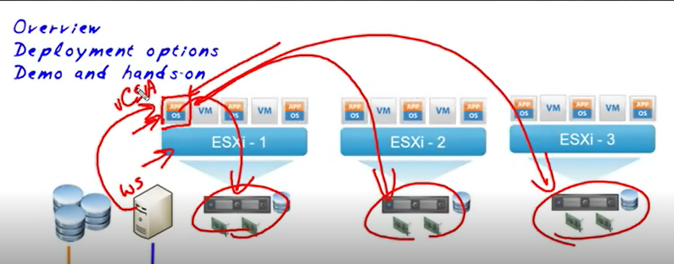

Manually start VM (vcsa) when esxi host starts

Vcsa iso on web client >> vcsa-ui-installer>win32>installer

Select deployment type> embedded/external

Deployment target> (esxi host)name,port,password

Deployment size>

Select datastore

Network settings

Appliance configuration> time synch,ssh

SSO configuration> domain name of vcenter

**Connection of vcsa to esxi hosts and VMs**

Web client>>vcsa

https://<fqdnvcsa>:443/vsphere-client

username: domain name of vcenter\Administrator

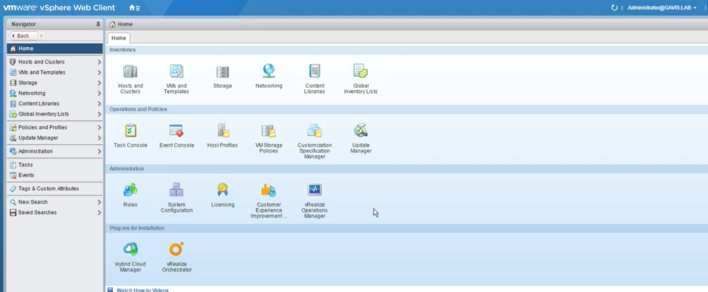

Adding vcenter server to domain

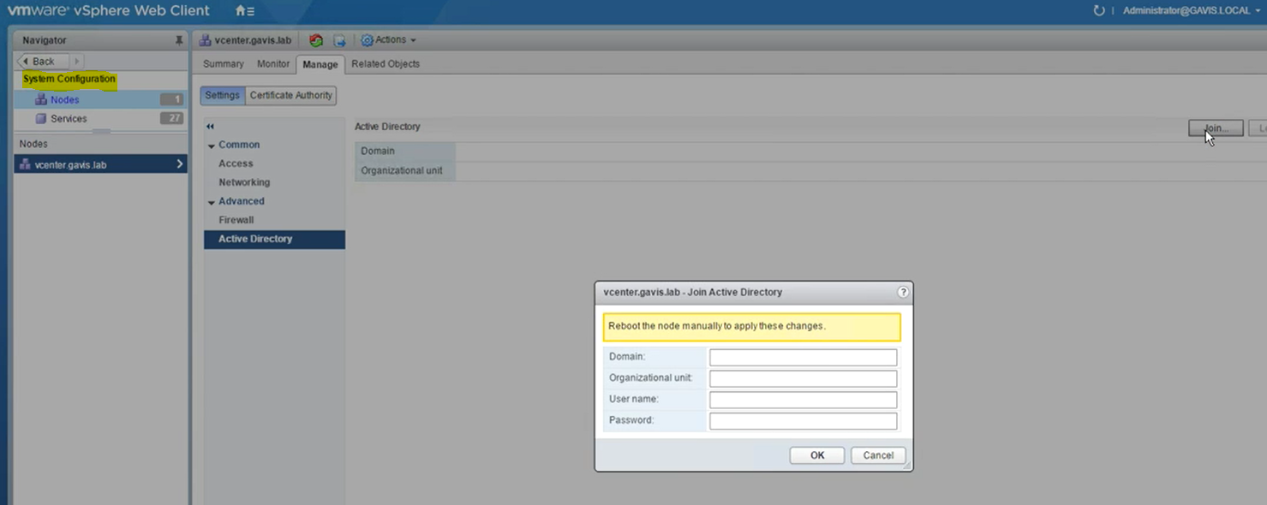

And restart

Connection to vCenter

https://vcenter.yigitaydog.local:9443/vsphere-client

Adding hosts to Vcenter

Vsphere web client-esxi host connection: 443TCP,902TCP/**UDP**(authentication-provisioning),903UDP(vm remote console)

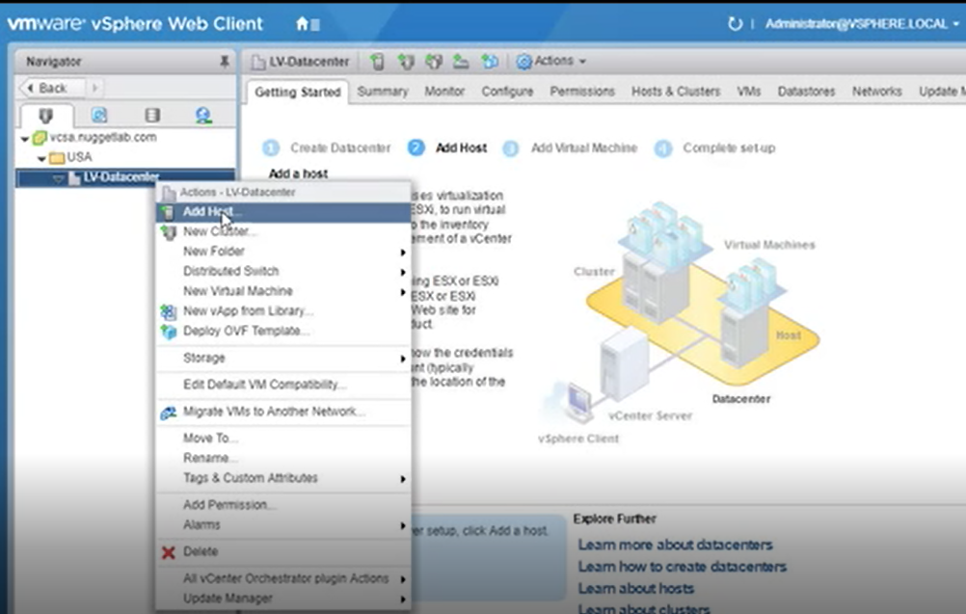

Add host

Name of esxi host and location

Pasword to connect esxi host

License

Lockdown mode

VM location (folder on vcsa console)

Final result

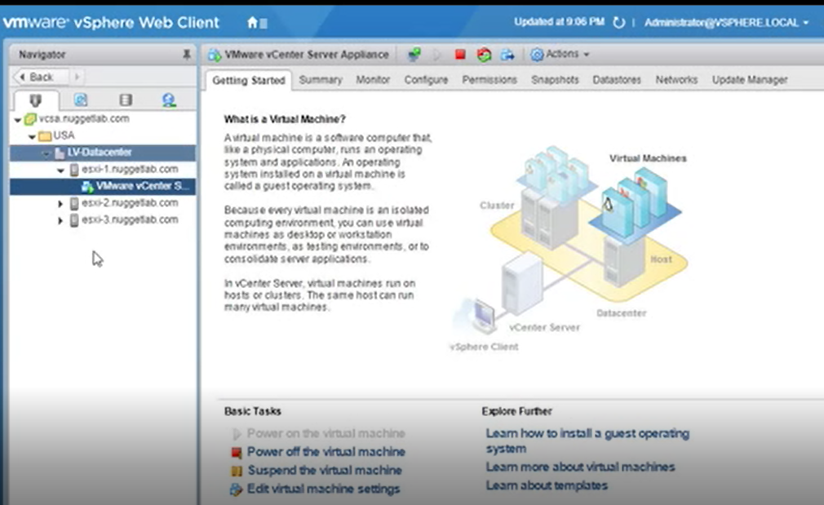

Possible to change password policy from this console

Deploying VM

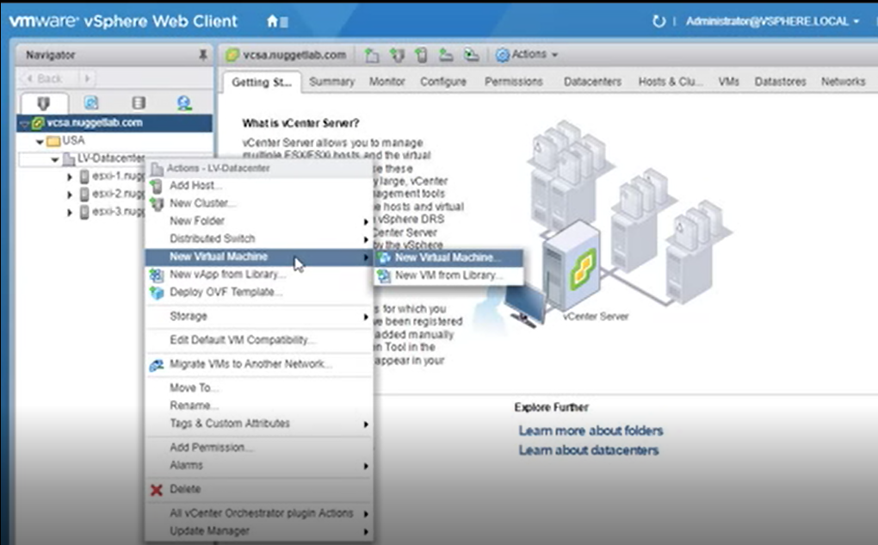

Steps

1.VM name

2.Location on console

3.Select host

4.Storage (from host)

5.Compatibility (esxi host version)

6.Guest OS Family

7.Customize hardware

To install OS for VM, connect to host via vsphere client. Summary>Storage>Browse datastore... move .iso

**Management of vCSA (management UI)**

From webclient (regular windows) >> https://<fqdnofvcsa>:5480

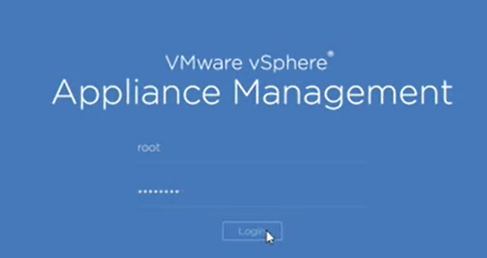

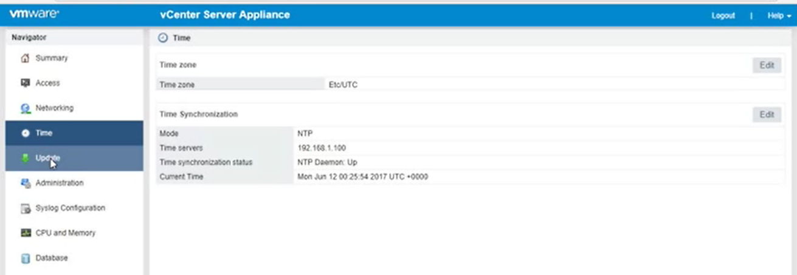

**SWITCHES**

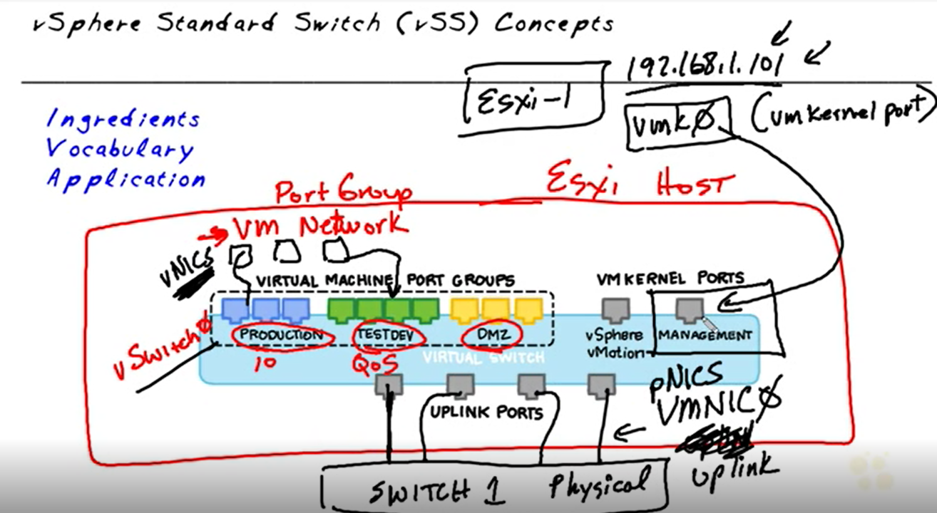

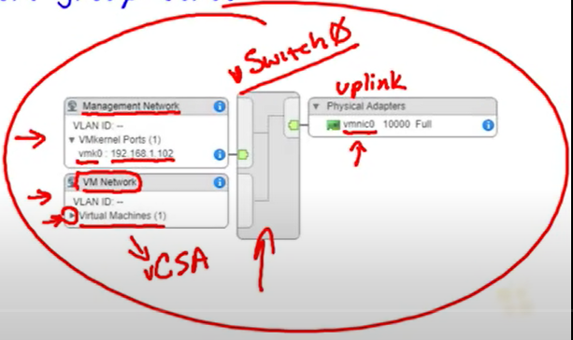

The main reason to use port groups is to get more than one function out of each switch.

VMkernel ports usage>> vSAN,FT,Management,IP storage,vMotion,Replication,Provisioning

vSwitch connected to Vmnic

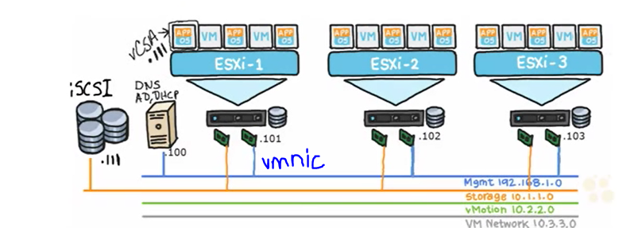

Creating switches

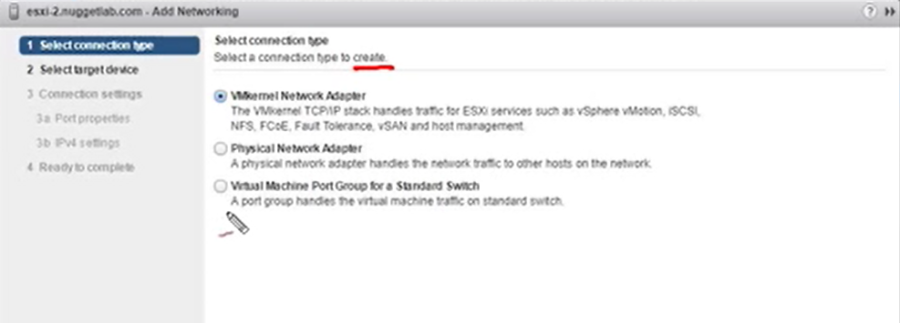

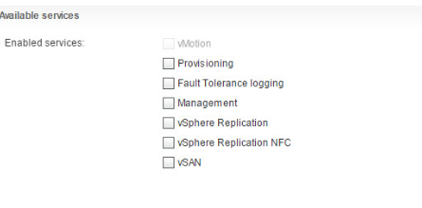

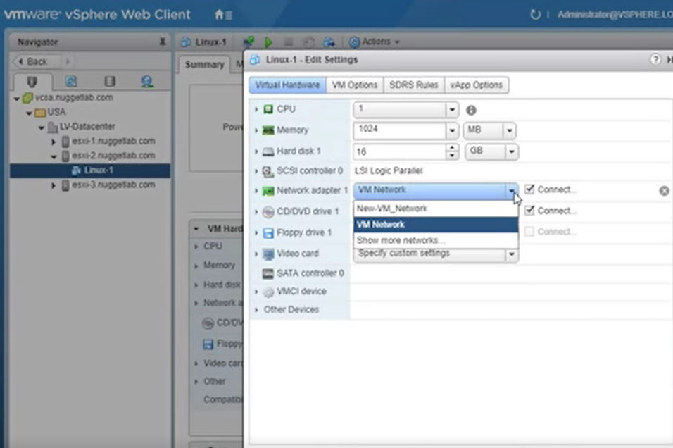

**STORAGE**

options

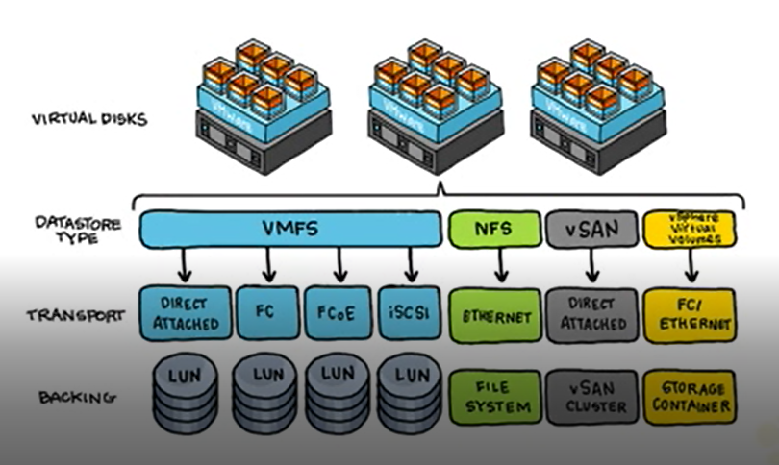

* directly attached>> cannot be shared with other esxi hosts
* network based storage > iscsi, fibre channel, fiber channel over ethernet

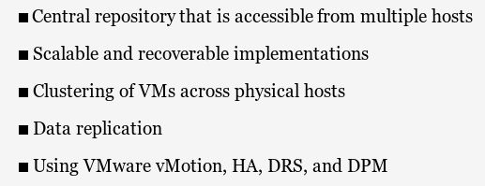

Naming convention

Storage Naming Convention

* Scsi inqiry identifiers
* Path based identifier
* Legacy identifier

vmhbaN:C:T:L,

vm stands for VMkernel.

hba is host bus adapter.

N is a number corresponding to the host bus adapter location (starting with 0).

C is channel, and the first connection is always 0 in relation to vSphere. (An adapter that supports multiple connections will have

T is target, which is a storage adapter on the SAN or local device

L is logical unit number (LUN),

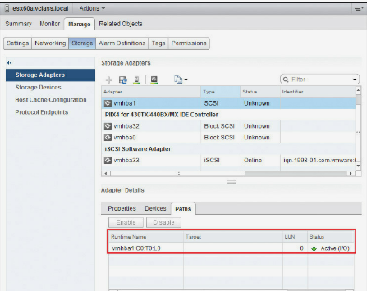

Types of storage adapters

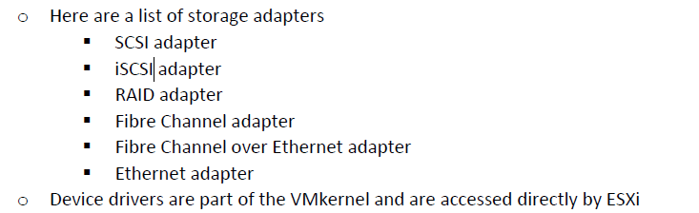

LUN zoning

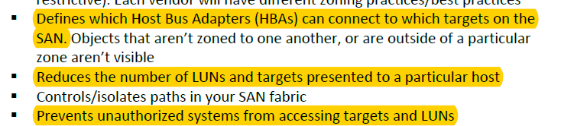

Storage Filters

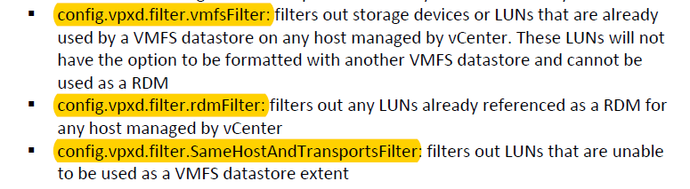

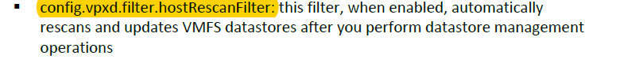

Managing storage filter

Vcenter>Settings>Advanced Settings>Edit

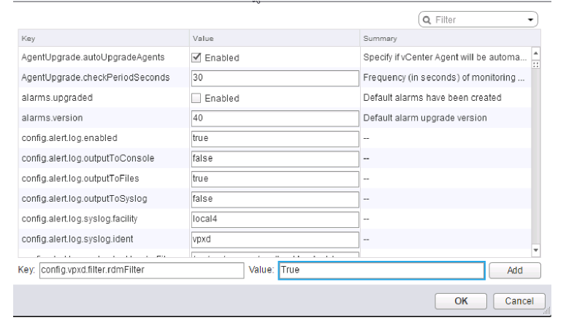

iscsi

server portion

*target

*storage processor has IP address

*IQN

Client portion

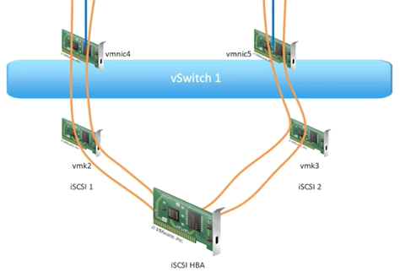

Host bust adapter

Vmkernel port connection point between storage and esxi host

No routing between esxi host (initiator) and iscsi appliance(target) >> they are on same network

İscsi adapter types

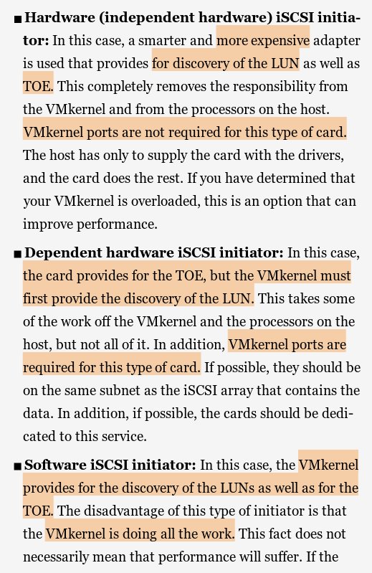

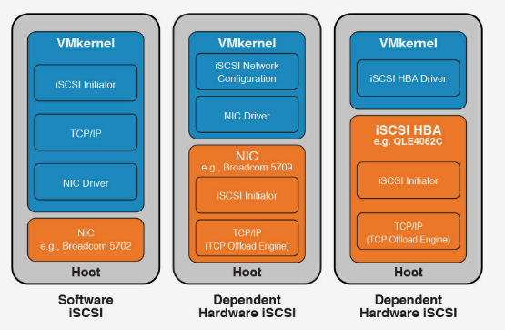

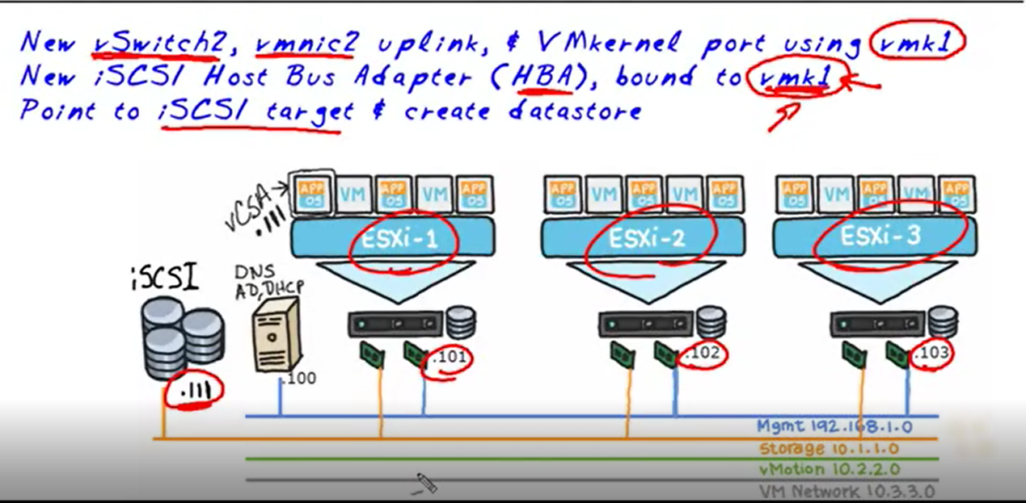

1.Create Vmnic switch (orange line) with ipv4 10.1.1.101 for esxi1 host

2.addd storage adapter (software iscsi adapter) on esxi host

3.network port binding (port3260)

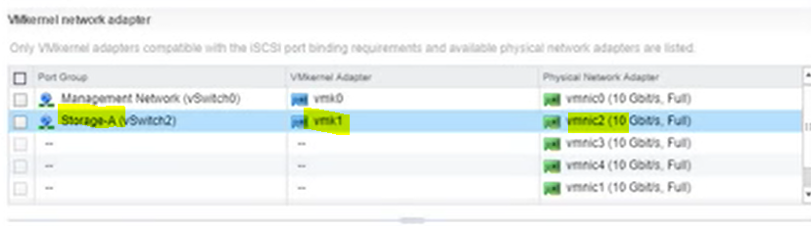

4.add target

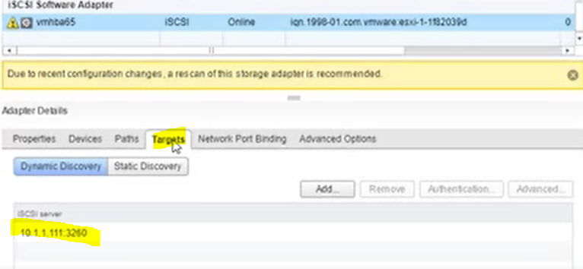

5.scanning

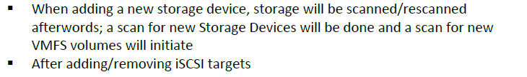

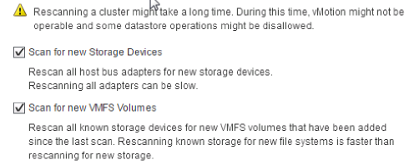

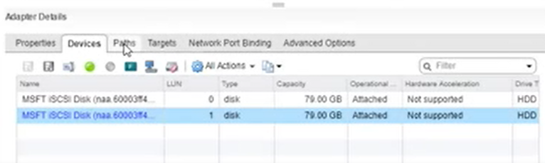

İscsi CHAP

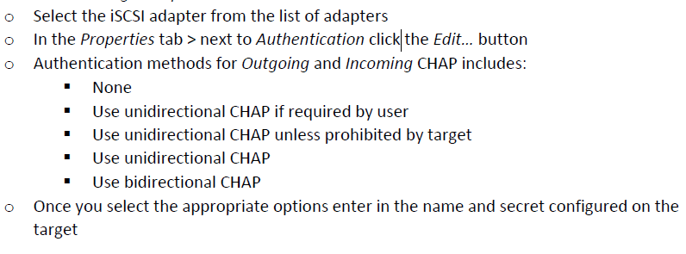

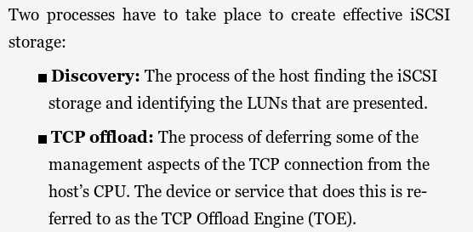

6. create new datastore (VMFS)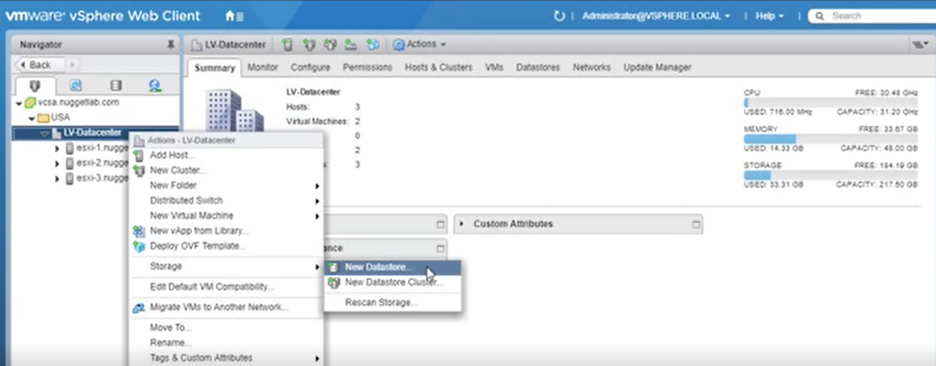

Select target and partition

İt can be NFS based datastore as well

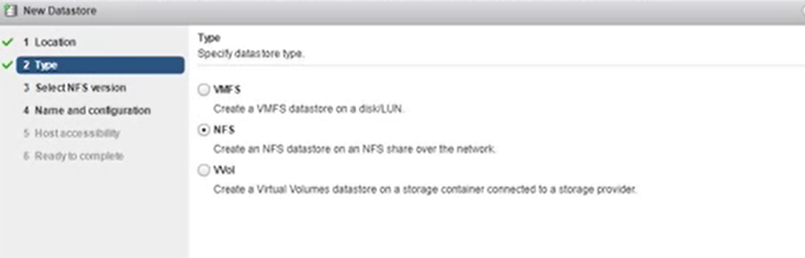

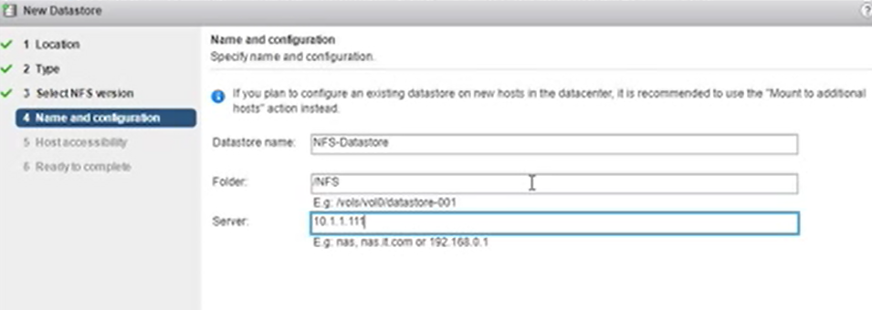

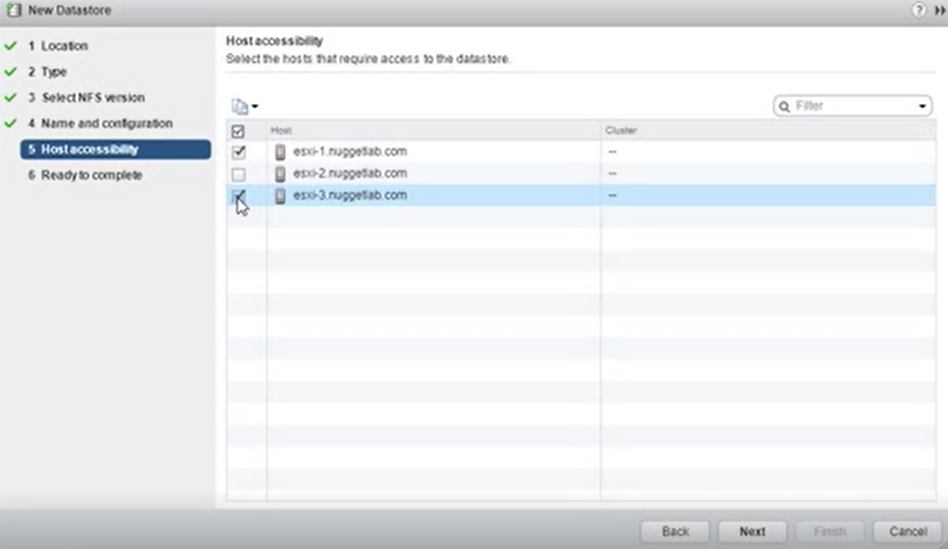

Managing VMFS datastore (increasing capacity)

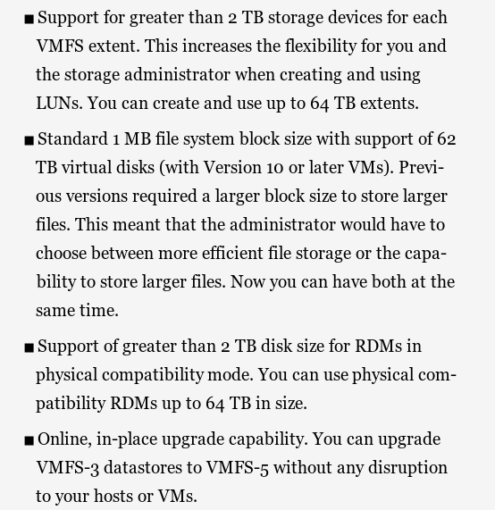

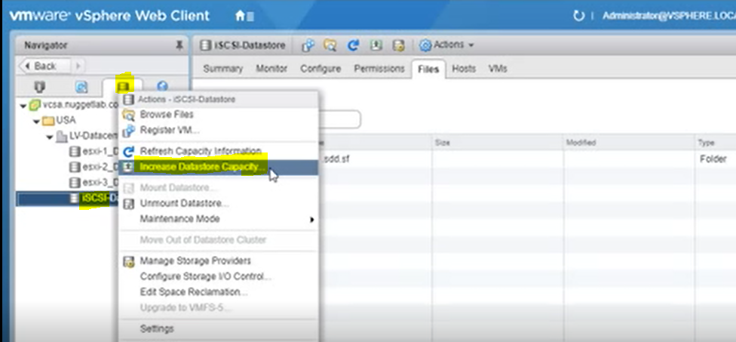

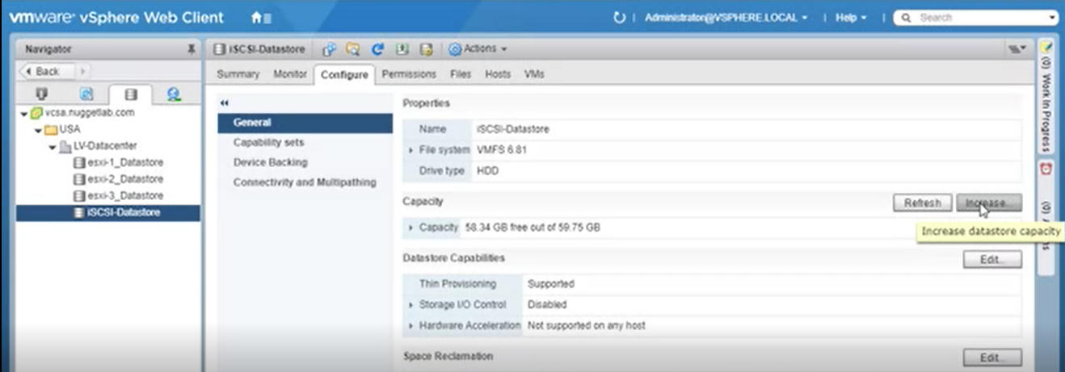

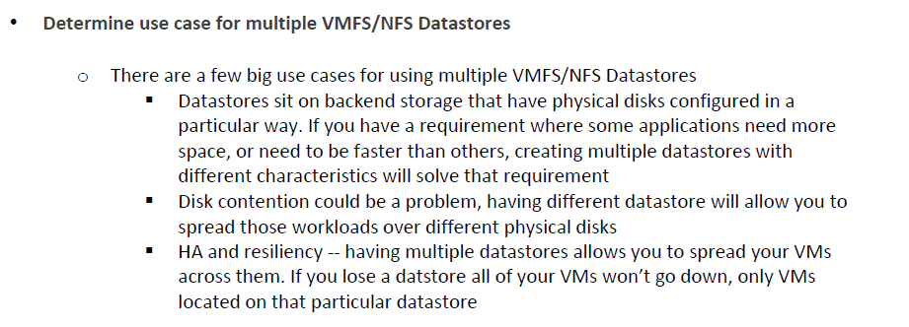

With NFS, possible to provision large number of VMs per datastore

With NFS, easier datastore management

Max size of VMFS datastore is 64 TB

Max size of NFS datastore is 100 TB

**Virtual Machine Configuration Settings**

**VM files**

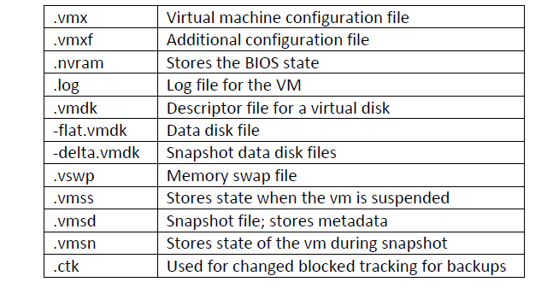

-rdmp.vmdk> raw device mapping setting (VM’in direk olarak LUN ları görmesi)

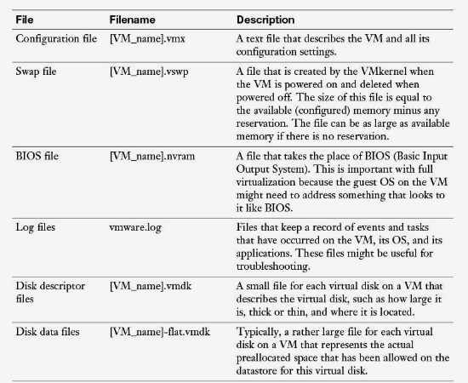

affinity location options

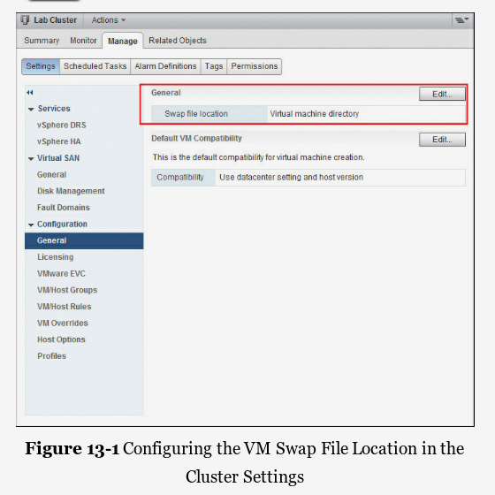

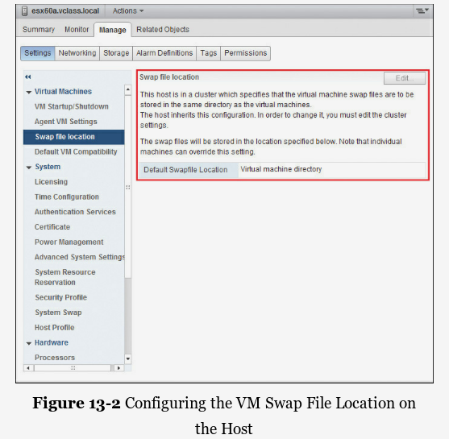

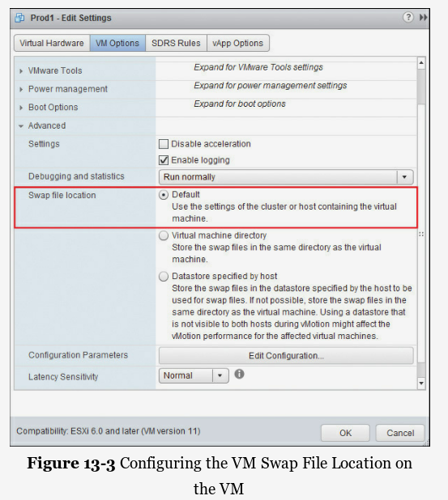

Memory state is kept if VM is on when snapshot is taken

Vmsn> keeps info if wm was on of off when snapshot is taken

.vmem

.vmsn

.vmdk

.vmsd

Snapshottan sonra Oluşturulur

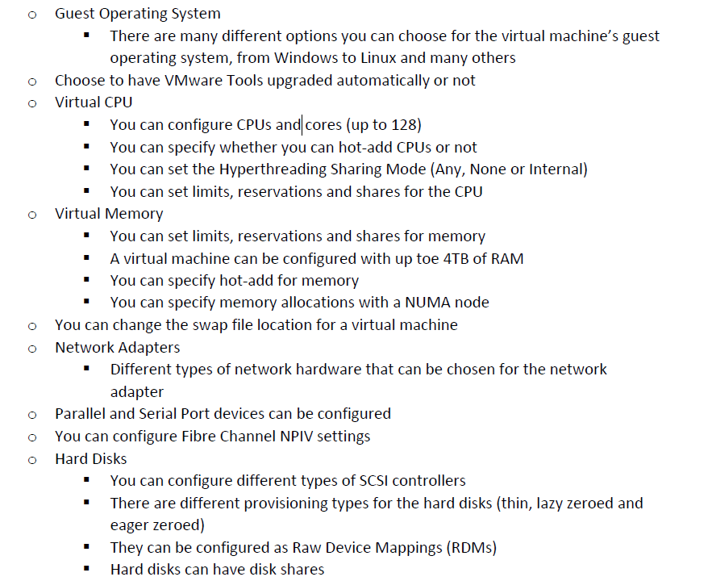

CPU hot add>> VM must be powered off

Memory hot add>> VM must be powered off

The guest operating systems on the system compatibility list for CPU hot plug will recognize the new memory.

orphaned vm> VM exists on Vcenter database but esxi host no longer recognize it

Direct Path I/O from pass-thru

VM to monopolize specific physical card

From host level>settings>hardware>PCI devices>add

Vmotion,DRS,HA,snapshots,FT cant be used in this mode

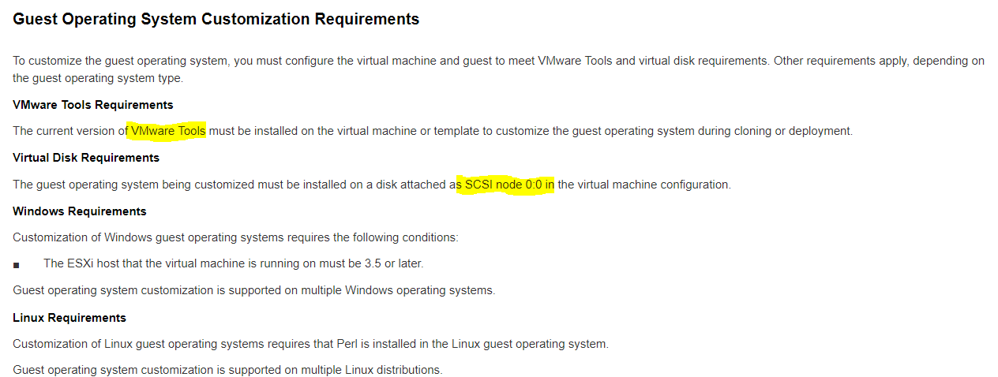

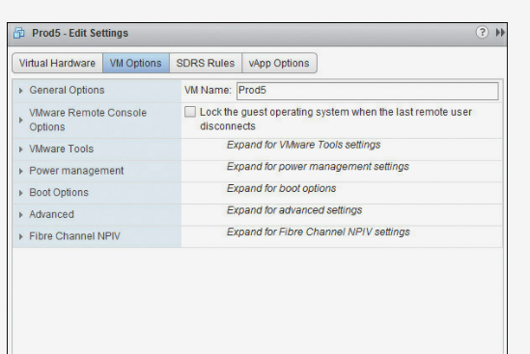

Boot options

Firmware

Boot delay

Force BIOS setup

Failed boot recovery

**Advanced virtual machine settings**

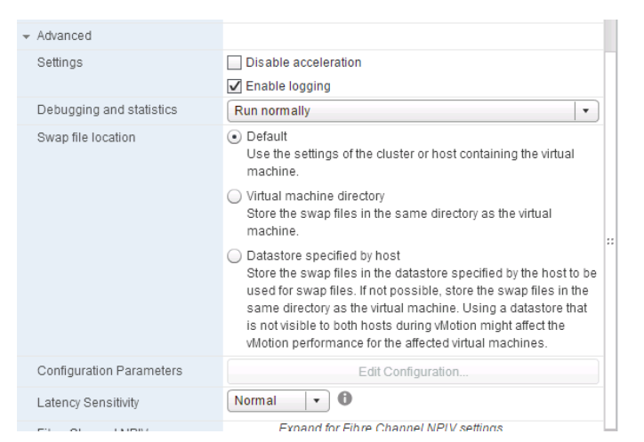

VM security best practices

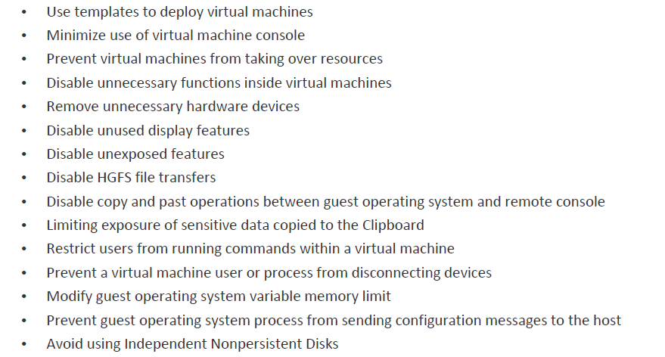

**VM Templates**

Can not edit settings of templates

Can not power on a template

.vmtx > template uzantısı

1.Perfect VM>clone>Template (vm can be on)

(vm and template will exist in the inventory afterward)

Template>> new VMs

2. Perfect VM>convert>Template (vm should be off)

(only template will exist in the inventory afterward)

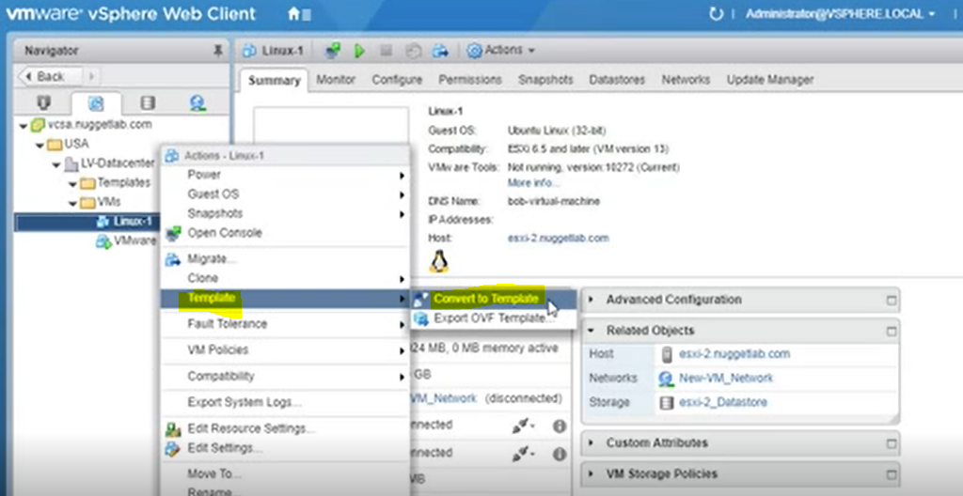

Template> new VM

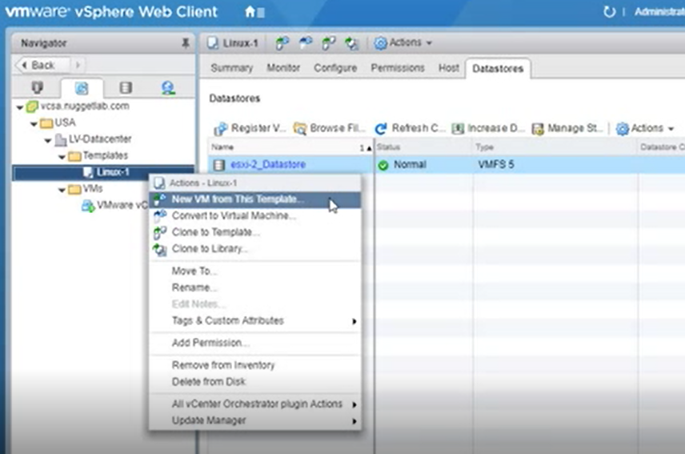

Select name and folder

Select host

Select storage(datastore) and provisioning

Custimization of OS (domain name,timezone,network)



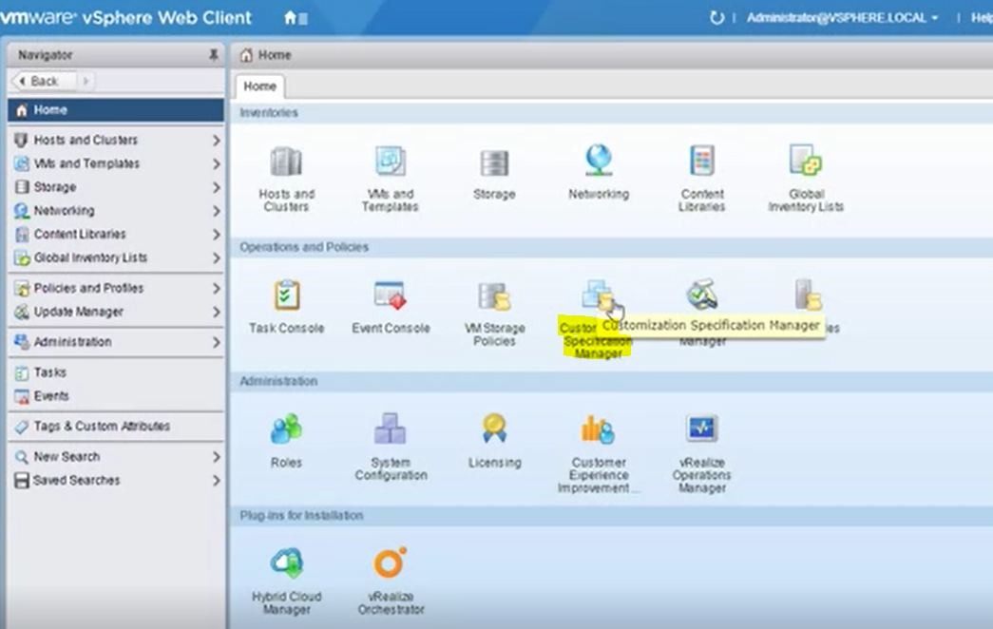

3. Template>clone>another template

Anoter template>new VM

Considerations of cloning

Different SIDs

Licensing

Networking

Customization specificaions

For linux based machines, microsoft machines

**CONTENT LIBRARY**

store all your templates, vApps, ISOs, and so on, that is accessible to you and to which other users (admins) can subscribe as well, even if they are in a different vCenter!

Types

Local

Subscribed >> autosynch,download options set by administrator

Shared

Shared resources between multiple vcenter servers

Publish content from one vcenter server

Synch of content

Subscribe from other vcenter server

From vsphere web client

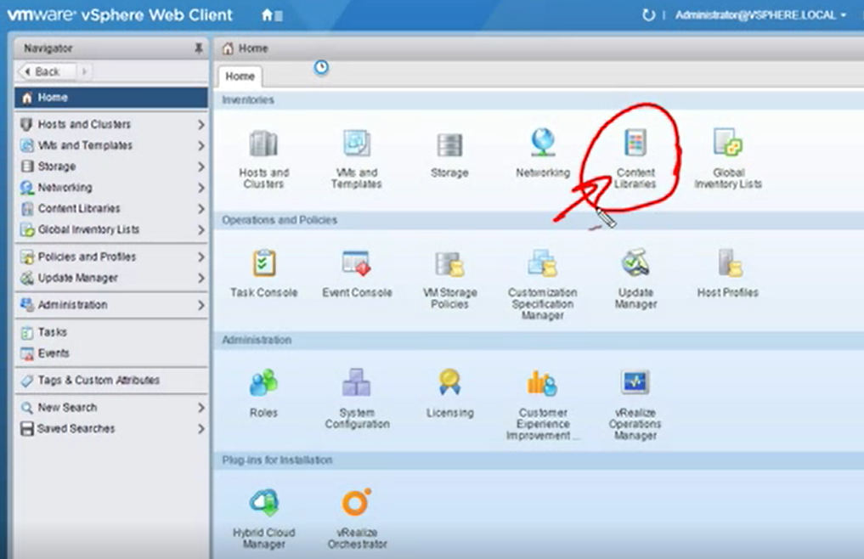

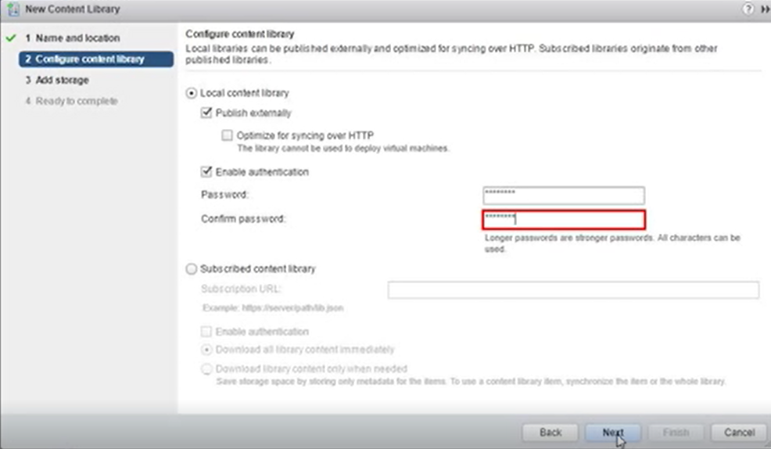

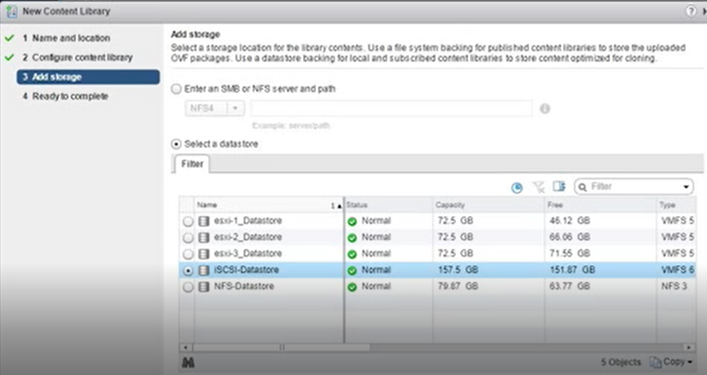

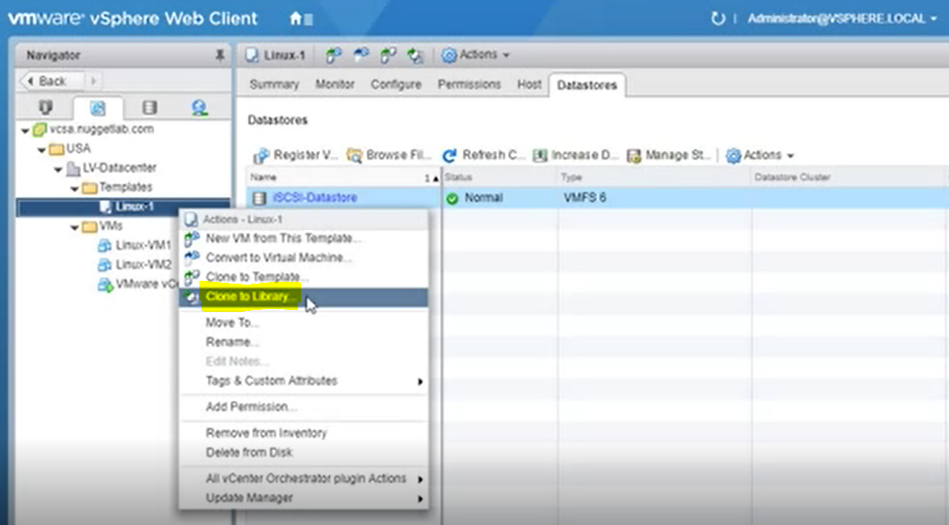

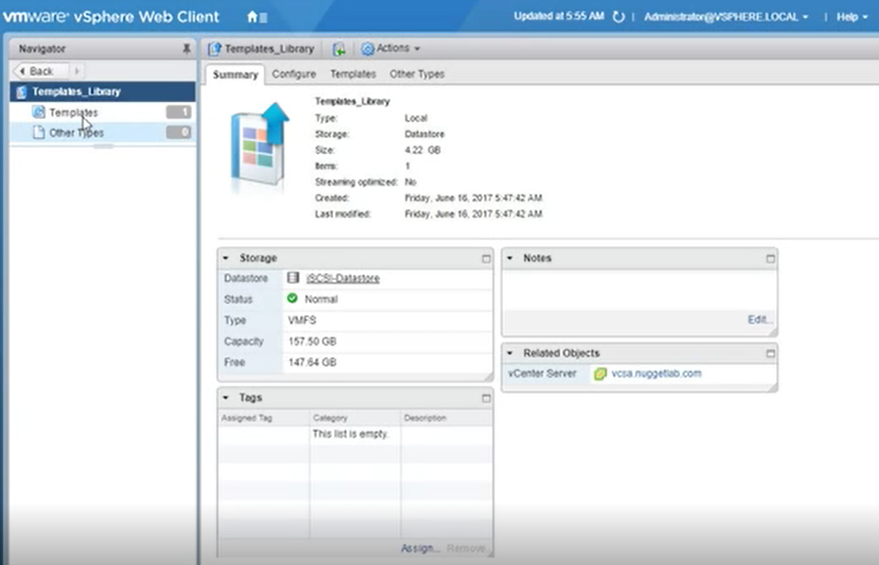

Then it s possible to generate VM from template in content library

**VM CLONE FROM VM**

Vm can be turned on when it is clonned!!

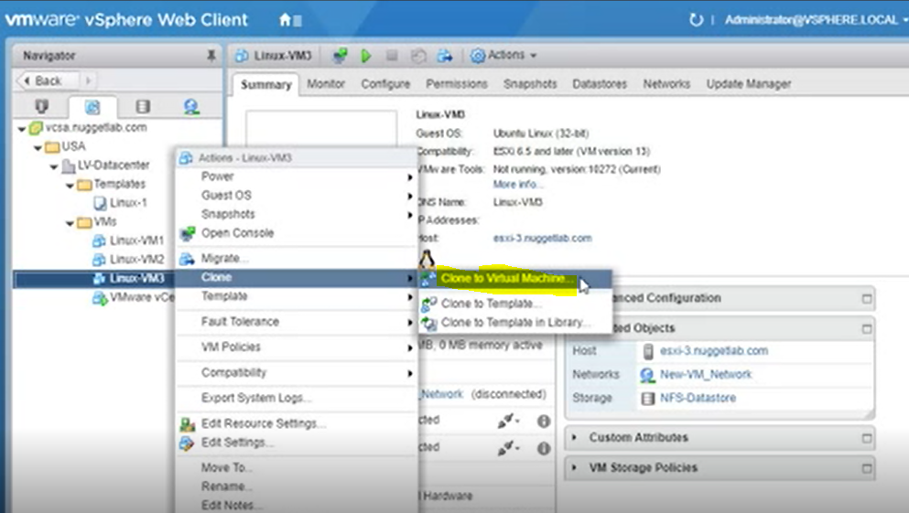

Select name and folder

Select host

Select storage and provisioning

Customize guest OS

**vMotion and Migration**

Enterprise licensing

vmotion boundaries

* Between two vcenter server systems
* Both vcenter servers must be using enhanced linked mode
* Both vcenter servers must be in the same SSO domain
* Time must be in synch
* Between two vsphere distributed virtual switches
* Between two vcenter server datacenter object

usage case

* maintenance of host> evcuate all VMs to another host
* DRS
* Manual movements for test

vmotion> changing host and when vm is running (no downtime)

migration> changing host and when vm is not running

Taşınacak vm’de lokalde bağlantılı bir disk iso’su bulunmamalıdır

Host requirements

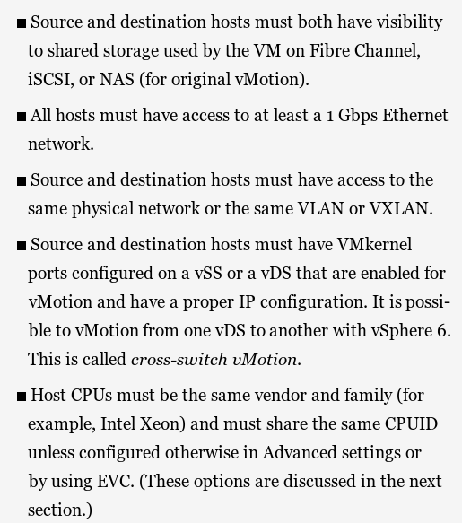

VM requirements

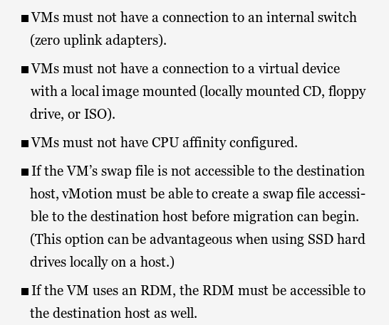

Enhanced vMotion

Migrate the state of a VM to a new host at the same time that the files are migrating to another datastore:

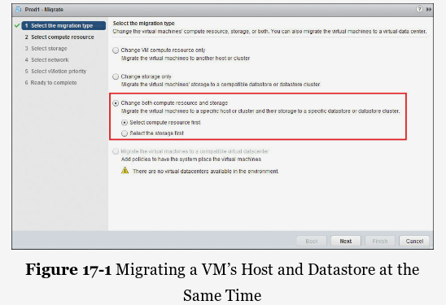

**ENHANCED VMOTION**

EVC ensures that all hosts in your cluster present the same feature set to VMs, even if the actual CPUs on the host differ from each other. When you configure EVC, you are telling all host processors to present a feature set of the baseline processor. This feature set is referred to as the EVC mode.

prerequists

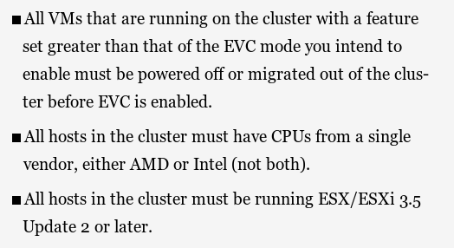

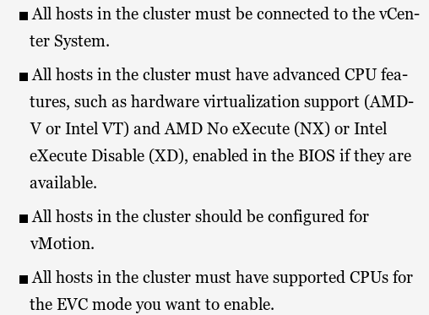

**Long Distance Vmotion**

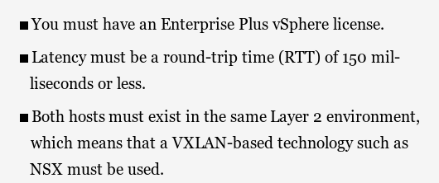

Separate dedicated network is needed for vmotion

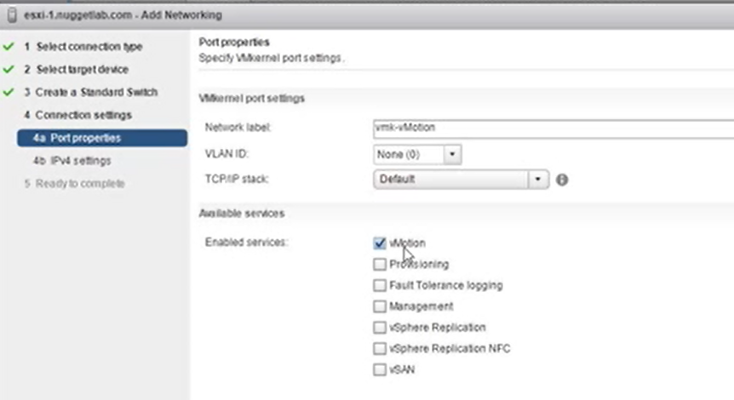

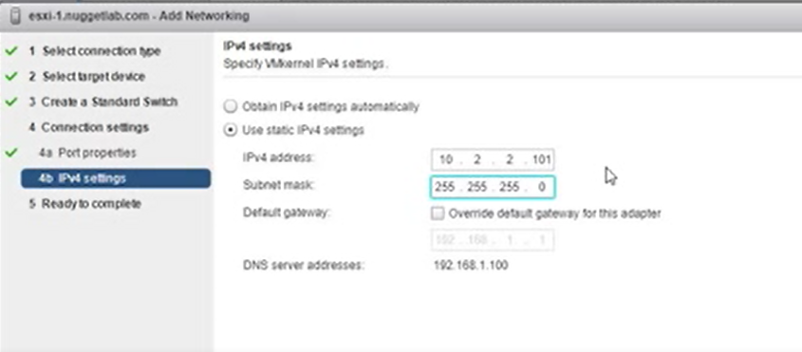

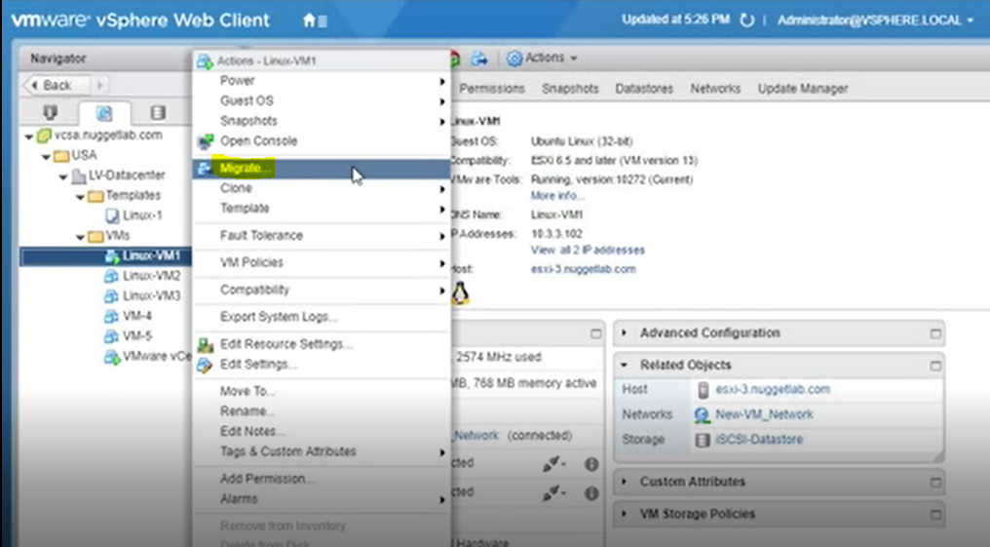

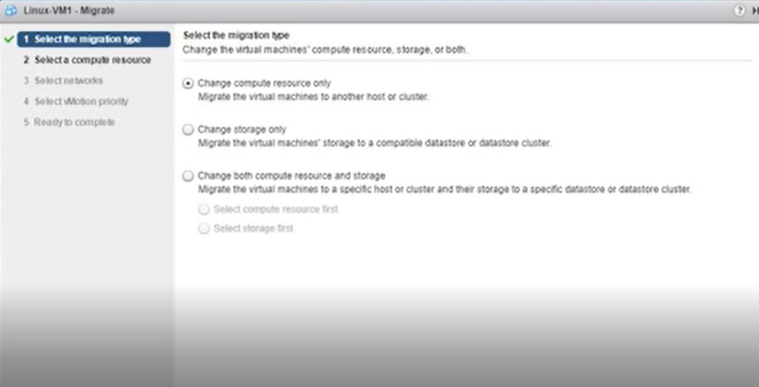

Sadece compute resource tasinacaksa vm in kurulum dosyalari nfs ya da iscsi uzerinde olmalidir!!!

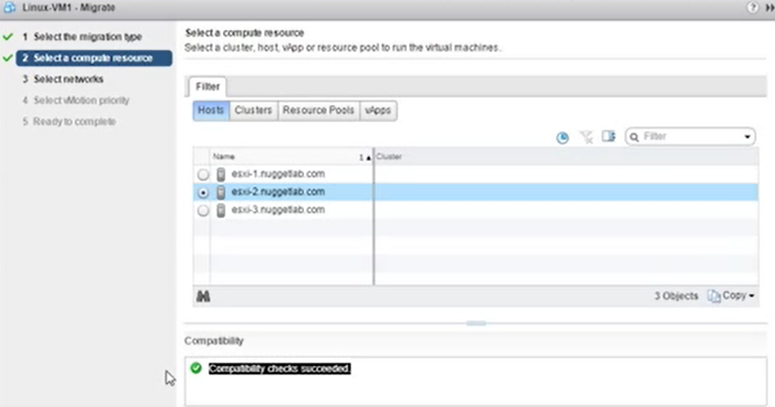

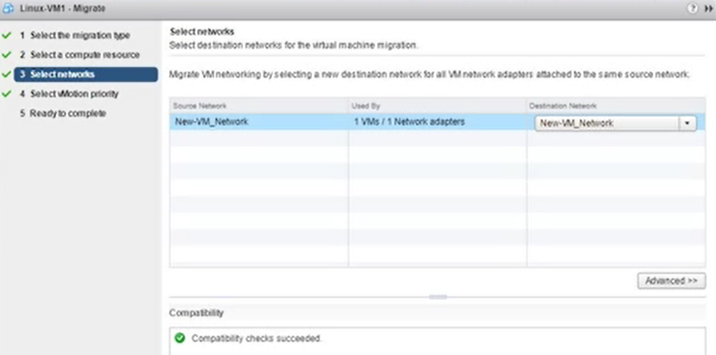

**SNAPSHOT**

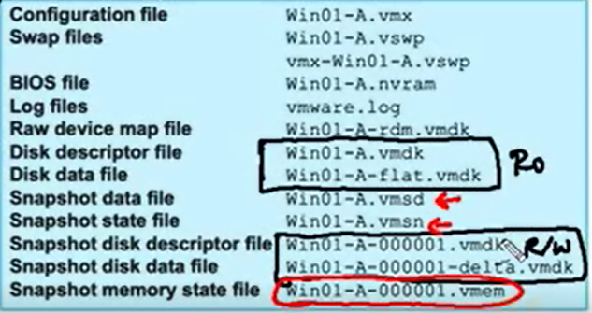

.vmsd >> snapshotların GUI de tutulması

.vmem>> snapshot alındıgında makine açıksa oluşur

before

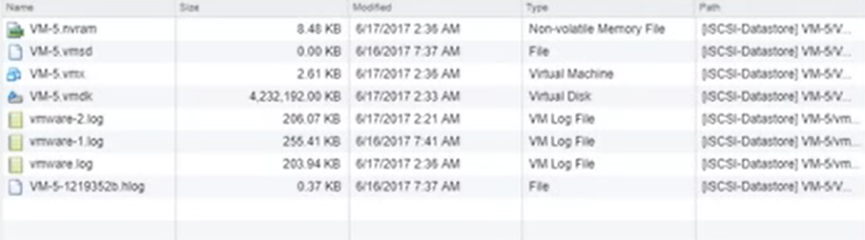

After 3 snapshots

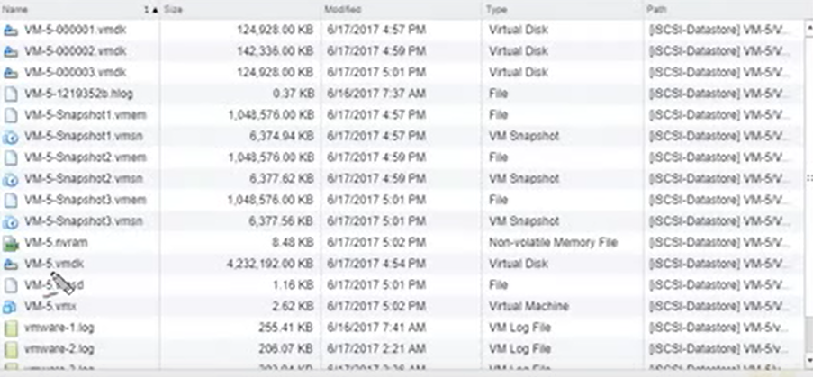

VM-5.vmdk >> original disk

VM-5-00001.vmdk >> delta disk

**VM INVENTORY OPERATIONS**

Remove from inventory> remove from vcenter console doesnt delete data

Bring back to inventory

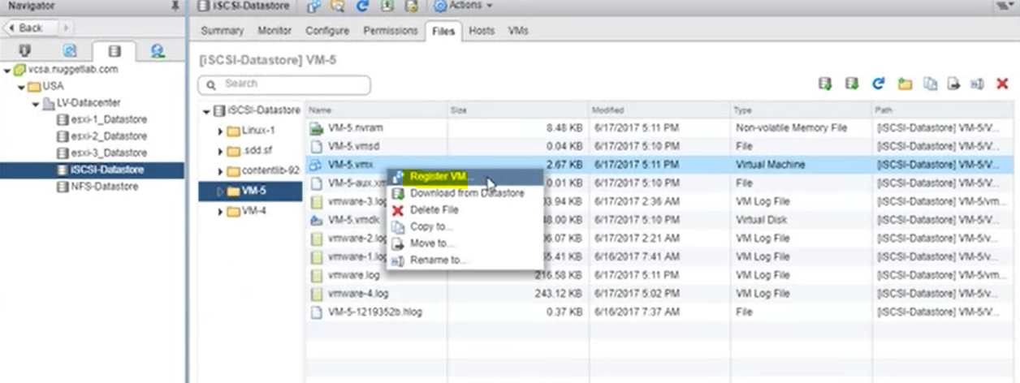

Delete from disk> remove from vcenter and deletes data

Rename> renames labels, doesnt rename vm folder names

Matching vm name and folder name after rename

**Backing up and restoring VMs**

Back up VM without interrupting their use +deduplication(2TB total)

creating, deleting, and consolidating snapshots.

Vmware DataProtection(VDP)

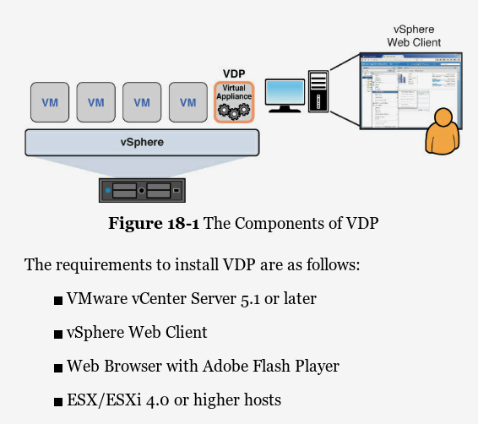

Each backup job can contain a maximum of 100 VMs, but you can back up only 8 VMs simultaneously.

you install one instance of vSphere Replication at your primary site and another instance at your secondary site. Also, after installing vSphere Replication, you can make configuration changes using the Virtual Appliance Management Interface (VAMI).

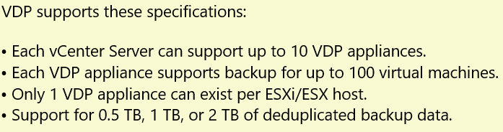

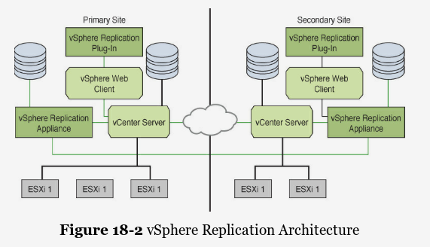

İnstalling Vmware Data Protection

Vms and Templates>datacenter>Deploy OVF template

Download VDP appliance .ova package and browse to it

Enter name of VDP appliance

Select host

Select storage

Select network

From where to Backup>>web client VDP plugin under solutions and applications

Creating backup job

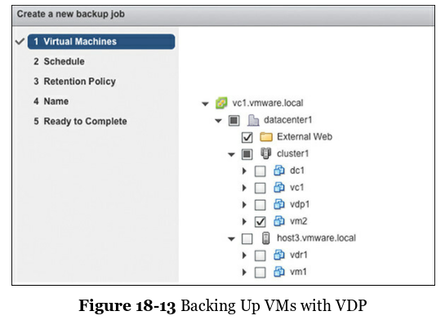

Replication

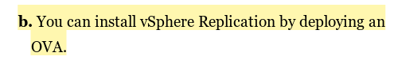

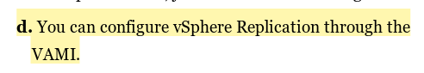

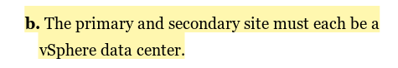

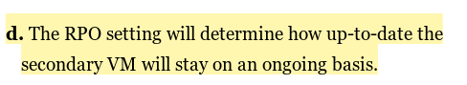

This range is from 15 minutes to 24 hours

Recovery

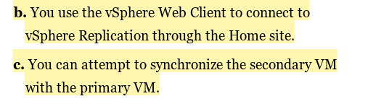

Viewing VMs that needs consolidation

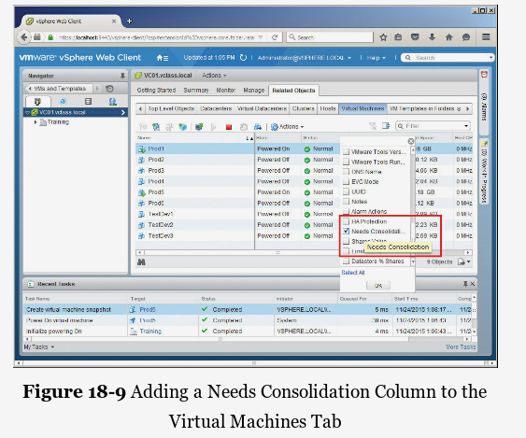

**SWITCH POLICIES**

Minimum number of hosts that you can connect to vDs:1

Maximum number of hosts that you can connect to vDs:1000

**Policies for Vss**>> security, trafic shaping(outbound only),teaming and failover (From switch level or port level> port group settings override switch setings for VMs on the port group)

Policies for Vds>> can be set at the port group level on a vDS and be overridden at the port level include Security, Traffic Shaping, VLAN, Teaming and Failover, Resource Allocation, Monitoring, Miscellaneous (port blocking), and Advanced (override settings).

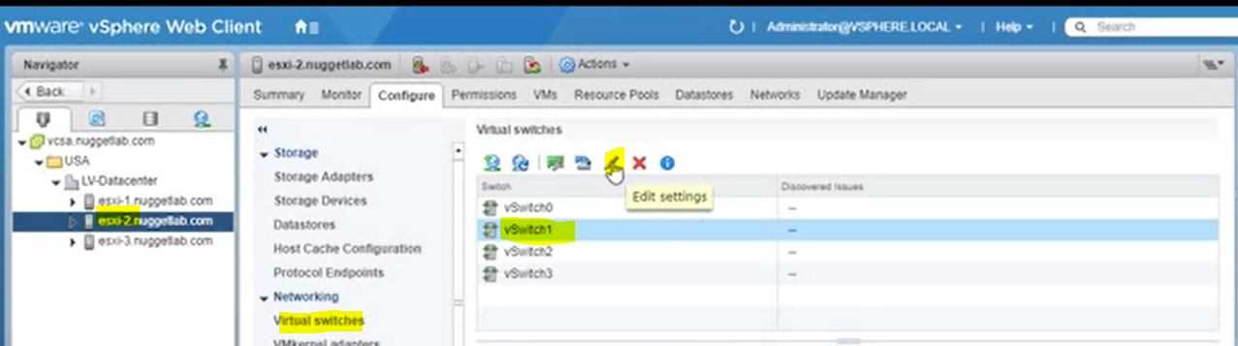

Number of ports>> elastic (automatically creation of ports for VM)

Security

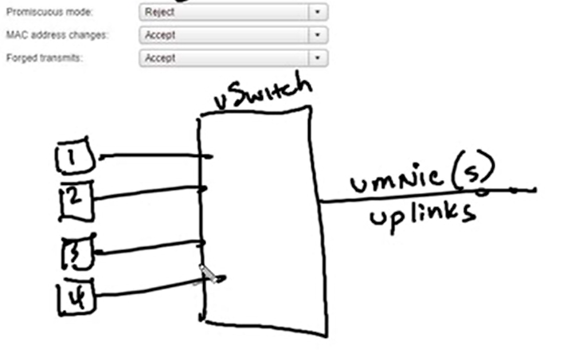

**Promiscious mode** > Accept> VM’lerin birbirleri arasındaki trafiği görmesini sağlar

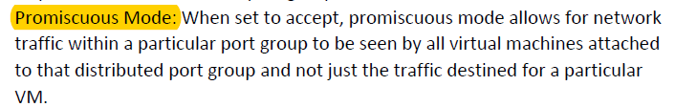

**Mac address change** >> Accept & Reject>> traffic is sent to changed mac address of vm or not (inbound of VM)

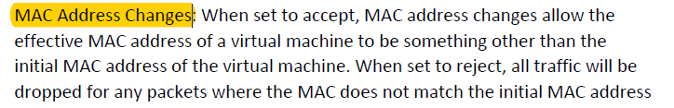

**Forged transmits** (outbound of VM)>> When enabled, it allows to change mac address from guest OS and traffic is still allowed. When it is set to reject, source address of packet is compared to effective MAC address of adapter, if it is not matched, packet is dropped

Traffic shaping policy

Control flow of traffic from vms over switch

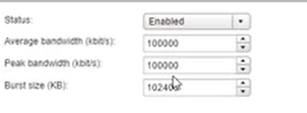

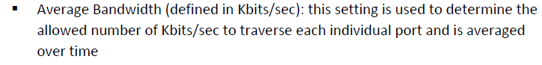



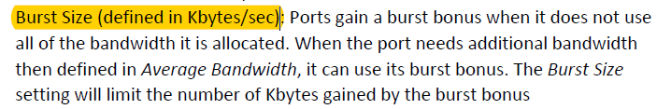

NIC teaming

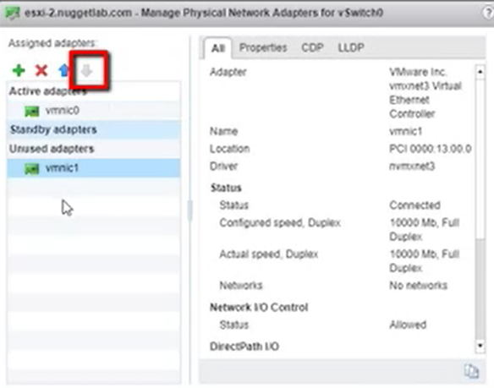

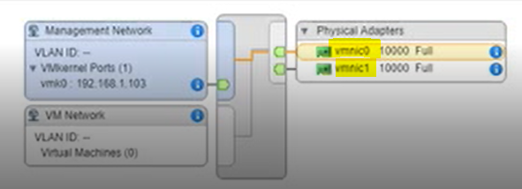

Switch Policies

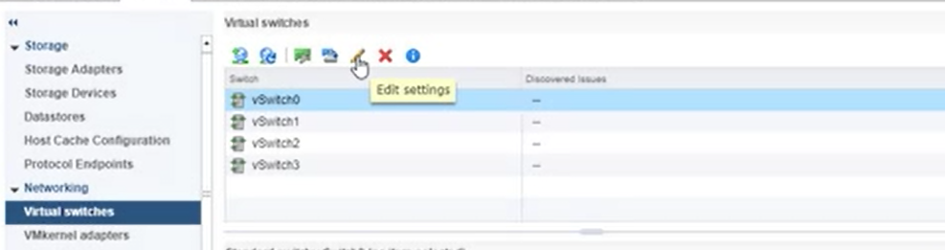

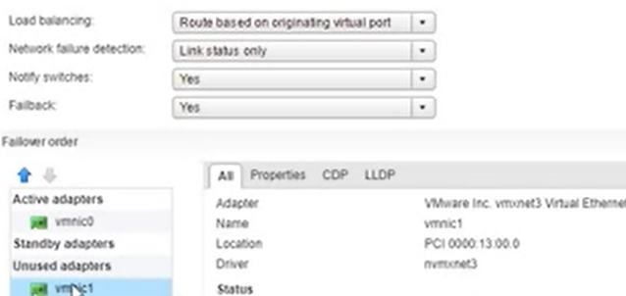

Failover Order

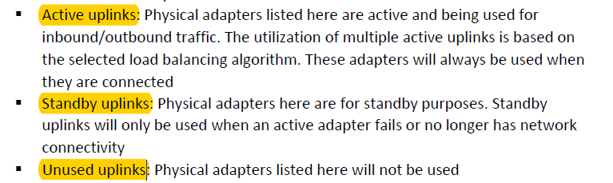

Load Balancing options

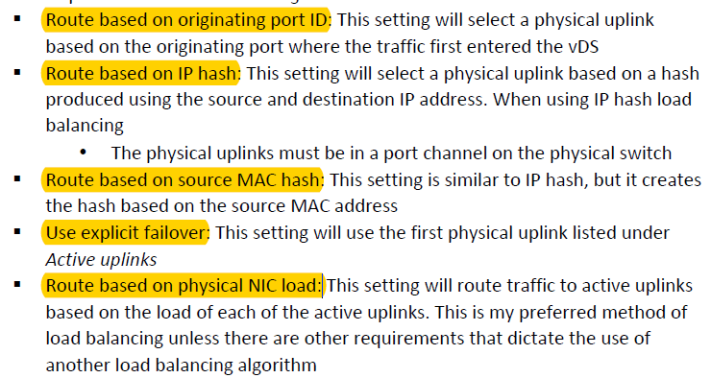

Route based on physical NIC load> newly available on vsphere standard switch

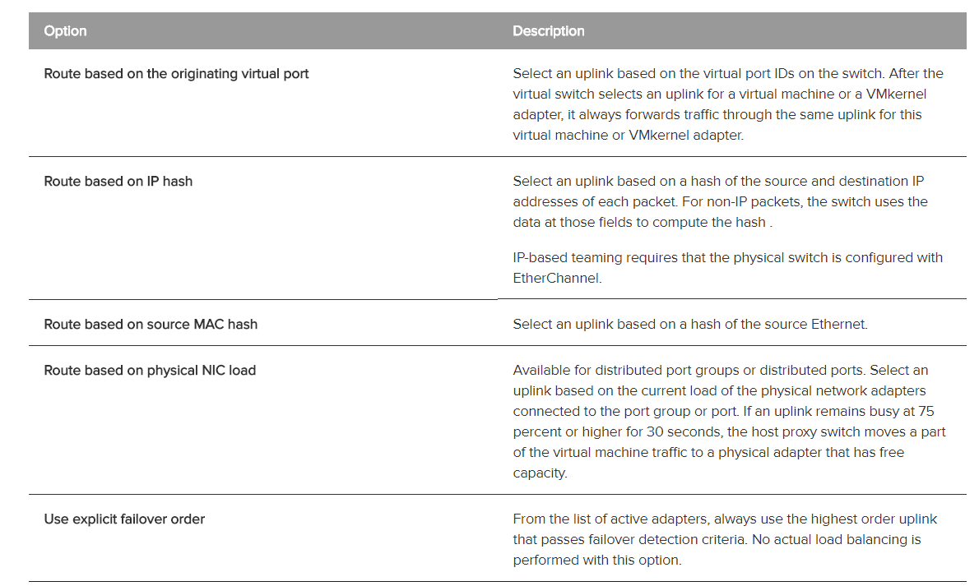

Notify switches

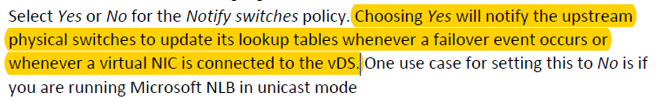

Failback

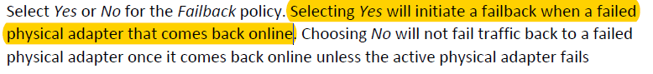

Network Failure Detection

Link status only (connection cut)

Beacon Probing

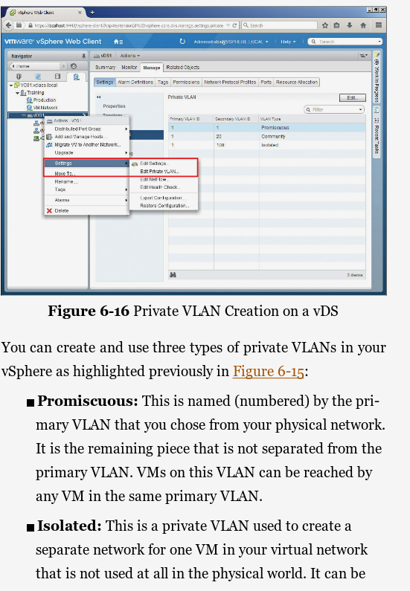

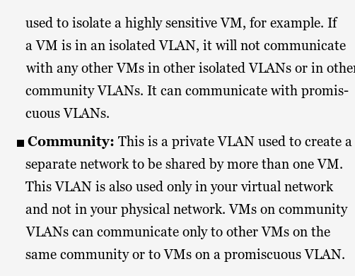

**Policy’lerin tüm esxi hostlar tarafından kullanılması için**

**Distributed vSwitch**

* Enterprise+ licensing is required

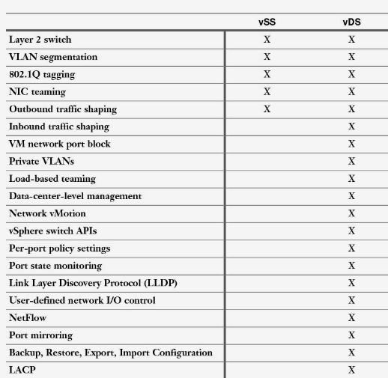

**Inbound traffic shaping**: A port group setting that can throttle the aggregate bandwidth inbound to the switch. This might be useful for a port group containing VMs that are being used as web servers.

**VM network port block:** Specific ports can be configured as “blocked” for a specified VM’s use.

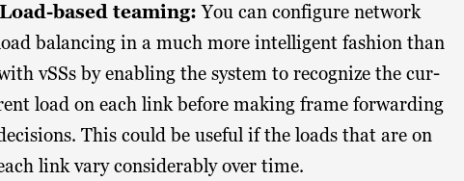

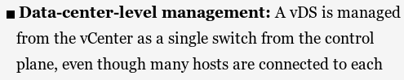

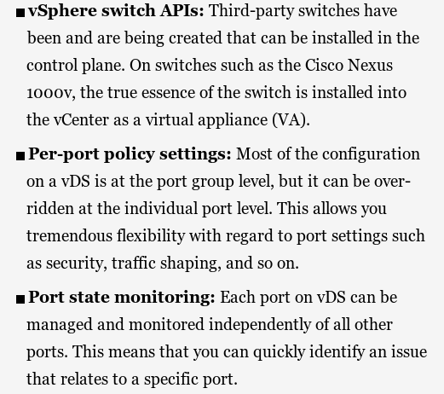

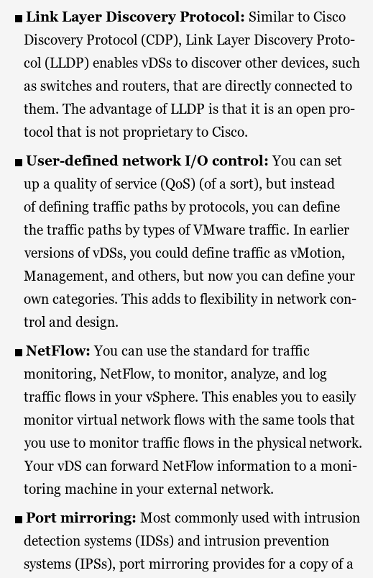

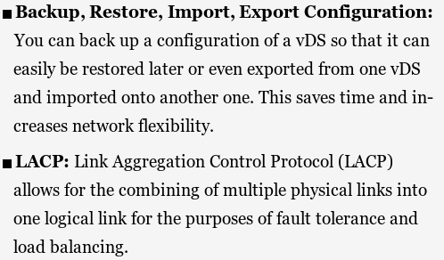

LACP LIMITATIONS

Software iSCSI multipathing is not compatible.

It does not support configuration through Host Profiles.

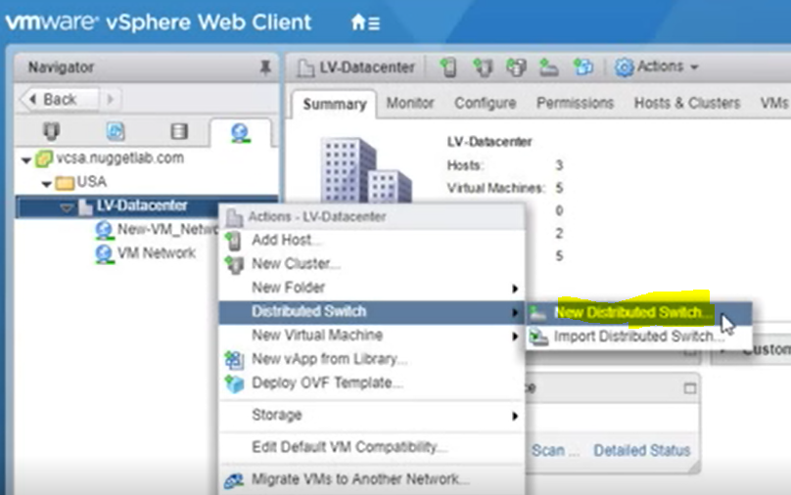

Distributed Switch versions and features related to it

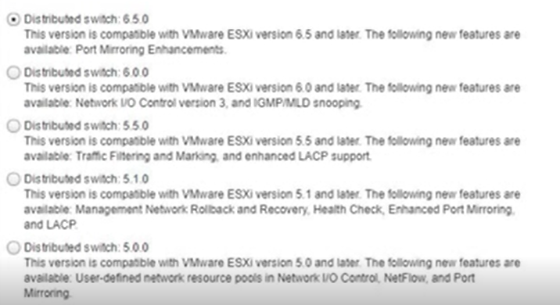

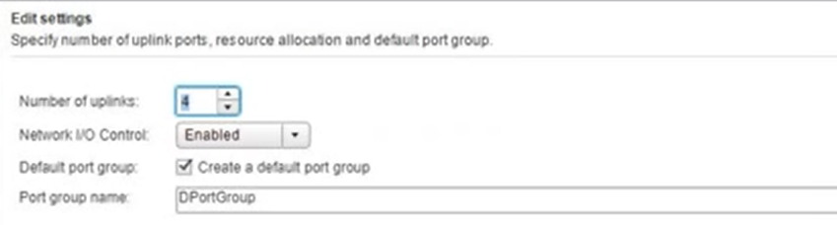

Network I/O Control (NIOC) >> requires enterprise+ licensing

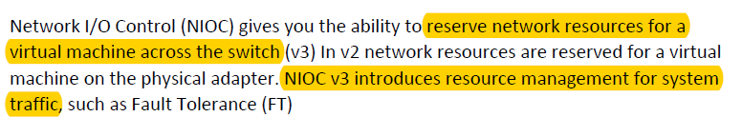

Set shares and priority for iscsi,ft,vmotion from available network BW

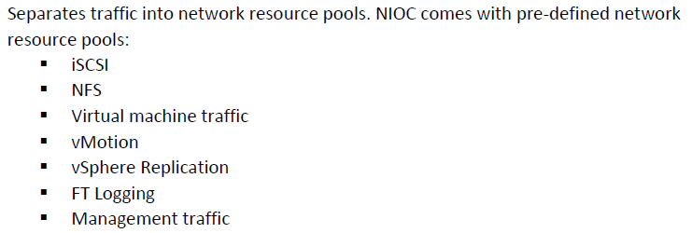

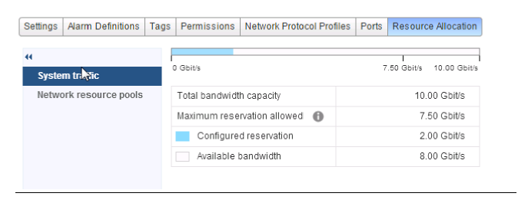

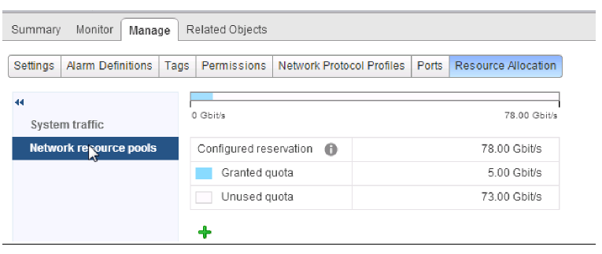

Private VLAN

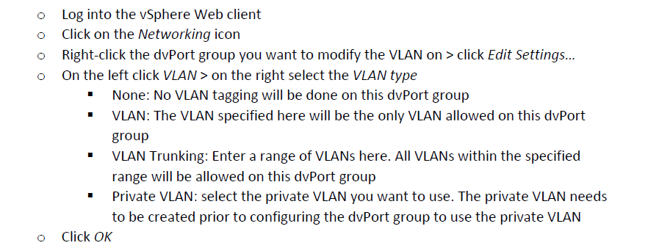

Vlan tagging modes: external switch tagging, private vlan tagging, virtual switch tagging

**DRS (Distributed Resource Scheduler) Cluster**

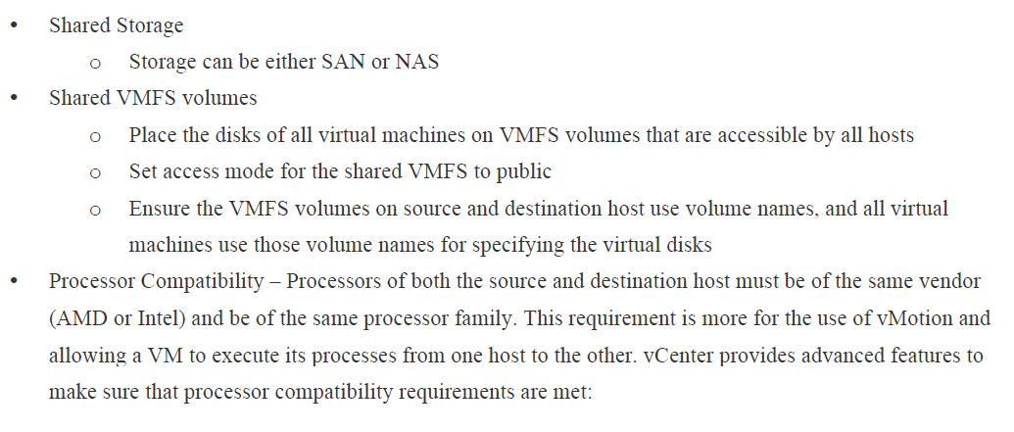

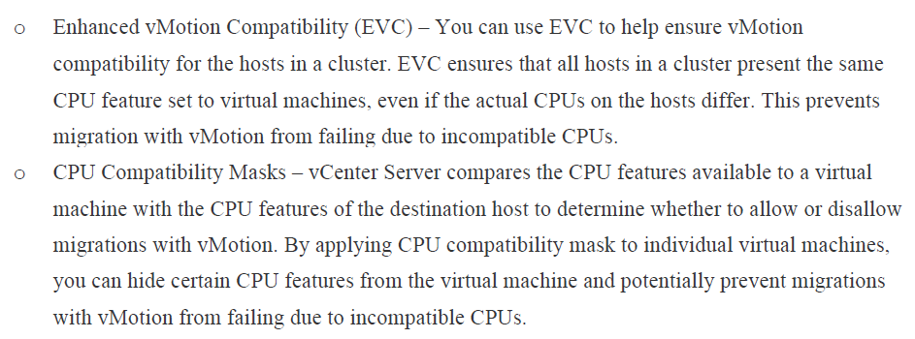

Esxi hosts in cluster

Vm can move to different host according to load

Possible causes of imbalance

-affinity rules

-local mounted drives on VMs

-vMotion is not configured and enabled

-DRS rules prevents VMs from being moved

Creating cluster

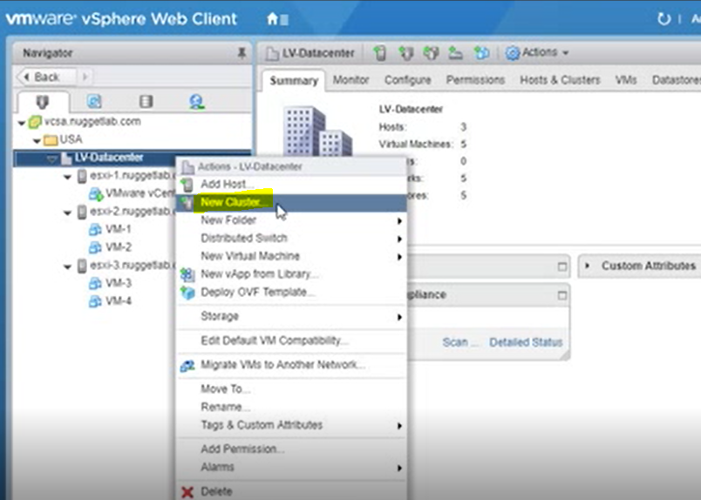

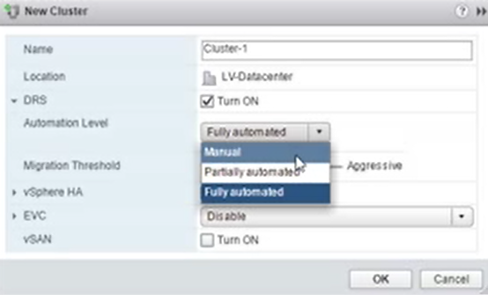

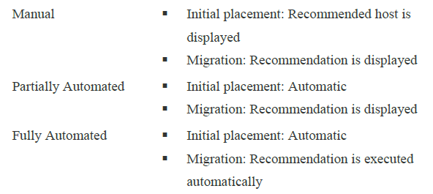

Move hosts to cluster

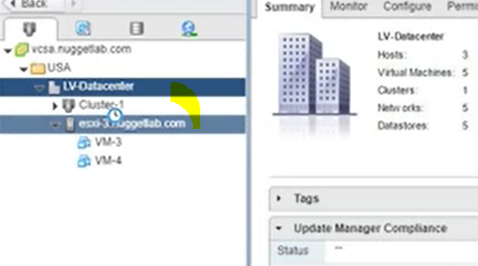

Host üzerindeki vm’ler de beraberinde taşınır

Vm power on recommendation >> which host VM use when starts

DRS recommendations & monitoring

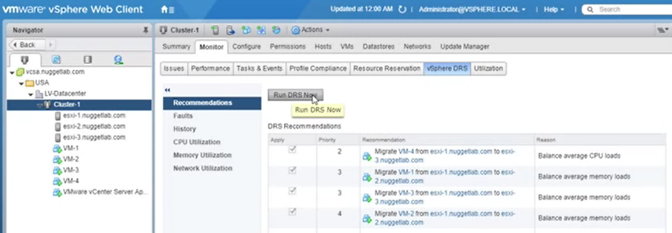

Changing DRS settings on cluster

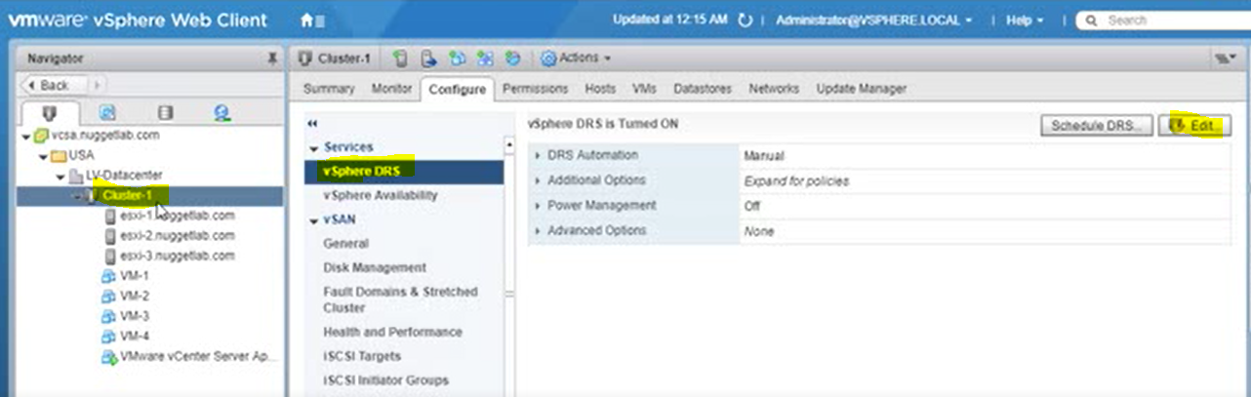

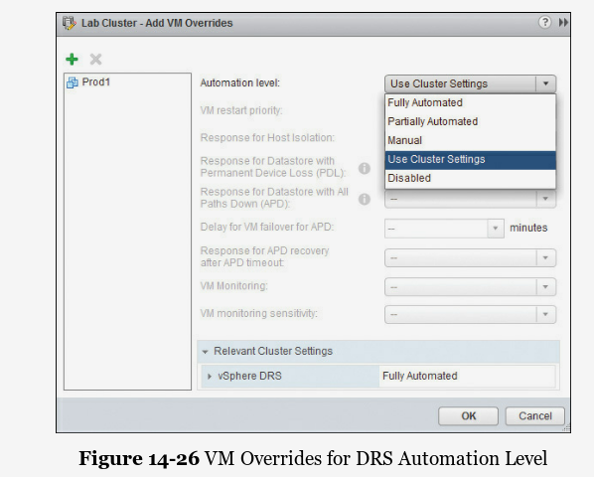

**AFFINITY**

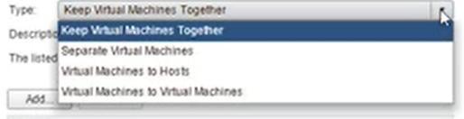Possiblities>>

1.Vm together,

2.VM apart,

3.VMs to specific host,

4. VMs away from specific host

DRS checks affinity rules

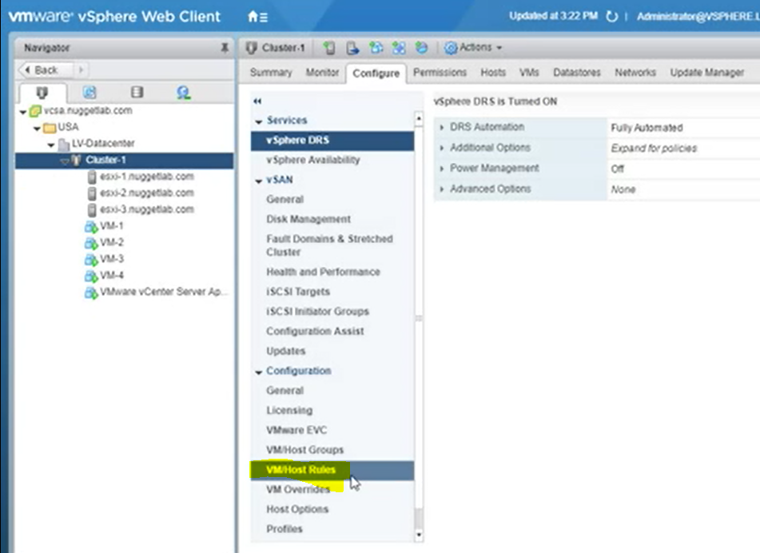

VM-HOST AFFINITY

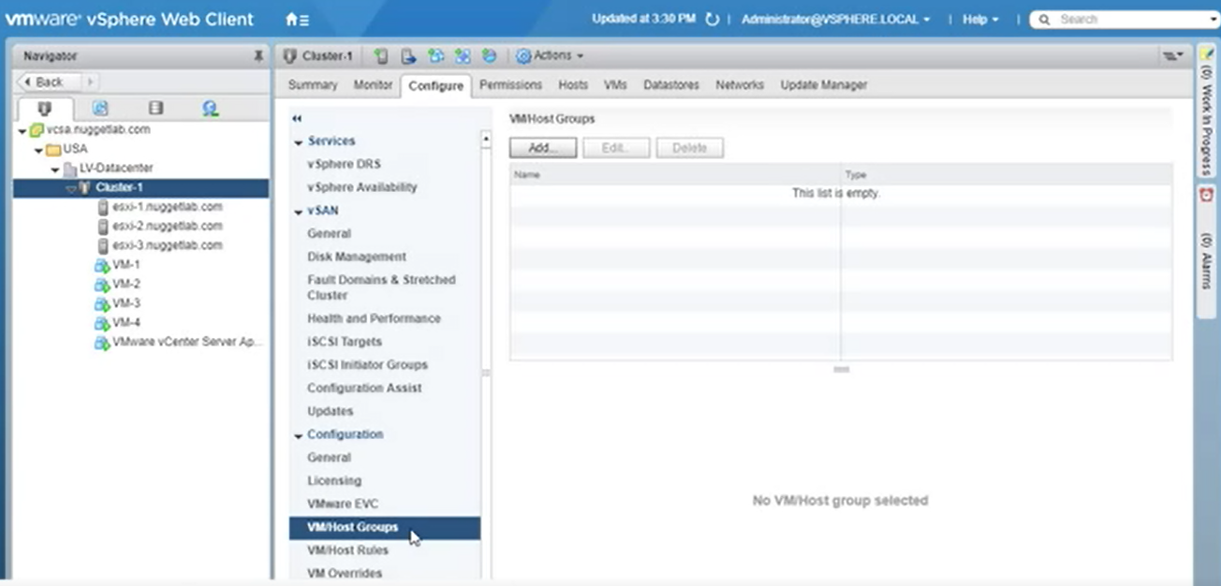

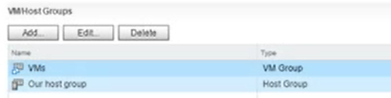

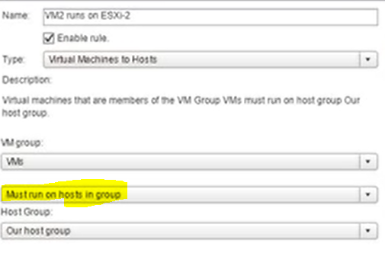

VM to VM Affinity

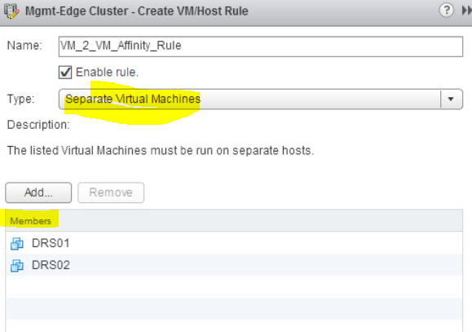

**HIGH AVAILABILITY**

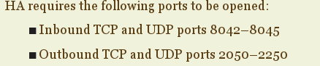

**Failed host>** network and storage heartbeat are not available

VMs are started in another hosts

**İsolated host>** host cant talk to master over management network, can talk to storage , VMs on host can work

Reaction>>

keep VM running,

shut down(graceful-good) and restart

**Partitioned host>>** master cant talk to slaves but slaves can talk to eachother, they can talk to storage

Solution>> HA does nothing, VM runs, hosts are partioned and disconneted from vcenter , warning appears

Requirements

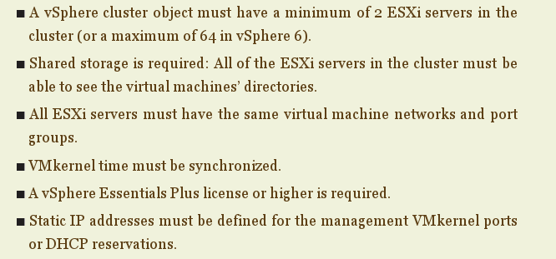

Cluster level

When a host is down, cluster detects and VM restarts over another host

Vm ad application monitoring (heartbeat)

One of host is master in HA concept

Heartbeat on management network

Datastore heartbeat

Host isolation

All paths down

Permanent device loss

Moving Host from one cluster to another

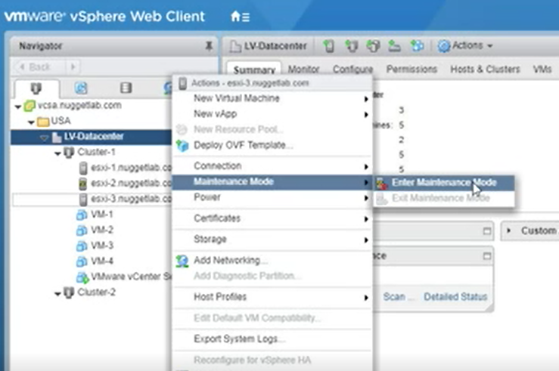

Move host (those in maintanence) into new cluster

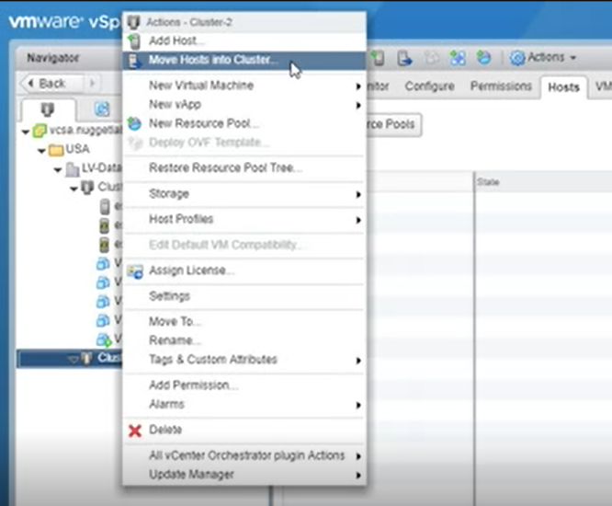

After moving host into new cluster, make ‘exit maintanence’

Migrating VMs to new cluster

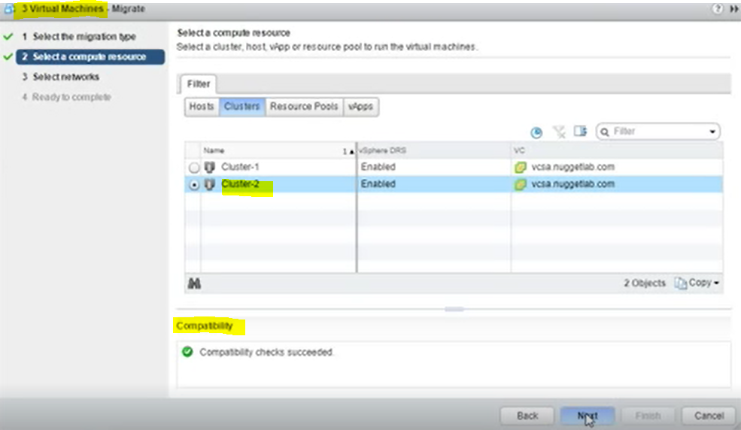

HA

Edit cluster HA settings

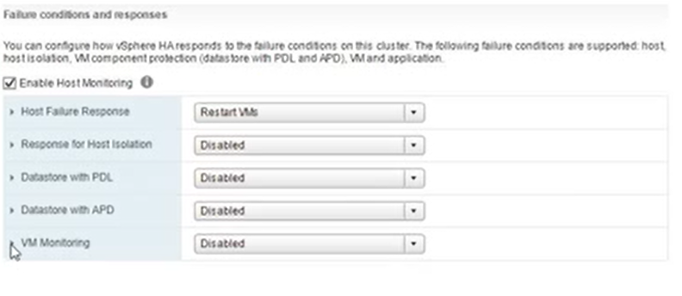

Admission Control



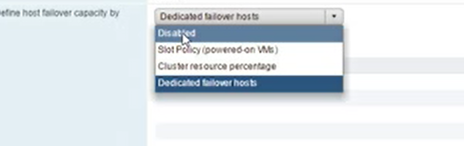

Heartbeat datastore

Management network düştüğünde storage kontrolü

Automatically select, select from list of datastore

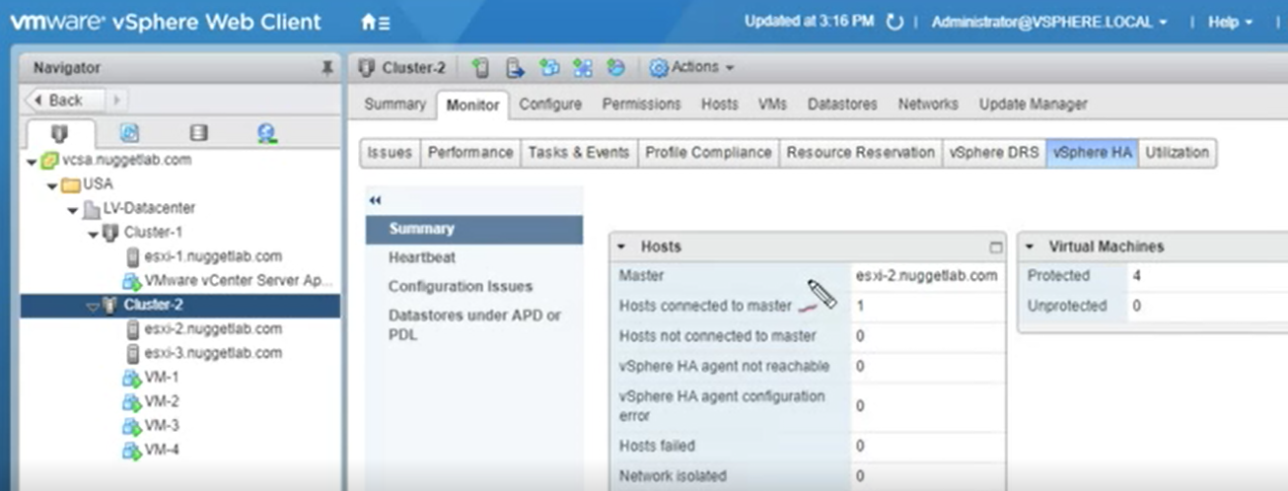

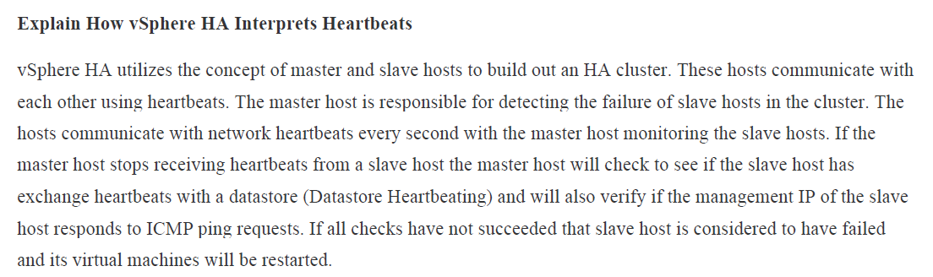

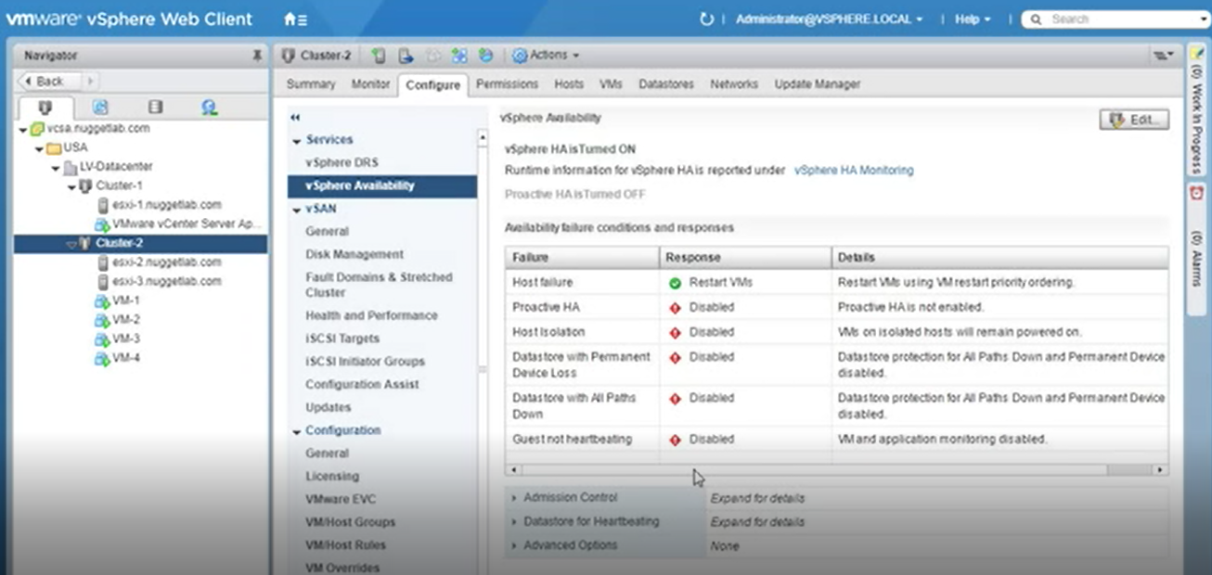

How to change failure responses

During the vSphere HA setup options such as the **VM restart priority** or **Host isolation response** are configured. These options are set for the entire cluster. You can override these settings for individual virtual machines by using the **VM Override** section of the cluster settings window.

Services>Configuration>VM Overrides

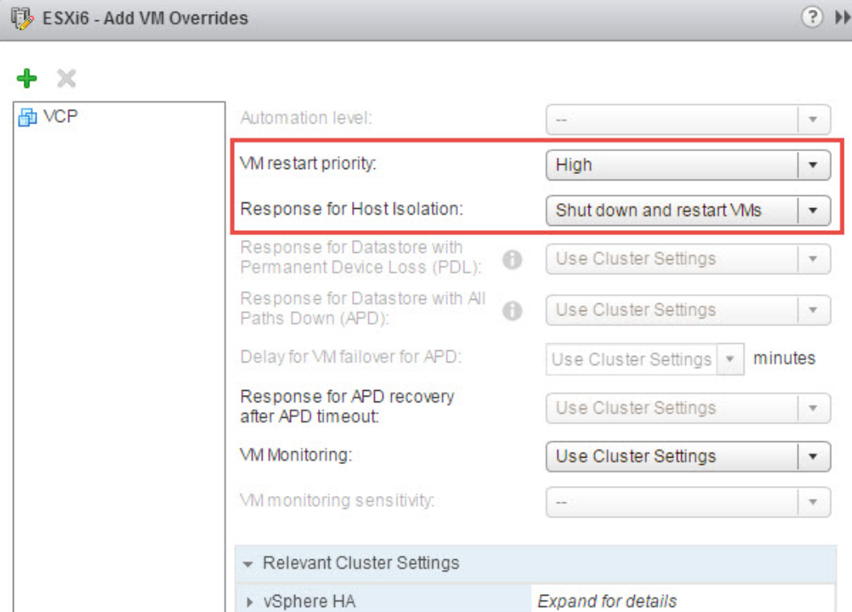

High availability advanced settings (from cluster level)

<https://kb.vmware.com/s/article/2033250>

examples

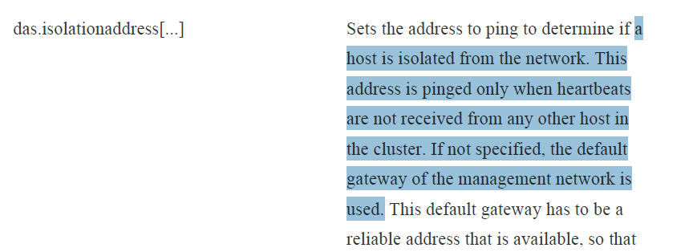

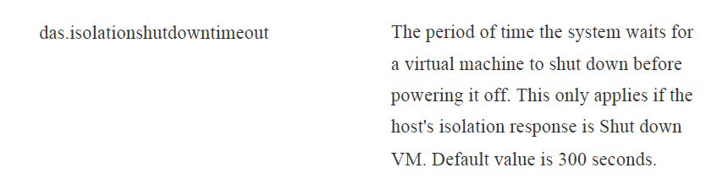

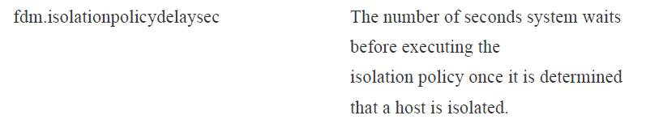

Where to configure

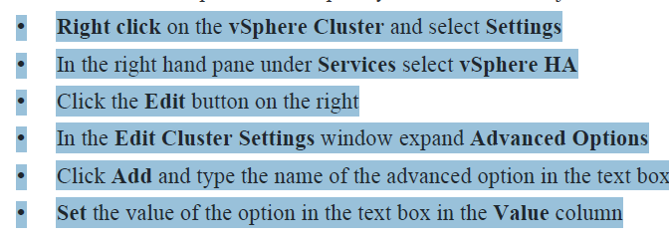

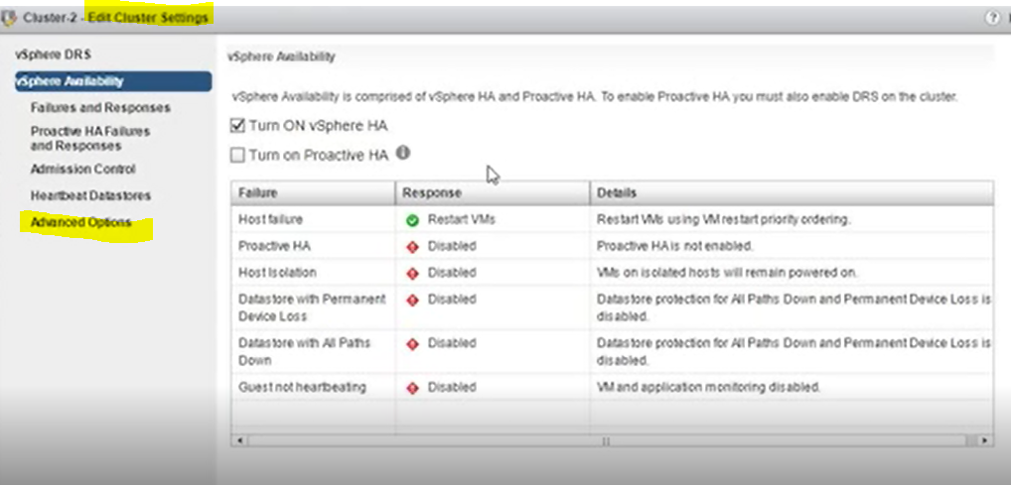

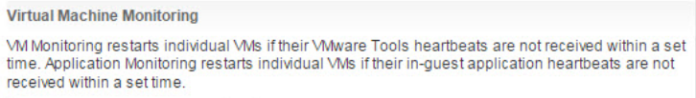

**Virtual Machine Component Protection (VMCP) Settings**

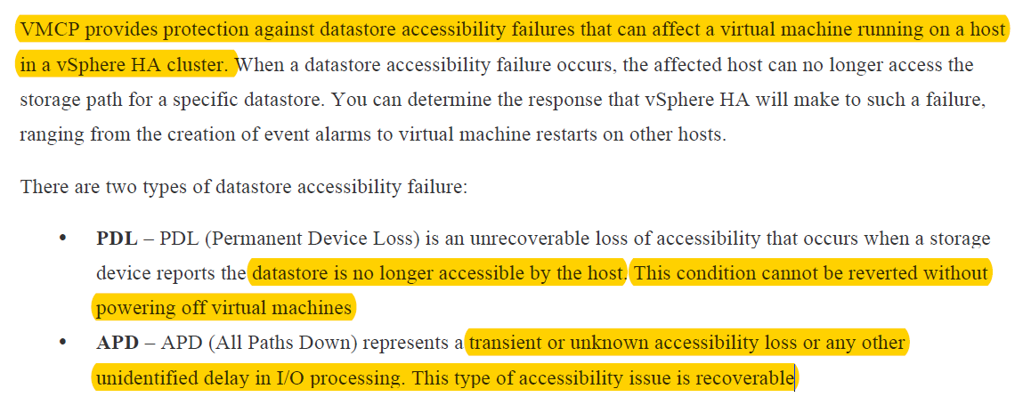

PDL actions

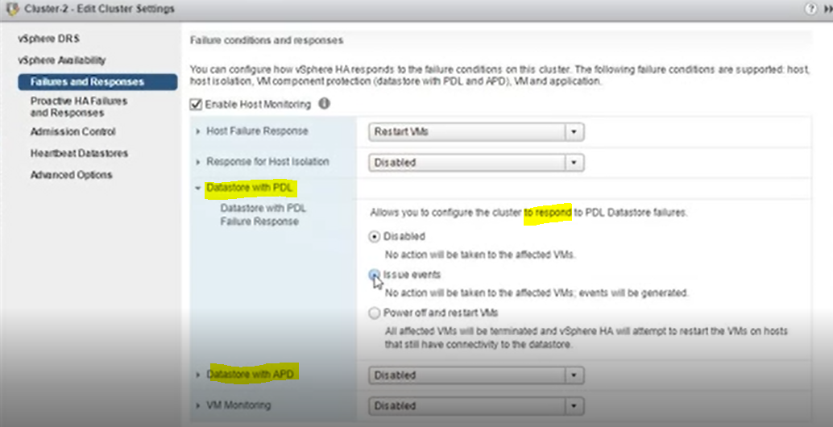

APD actions

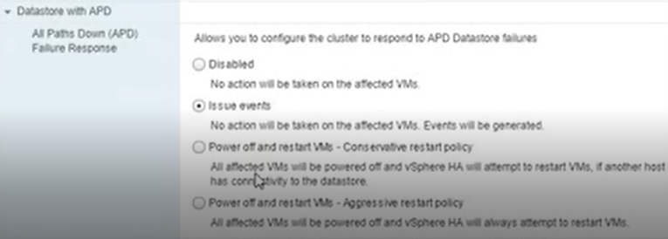

iSCSi multipath

**path selection policies**

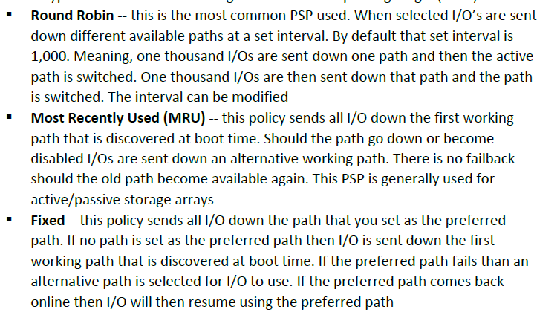

Fixed is configured in default

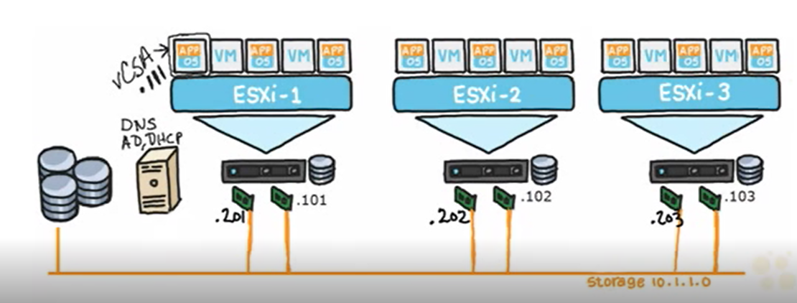

Create two vSwitch

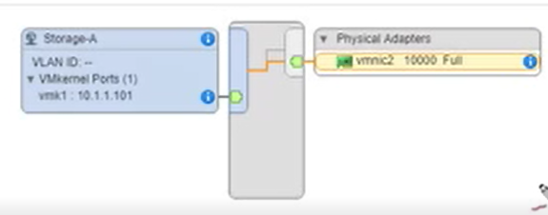

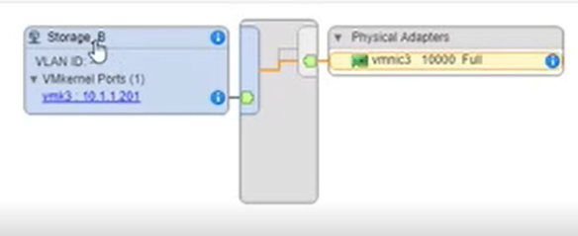

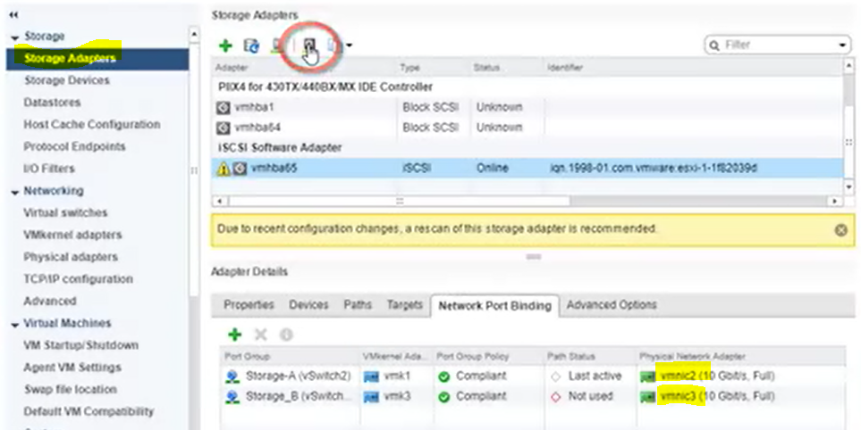

CPU and Memory Utilization

Reservation & Limits

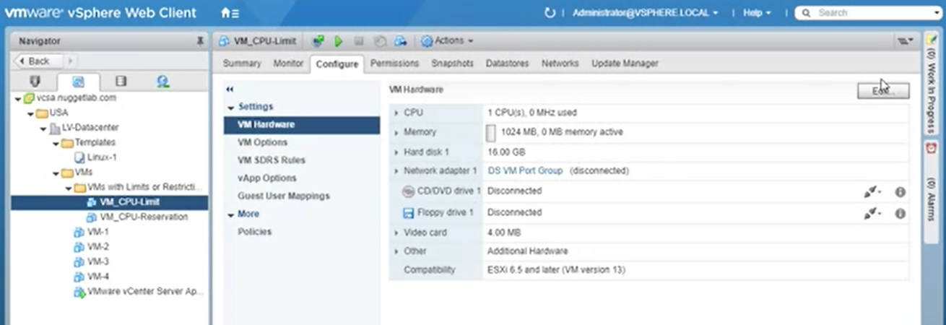

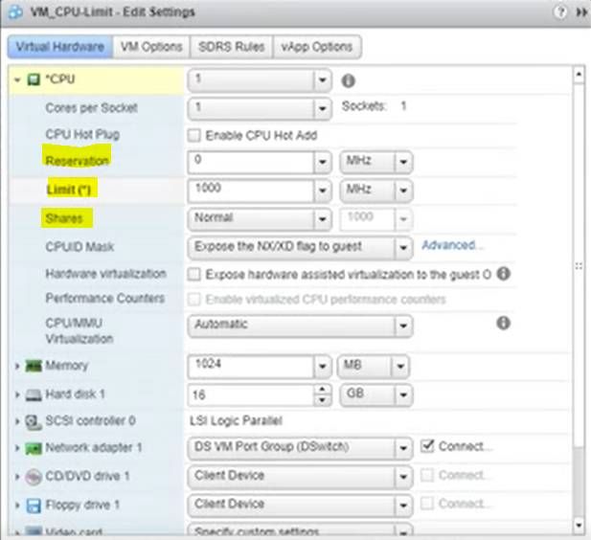

Share> how much VM will use when there is scare of resources compared to others (contention)

Share concept:

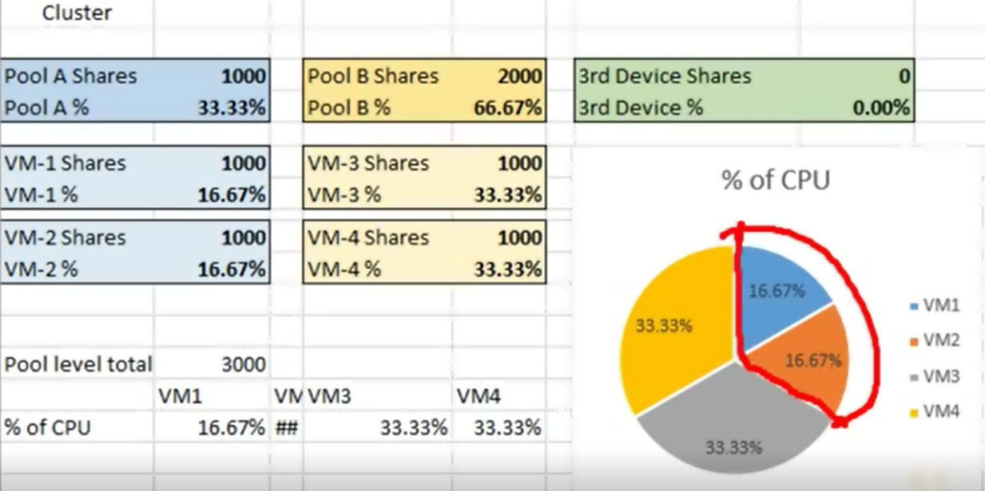

Low share> 500 k

Normal share>1000 2k

High share>2000 4k

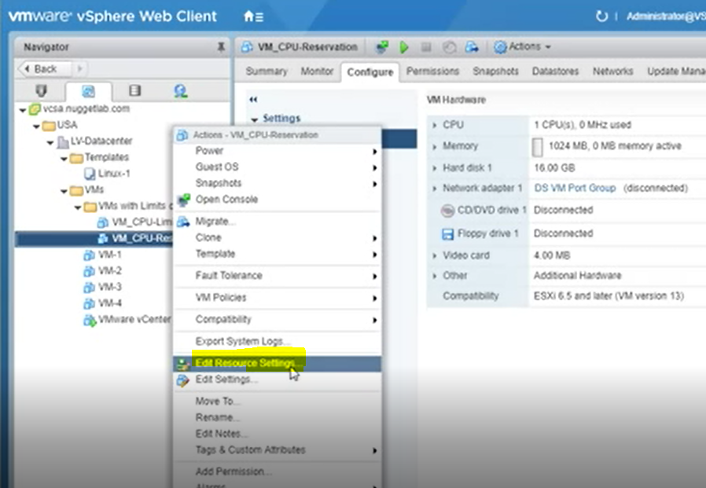

To view given limits and reservations

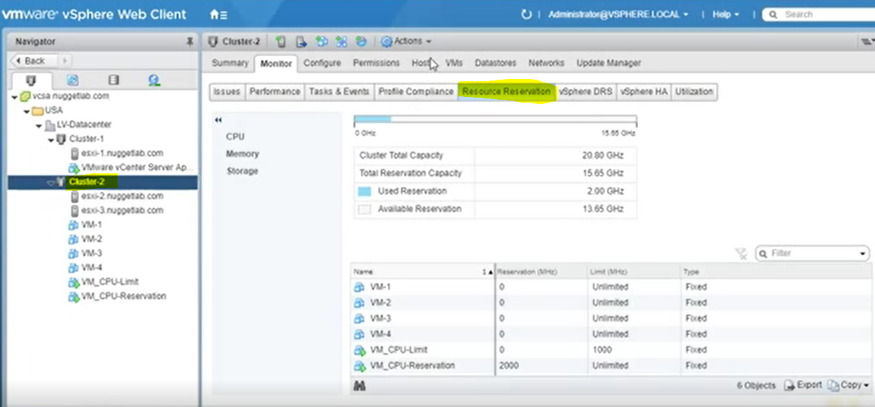

**RESOURCE POOLS**

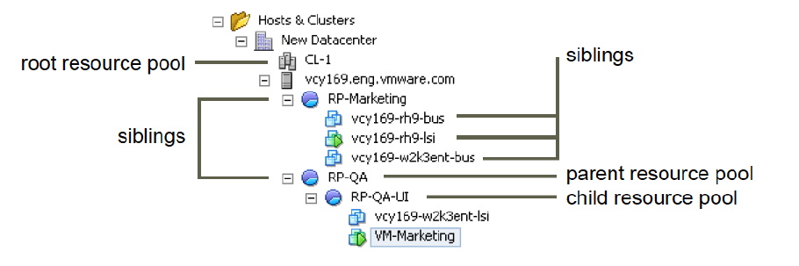

Cluster(root resource pool)>Host>ResourcePool>VMs

Root of resource pool can be standalone host or cluster with HA and DRS enabled

Expandable Reservation Parameter

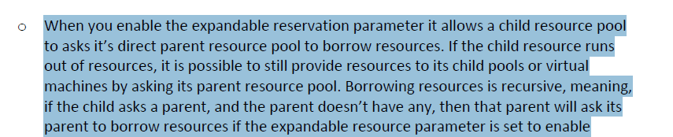

Reservation ve limitler pool seviyesinden verilir ve VM’ler pool’a bağlanır

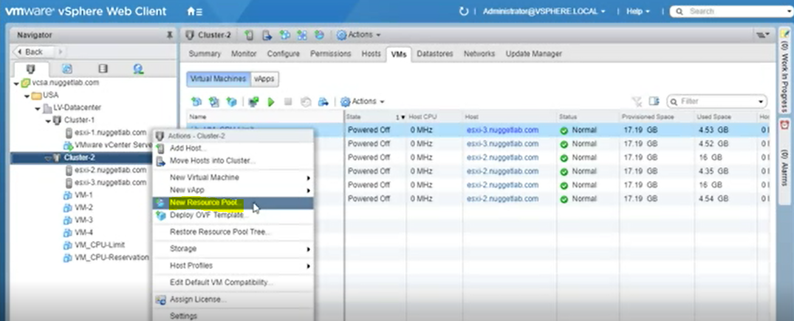

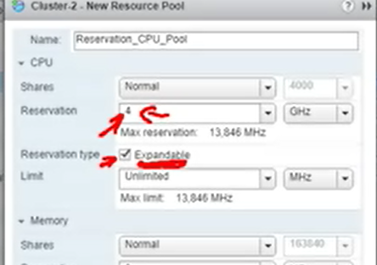

Expandable >> eğer VM poolda kendisine verilen reservation dan fazla kaynağa ihtiyac duyarsa clusterdan kaynak verilir(eger varsa)

Then move VMs to created pools

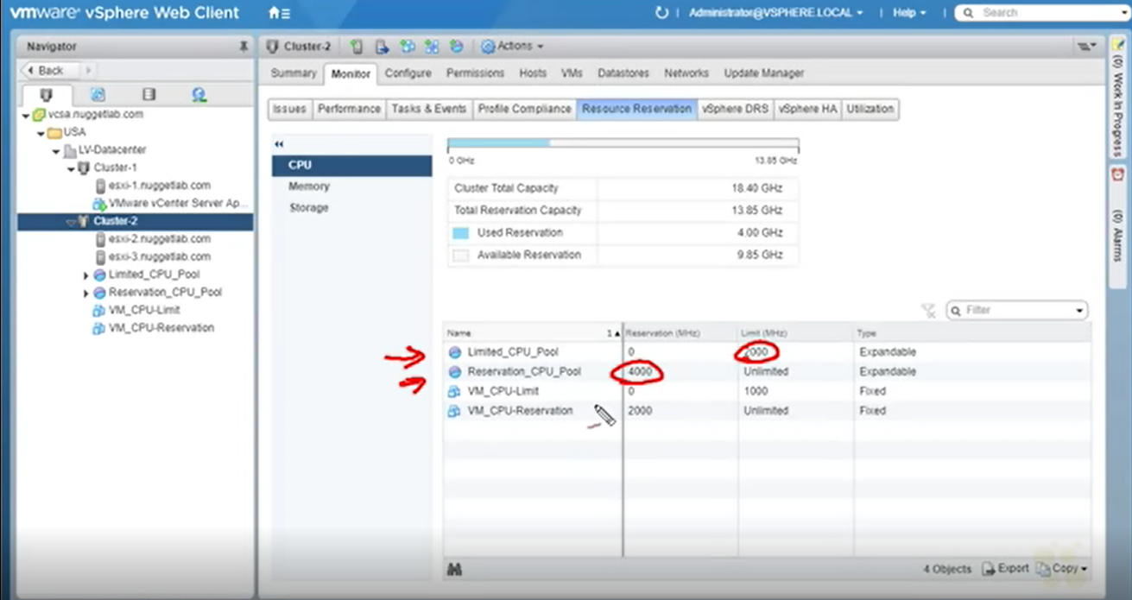

**vFlash**

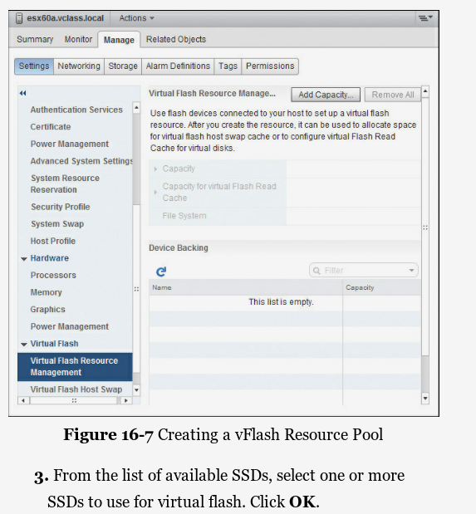

**vApp>> container**

when VMs need to communicate directly to each other as a group and you need to be able to control the whole group.

Requirements

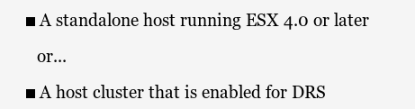

Cloning vApp> exact copy of vApp, can modify settings after cloning, cant clone vApp when it is powered on

put vm in vApp

**OVF (open virtualization format)**

**Definition:** A set of files in a package that can be exported and imported

> can export the state of that vApp as an OVF so that it can be imported at another location or division of your organization to be deployed as a vApp.

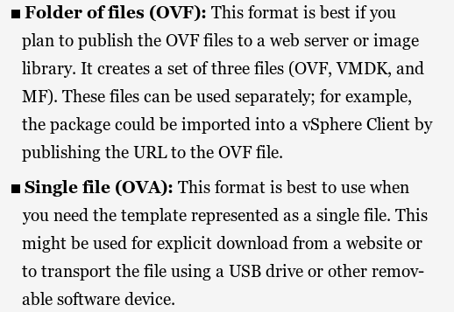

OVA (open virtualization appliance) > all in one

Definition: A single executable file that you can store on a USB drive

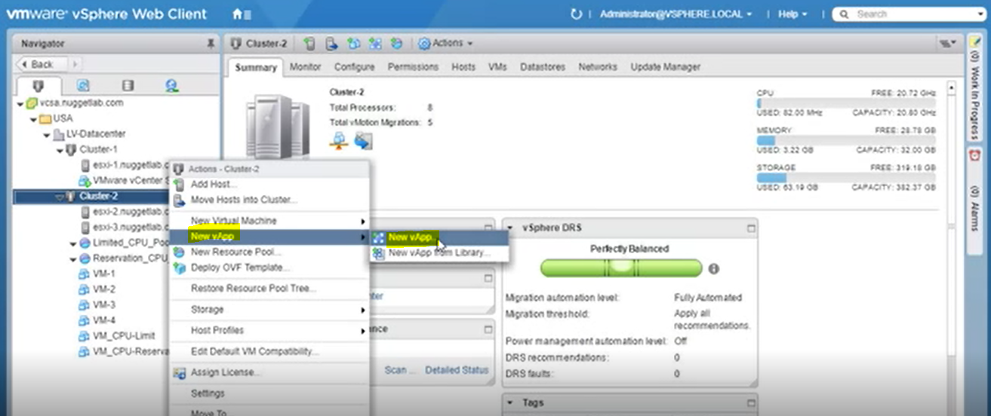

Create VMs in vApp

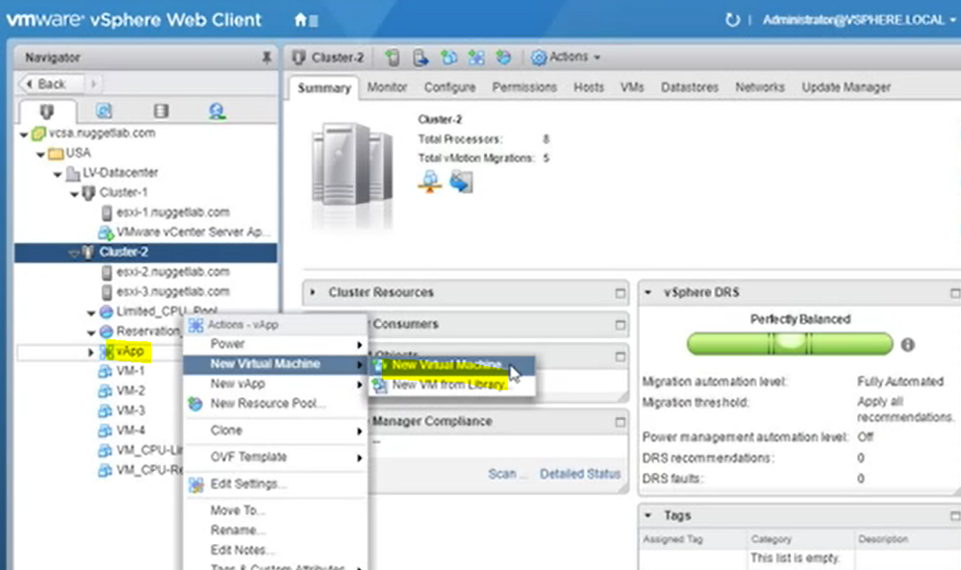

Configure Start order of VMs

(possible to give cpu and memory resources from vApp level)

Start vApp (and it starts VMs)

Editing vApp settings

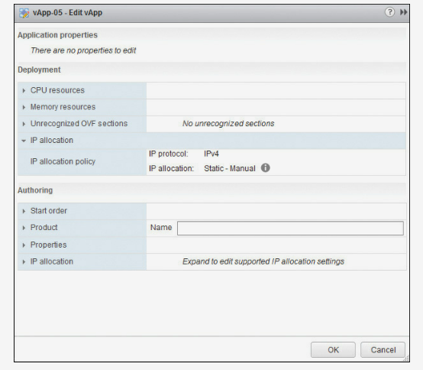

Default IP allocation> static(manual) IPv4

Transient IP allocation> IP POOLS TO ASSIGN IP ADDRESSES TO VMS WITHIN VAPP

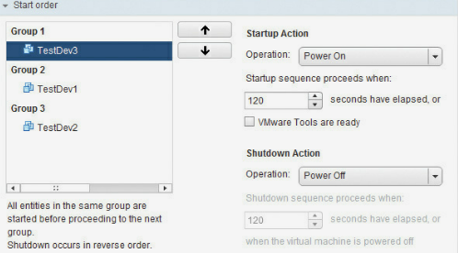

Start Order> Specifies categories of VMs and when each category of VMs will be started in relation to the other categories

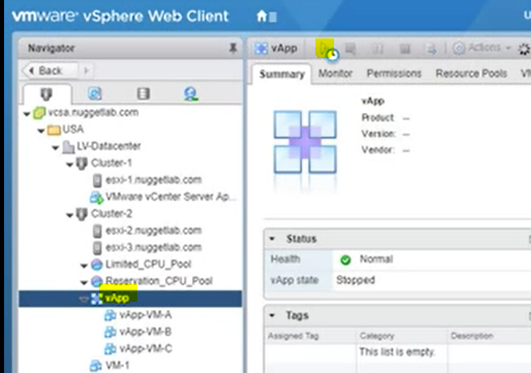

**STORAGE DRS**

Create datastore cluster

Data store should include same type of storage (iscsi,nfs) no mix type

Move datastore of VMs according to utilized space or I/O latency

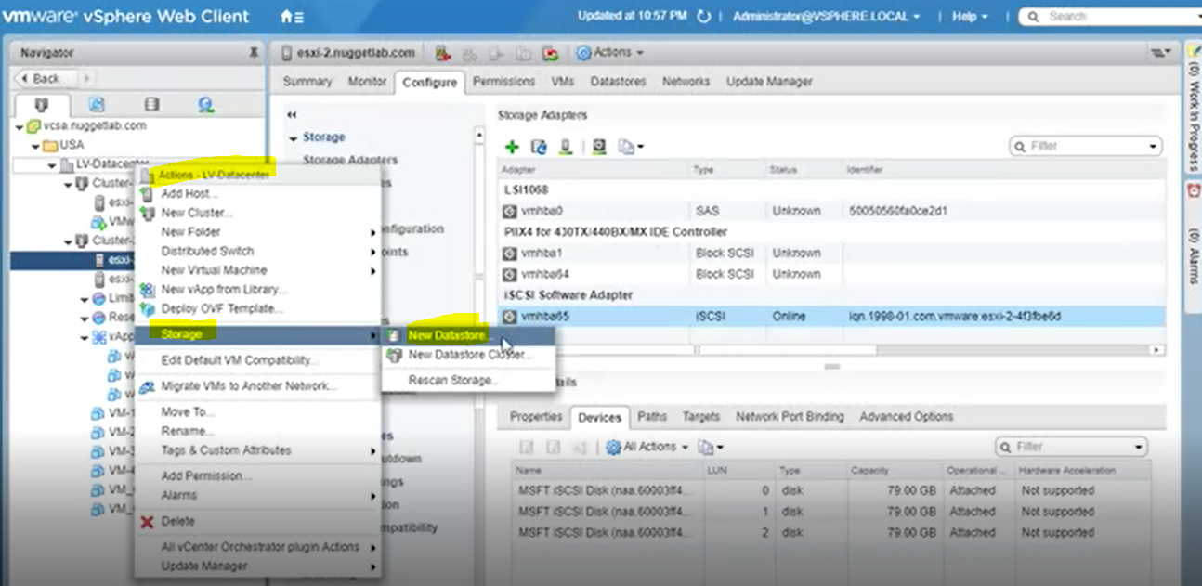

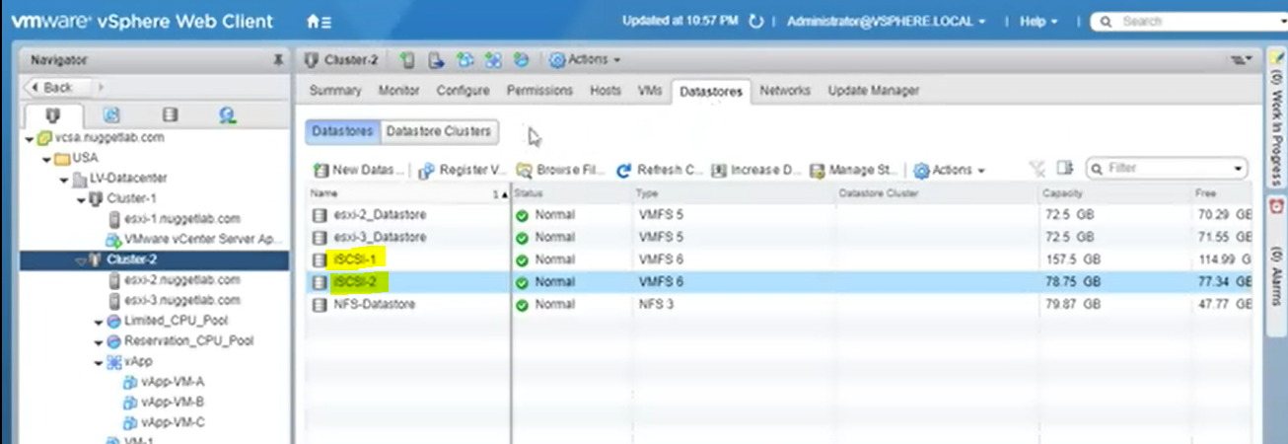

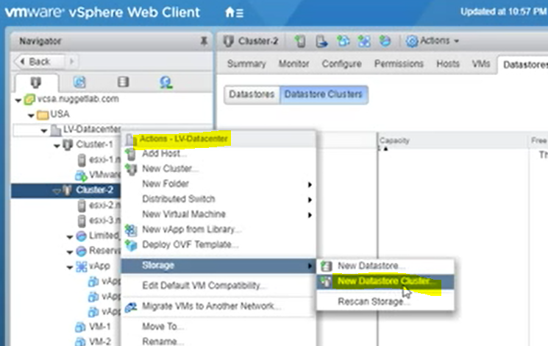

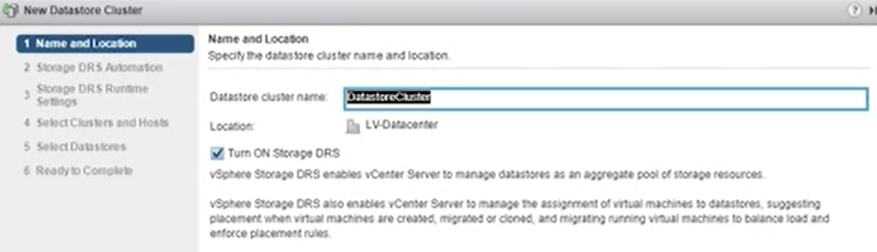

Storage DRS automation > no automation, fully automated

Space threshold

Select cluster that use storage cluster

Select datastores

Monitoring storage cluster

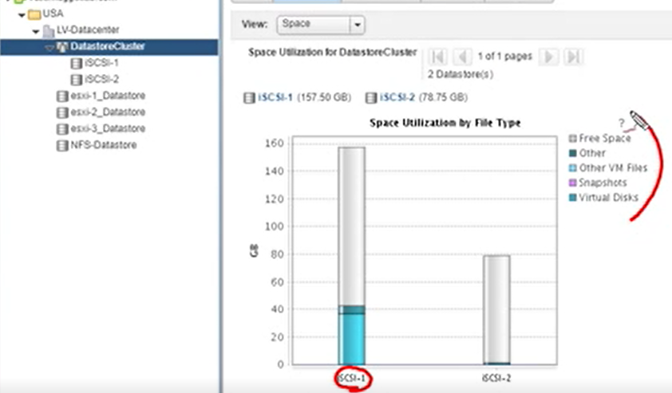

Use storage cluster when creating VM

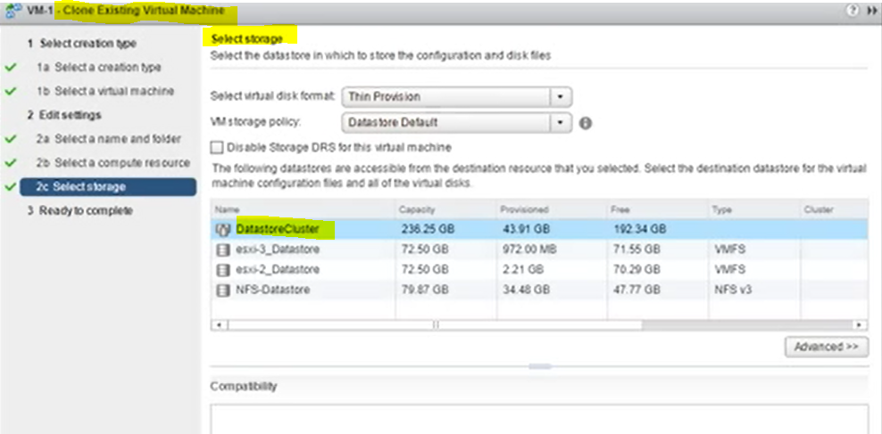

Cluster recommend which storage (iscsi1 or iscsi2 to use)

(initial placement recommendation for virtual disks based on space and I/O workload)

Other storage DRS functions

* Space load balancing among datastores within datastore cluster
* I/O load balancing among datastores within datastore cluster

**VM FAULT TOLERANCE**

Whereas the Primary VM continues to operate normally, the new Secondary VM does not connect to the network normally; instead, it is connected to the Primary VM using the FT Logging connection and Fast Checkpoint technology.

Primary VM copiees itself to another host by vmotion after FT enabled. By this way secondary vm is created

Use case

* In a case where clustering cannot be used for an application
* As an “on-demand” service to protect an application from hardware failure while a time-sensitive project is running

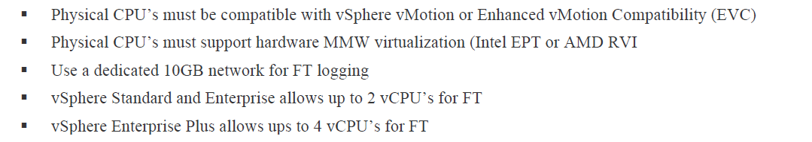

Recommendation

Enable FT on max 4 vms per host

Das.maxftvmsperhost controls allowed number of FT protected VMs per ESX host

Das.maxftvcpusperhost controls total number of allowed FT protected virtual cpus per esxi host

Minimum 3 hosts

Minimum 2network cards on host

vMotion and FT Logging should be configured on separate virtual switches and on separate VLANs (subnets). Three or more vmnics are recommended.

FT can be enabled when vm is ON

Testing FT> Right-click the VM that has been configured with FT and click Fault Tolerance and then Test Failover.

FT common problems

* Licensing
* Das.maxftvmsperhost controls allowed

Features that are not available if VM is configured as FT

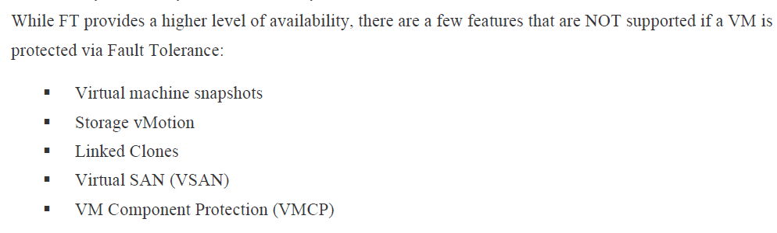

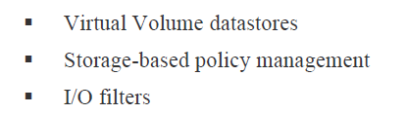

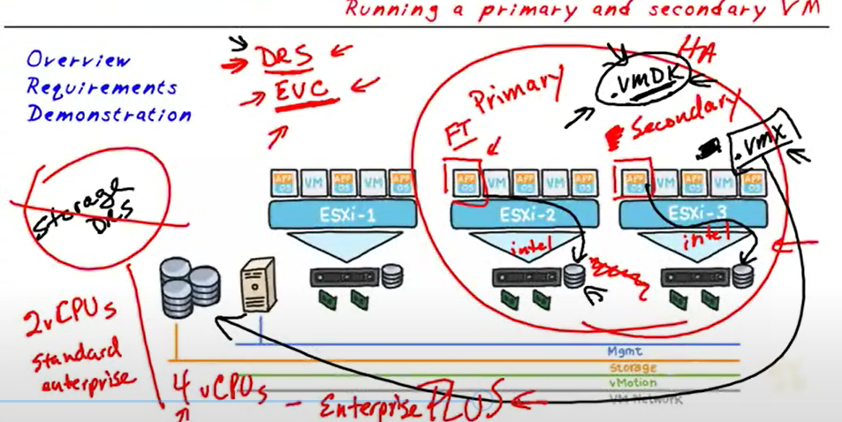

No vMotion, no snapshot

FT logging is enabled on VM kernel adapters of esxi host that will host fault tolerant VM

İso baglı cd rom varsa vm üzerinde çıkar

VM on esxi2

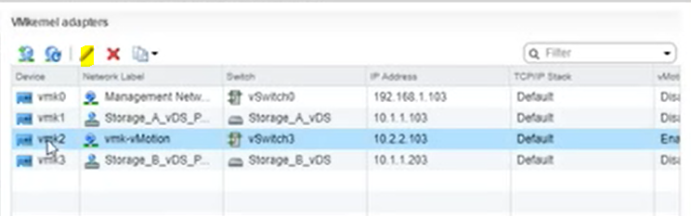

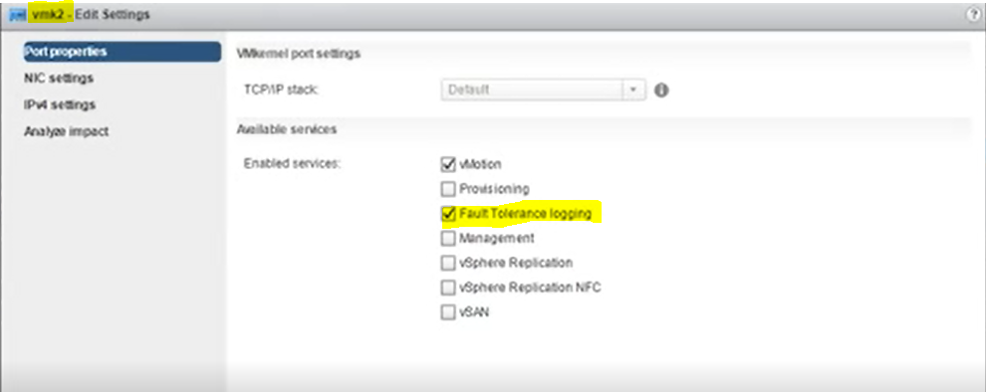

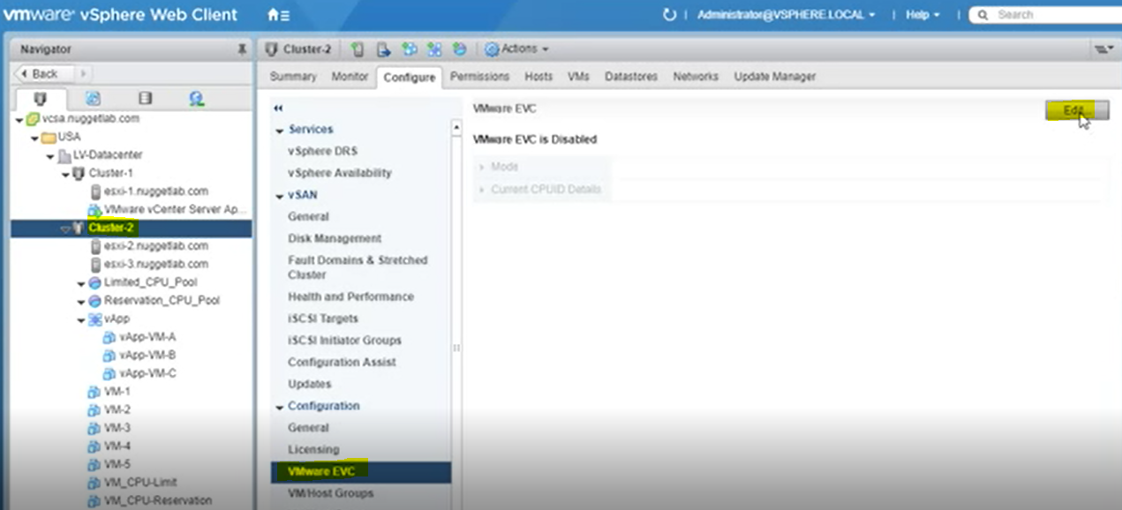

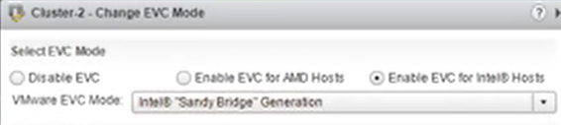

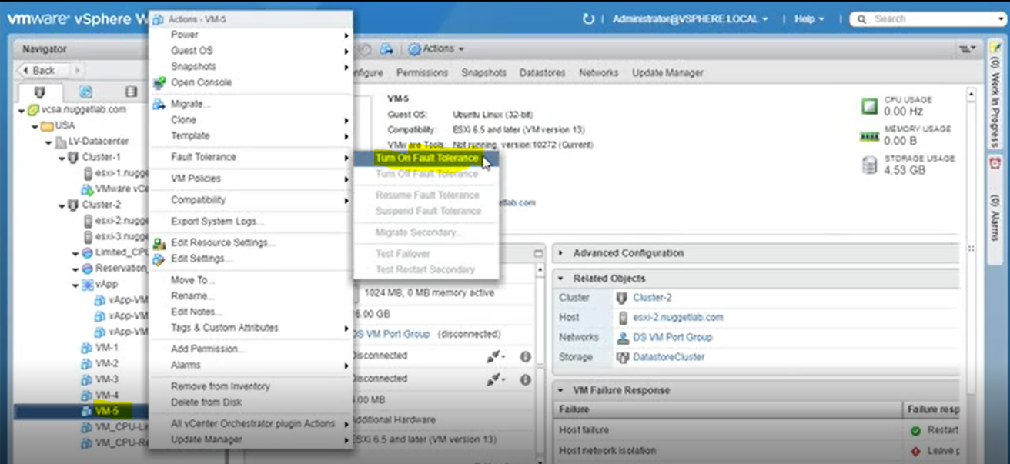

Vm in konfig dosyalarının nerede tutulacağı seçilir

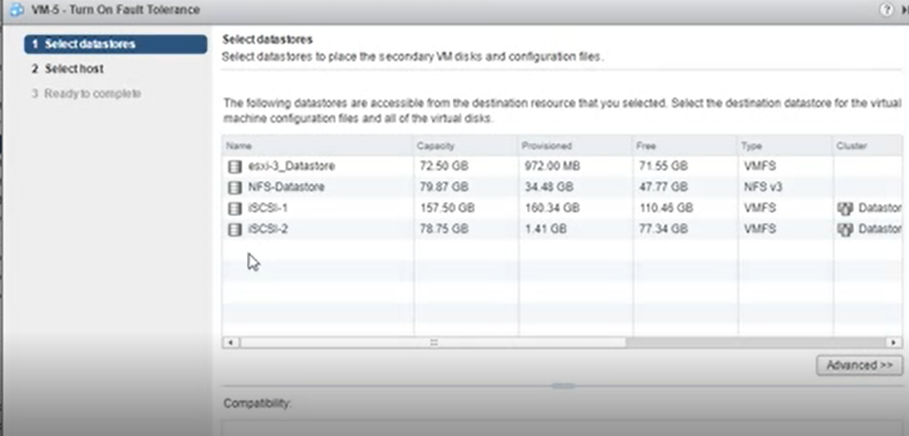

Secondary VM’in hangi host’ta tutulacağı seçilir

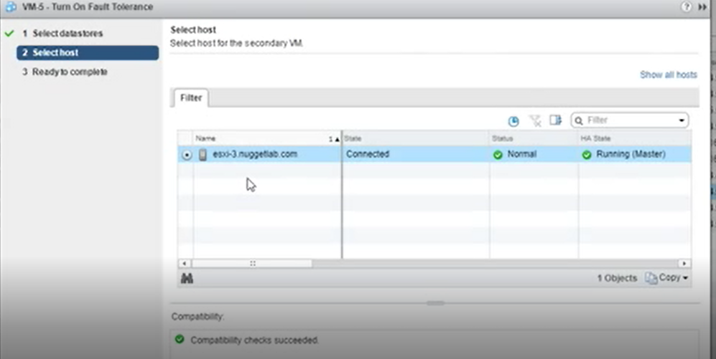

Tüm işlemlerden sonra

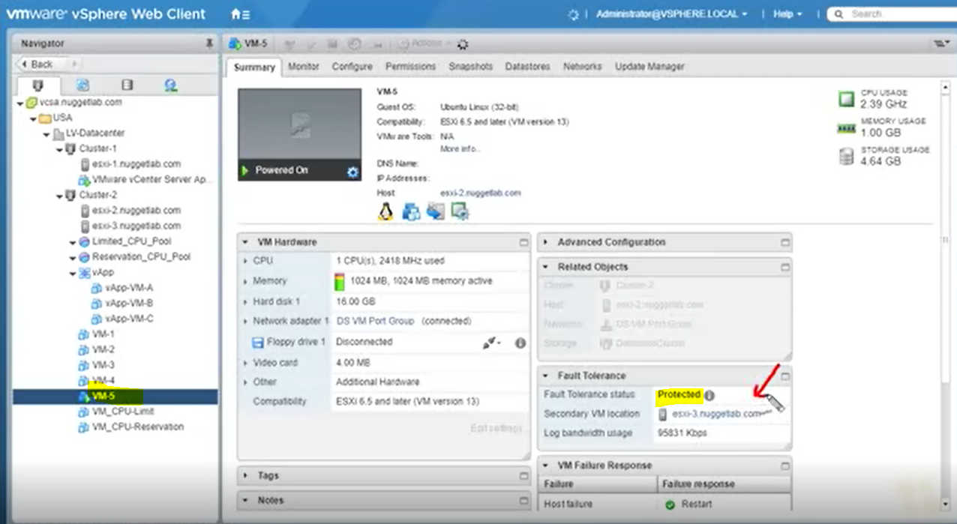

VM power on edildiğinde iki host’ta aynı anda çalışır (real time replication)

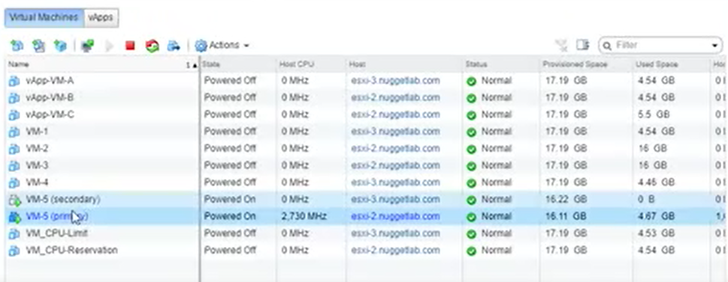

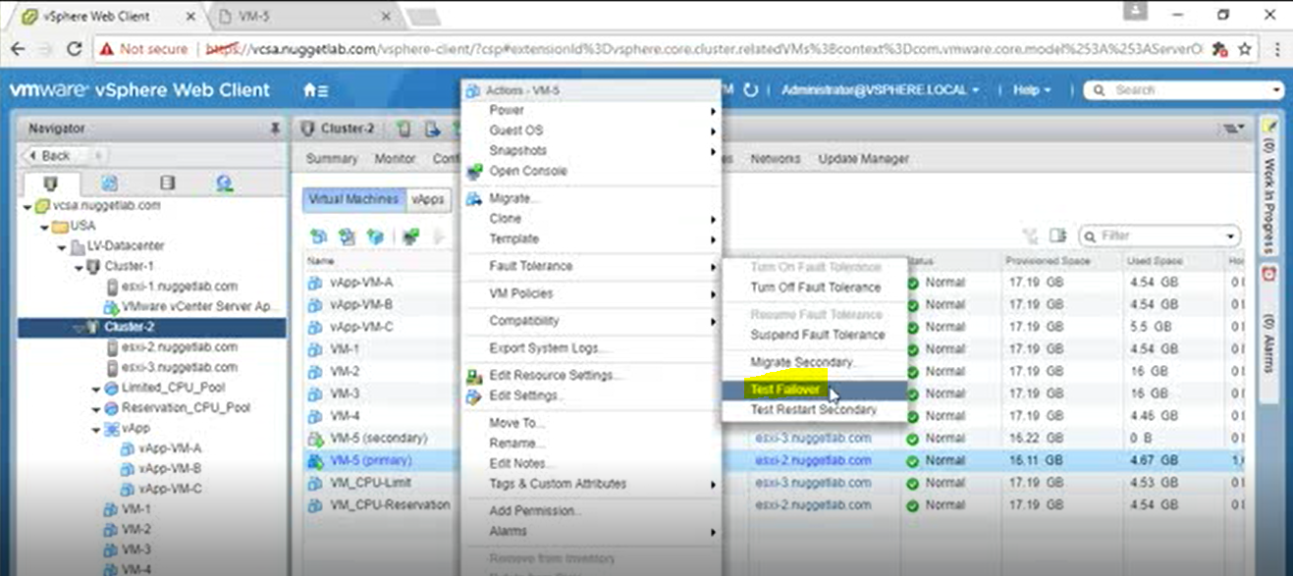

**Vsphere Alarms**

Default alarms

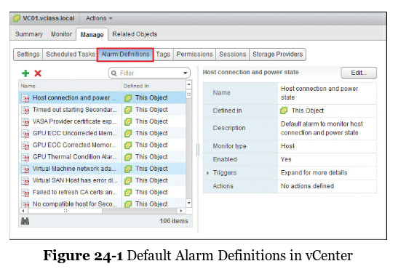

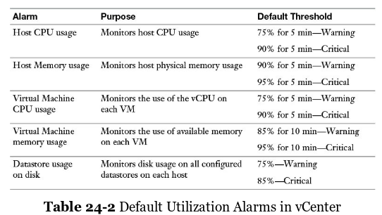

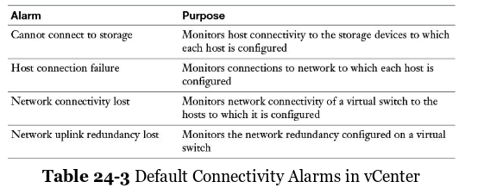

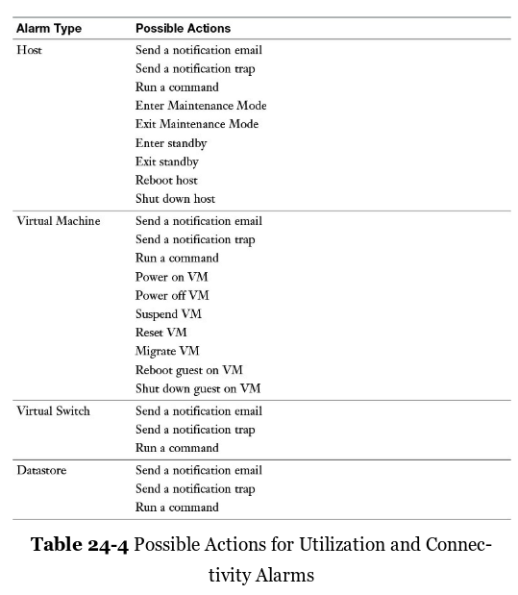

Creating alarm

From cluster level

Types of alarm triggers> Condition,State,Event

Alarm actions>

Condition> Threshold or Condition

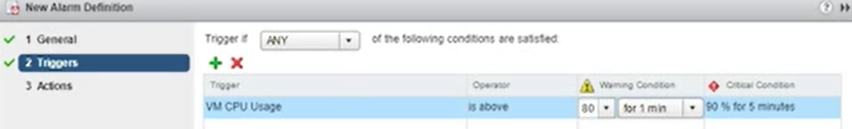

Triggers based on condition and events (cpu,disk,heartbeat etc.) can be one or two condition in same alarm definition

Events> e.x vm power off

Actions>> e.x suspend vm or e-mail

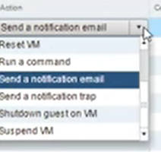

Vcsa seviyesinden alarm tanımlanabilir

Yada VM seviyesinden alarm tanımlanabilir

Yada cluster seviyesinden alarm tanımlanabilir

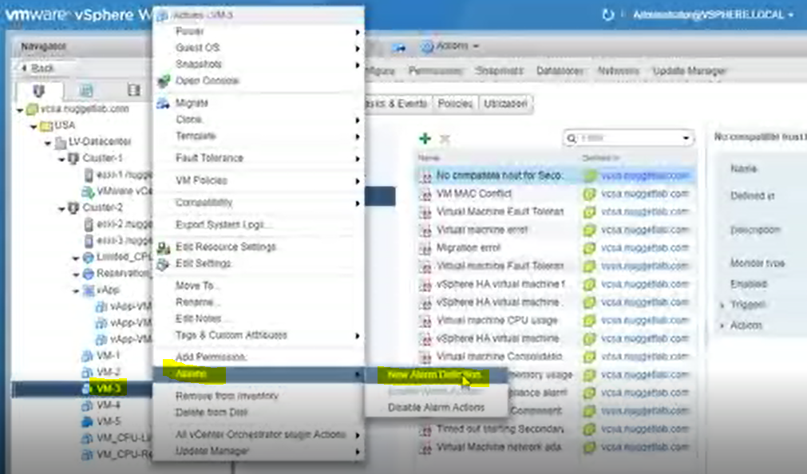

Editing alarm definition:

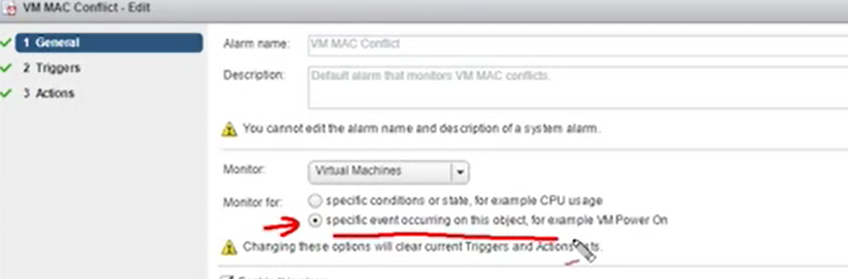

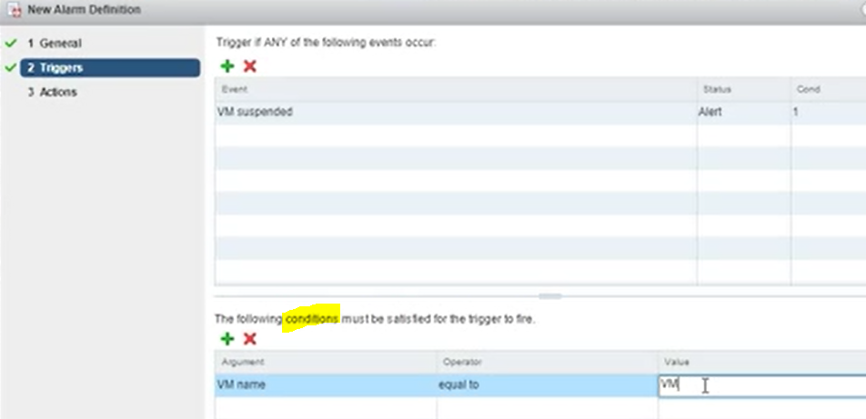

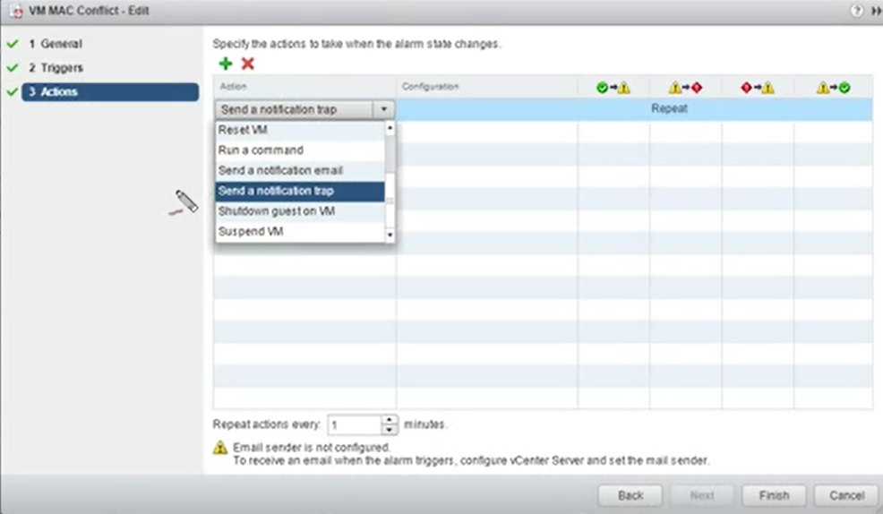

Viewing alarms

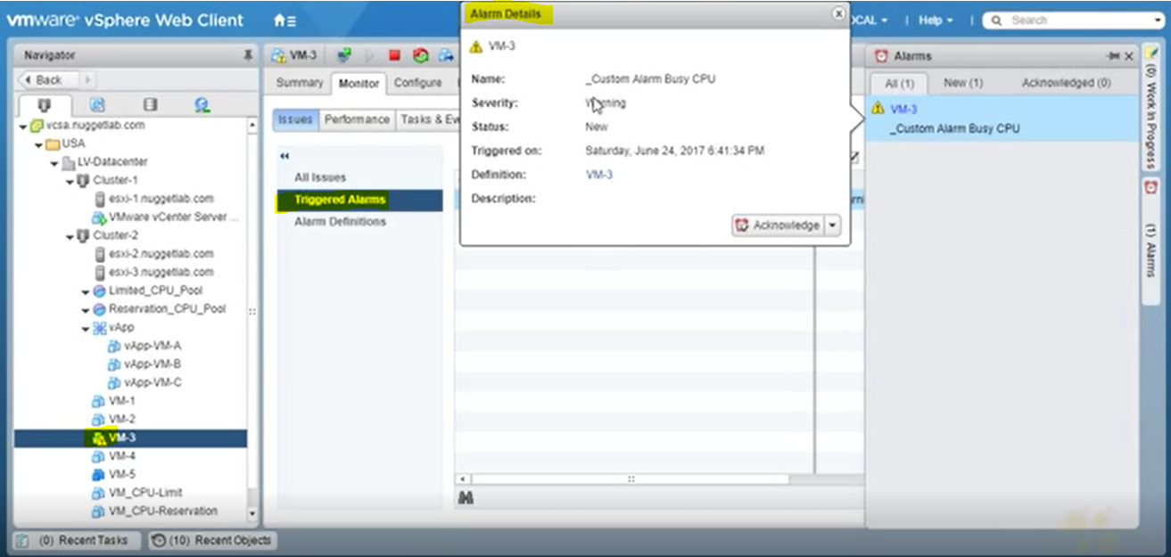

**SSO TO CONTROL VCENTER (with identity LDAP)**

Vmware Directory Service(vmdir) is component of SSO 6.0 that provides SSO domain and also holds certificate information

LDAP directory port 389

Webclient’a single sign on ile giriş şartları

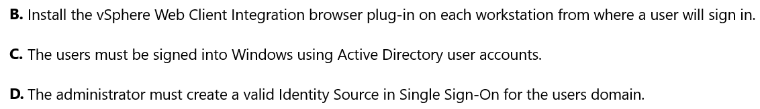

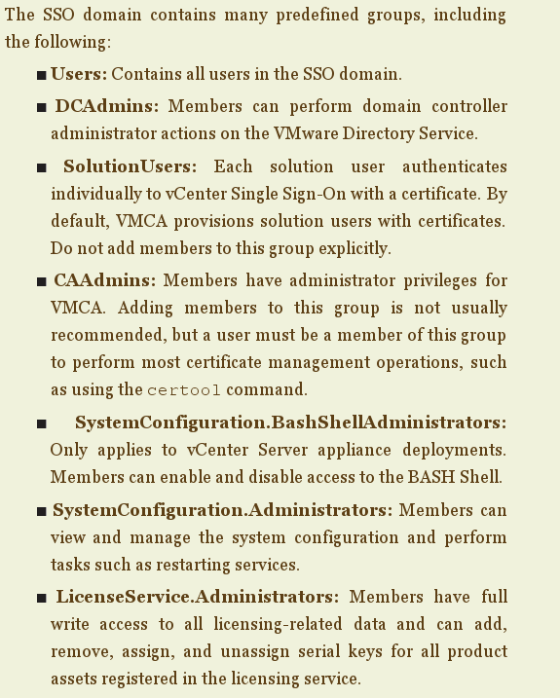

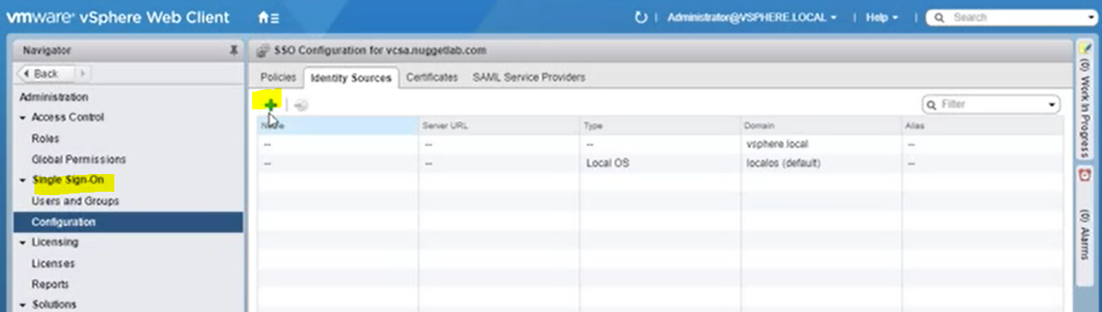

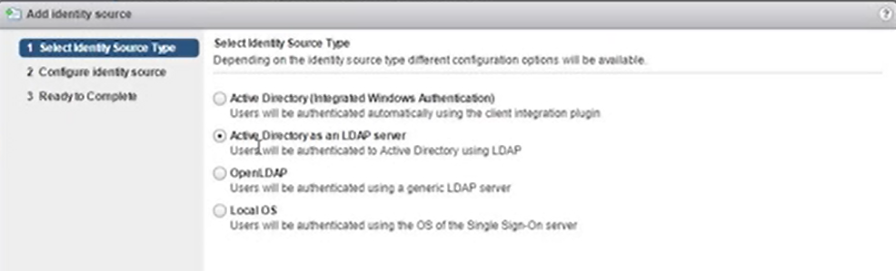

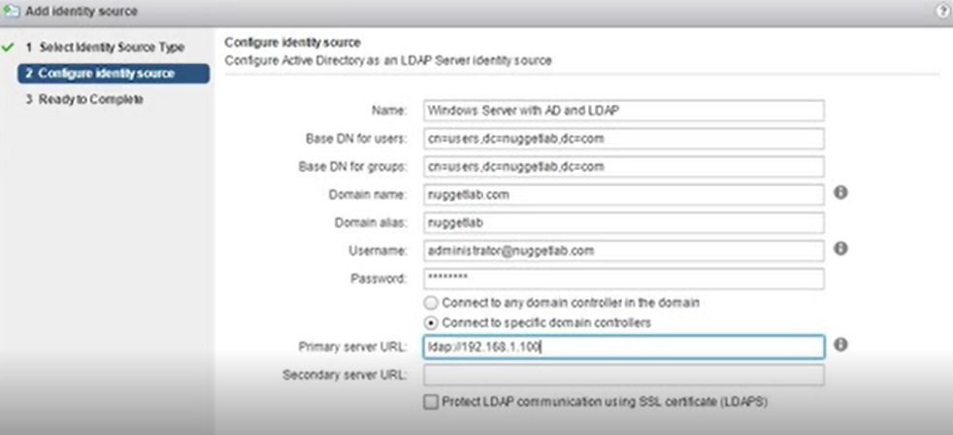

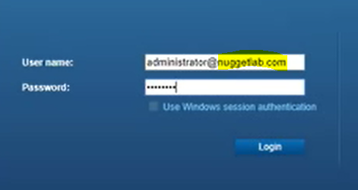

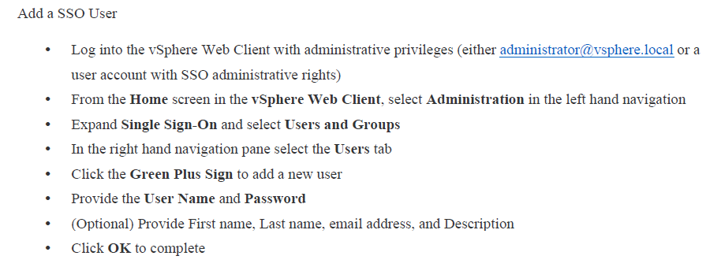

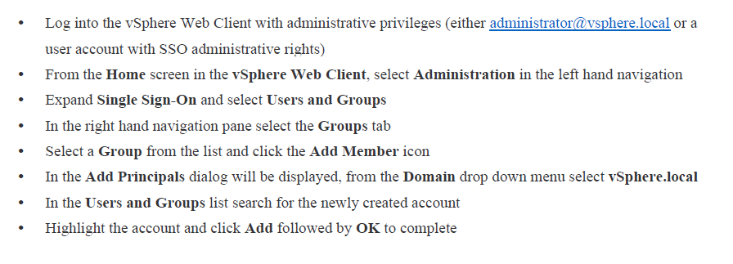

**SSO POLICIES**

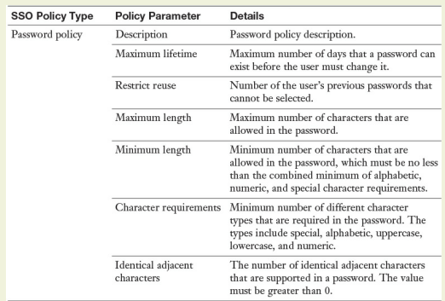

Default password policy (vcsa)

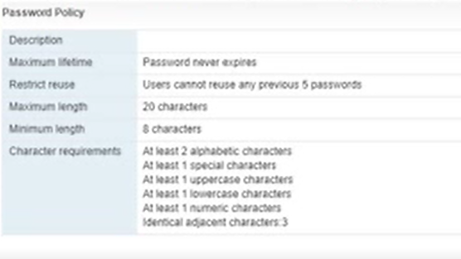

Vcenter Default lockout policy

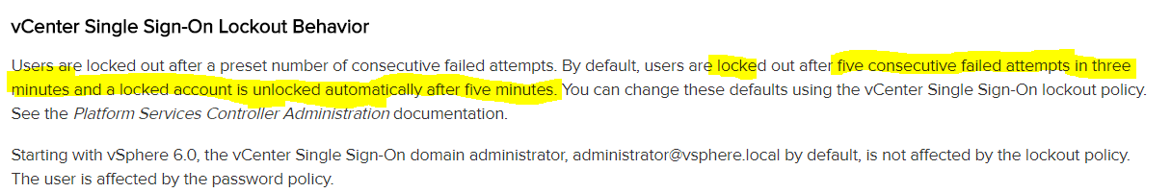

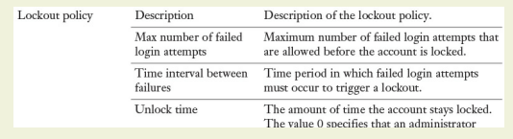

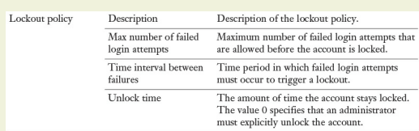

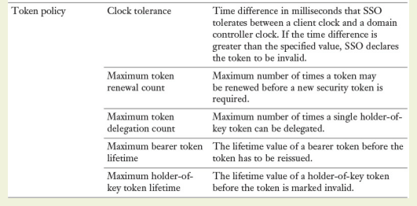

Esxi host lockout policy

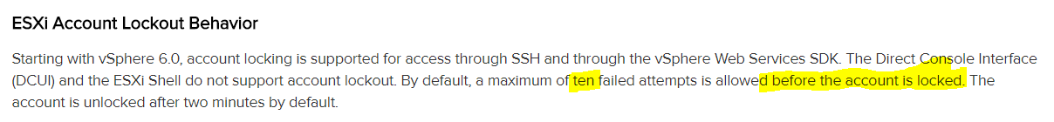

ESXi password policy

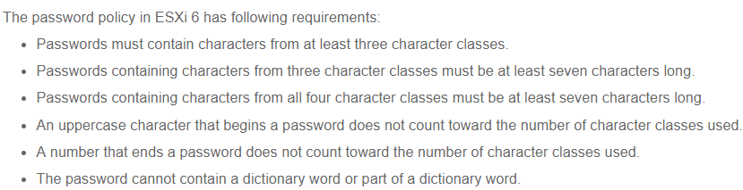

Modify these settings> Security.Password.QualityControl

Inventory Tree

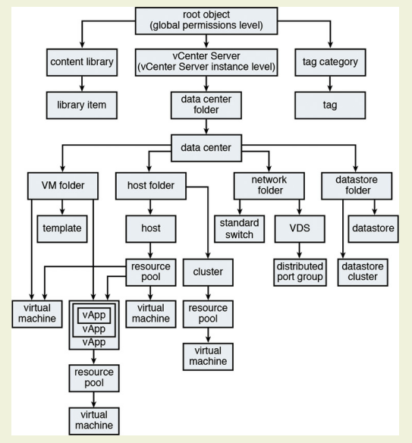

**Giving permissions**

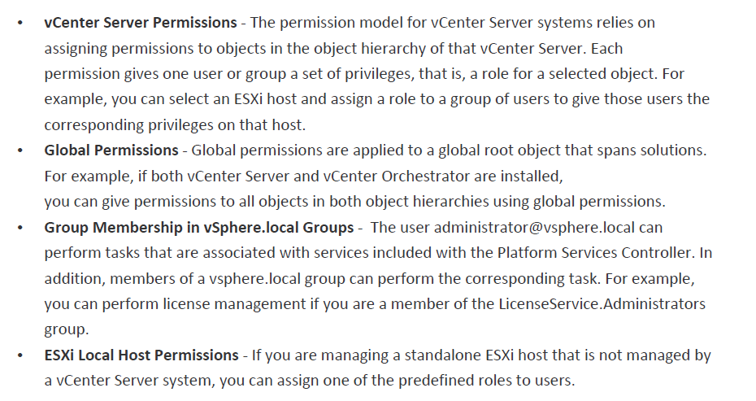

Default roles

<https://pubs.vmware.com/vsphere-4-esx-vcenter/index.jsp#com.vmware.vsphere.bsa.doc_40/vc_admin_guide/managing_users_groups_roles_and_permissions/r_required_privileges_for_common_tasks.html>

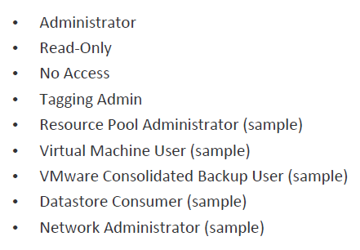

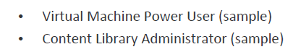

ROLE & USER-GROUP & OBJECT

Built-in roles and priviledges

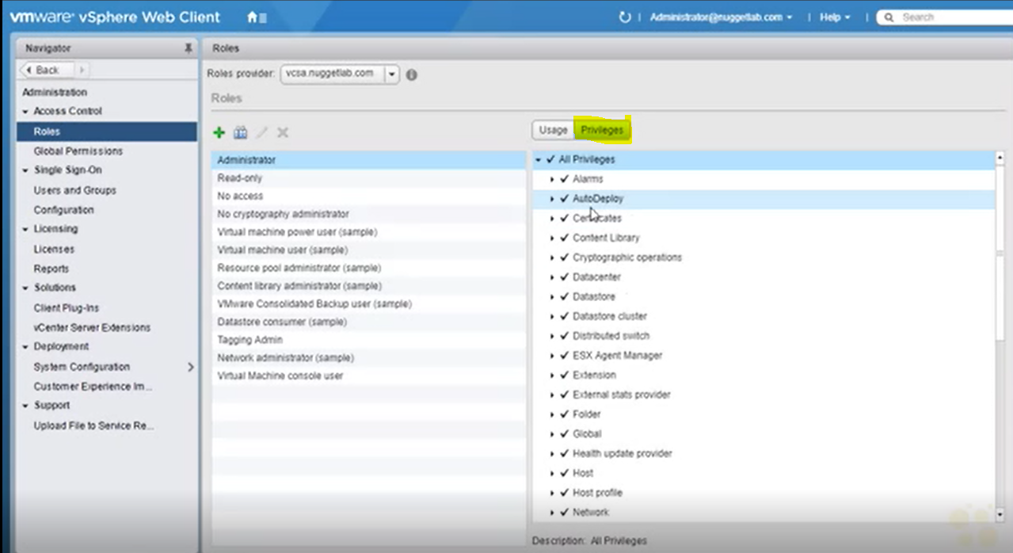

!! Global permissions

Giving permission from cluster level

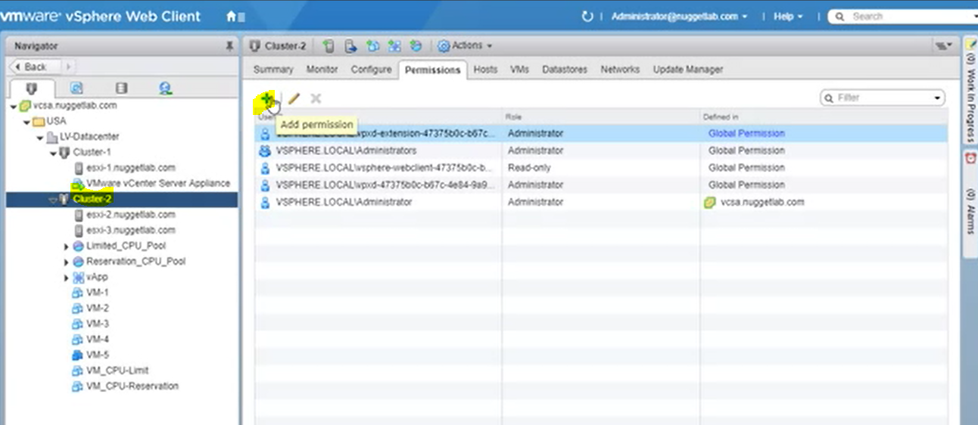

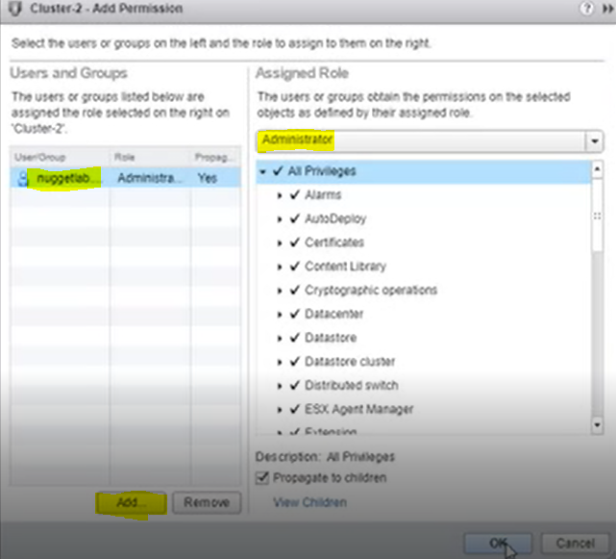

!!propagate to childeren

Assigned rules>> administrator, read-only, no access

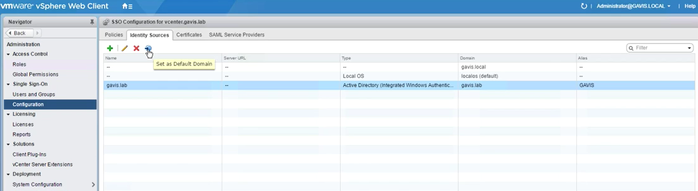

Set as default domain den sonra kullanıcılar sadece AD user isimleriyle girebilir

**vSAN**

Maximum host in cluster that supports vSAN > 64

Disable HA before vSAN

Max 5 vsan disk groups per host, up to 7 HDD and max 1 ssd per disk grouptor

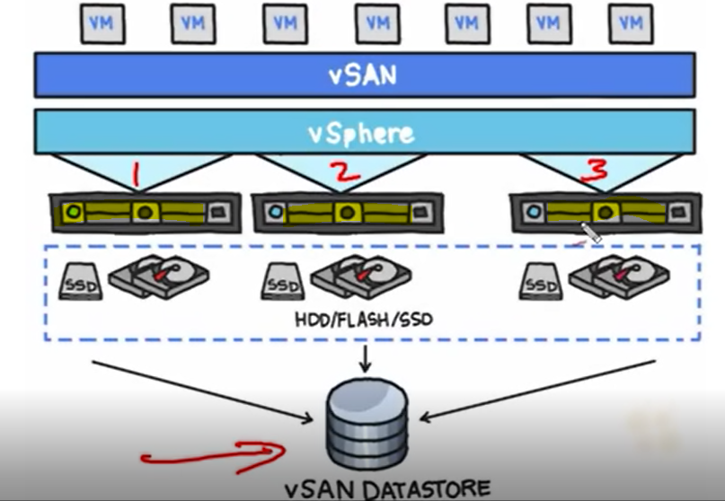

disks are on hosts are used as vSAN

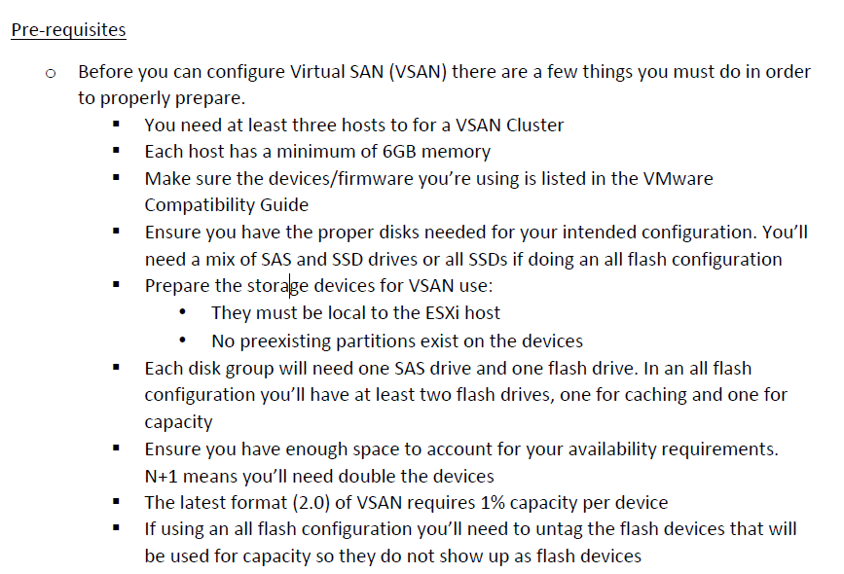

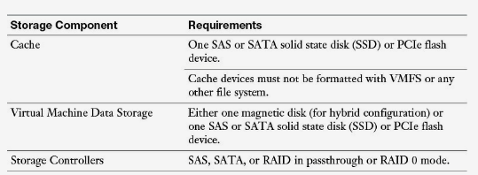

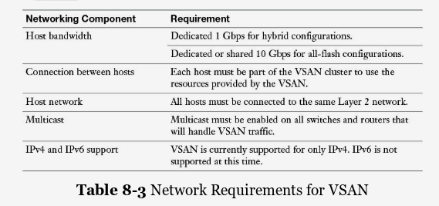

HDD+SDD

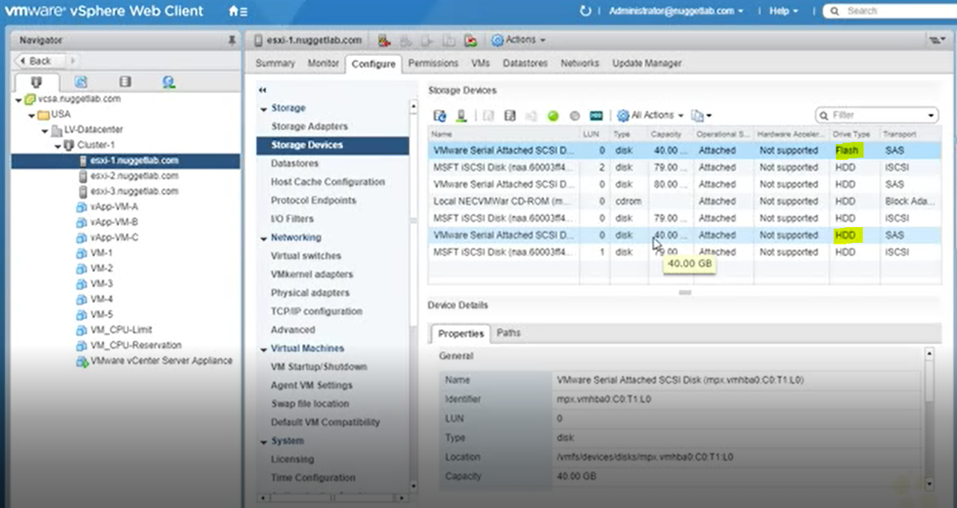

Allow Vmkernel adapter on esxi host to allow vSAN traffic (for all host)

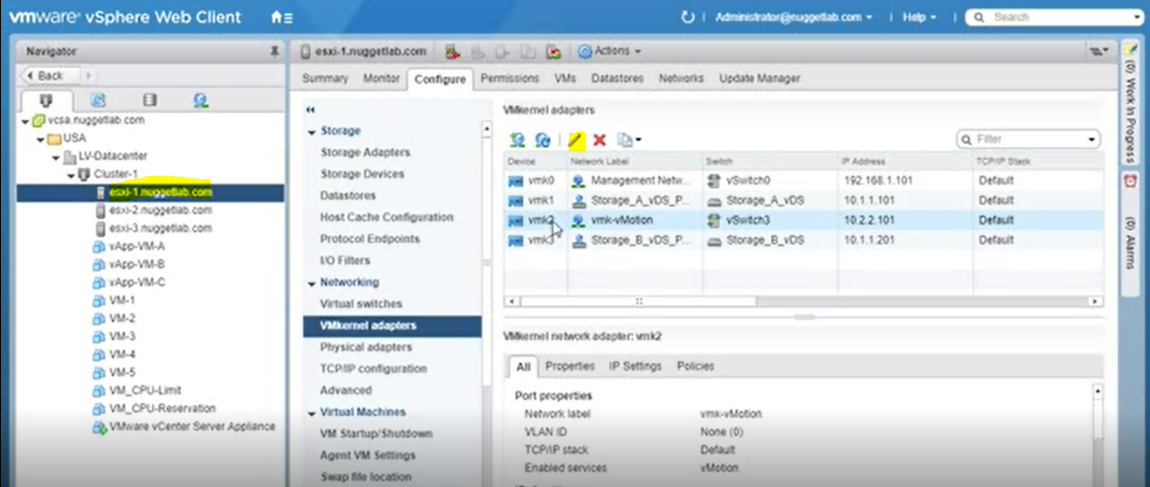

Vsan option is enabled on vmkernel adapters

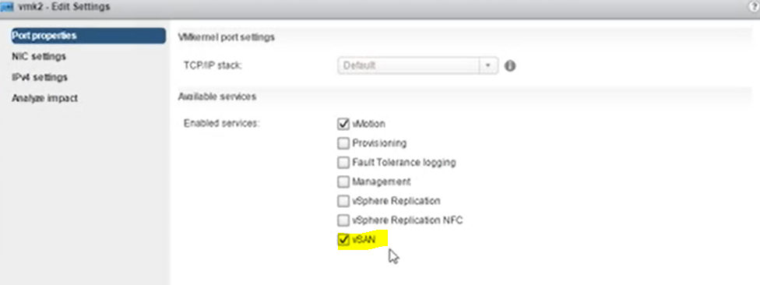

Vsan is enabled on cluster level

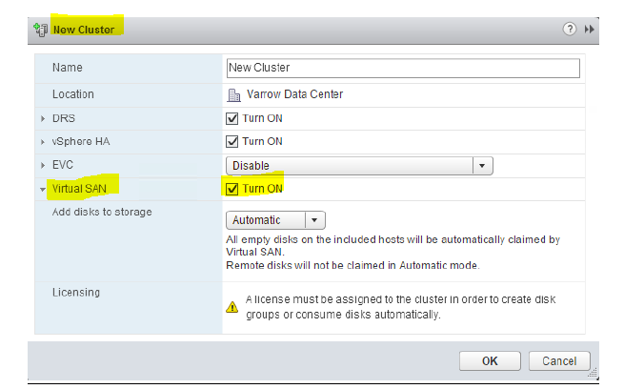

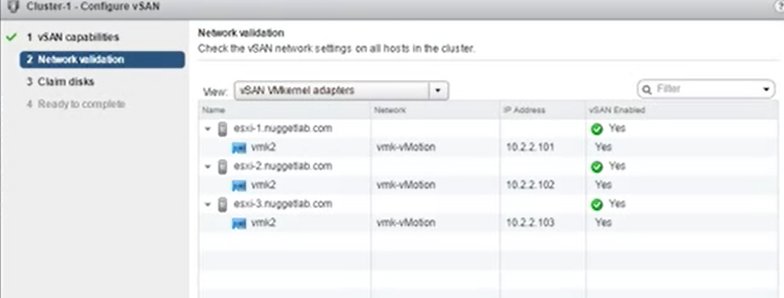

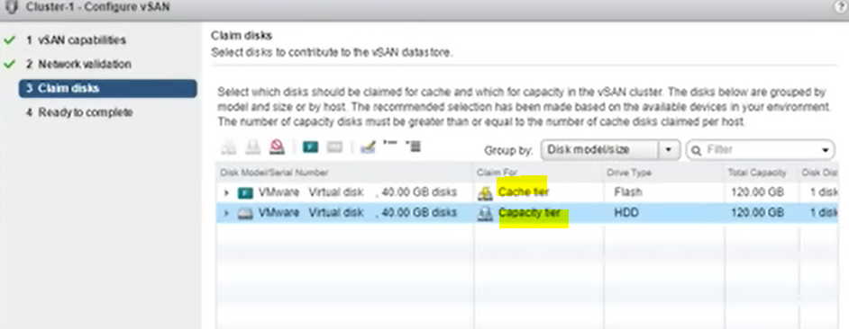

Create vm by using vsan storage

**STORAGE POLICY BASED MANAGEMENT**

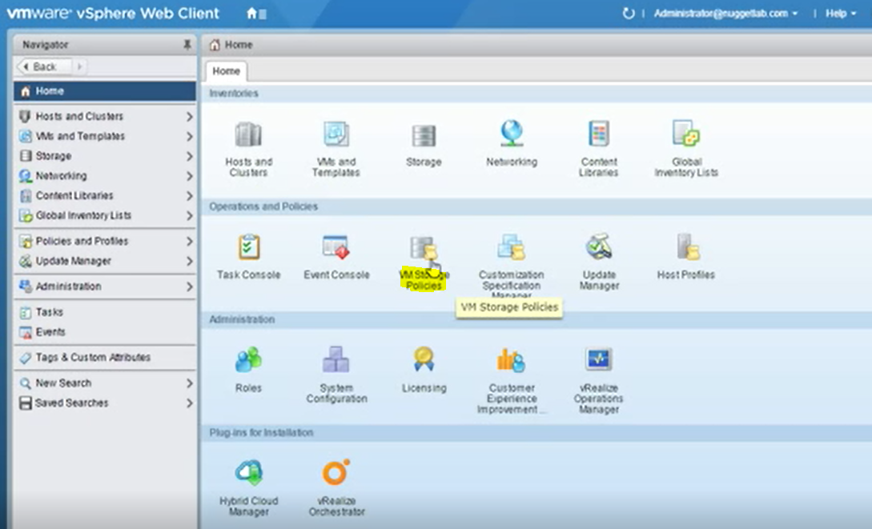

vSAN Default Storage Policy

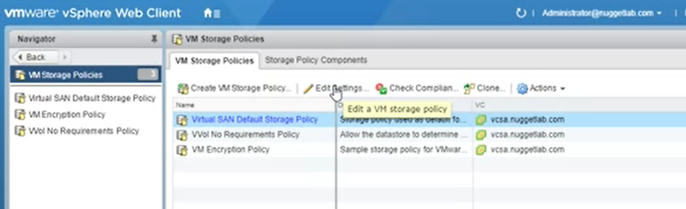

Assigning tags to storage

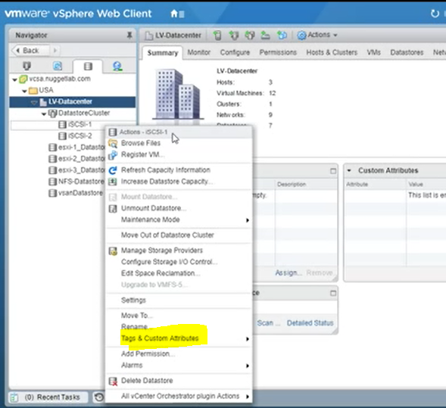

Create policy

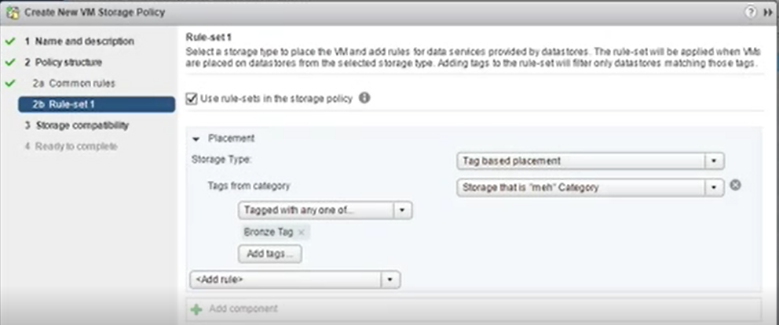

Create VM according to this policy (storage)

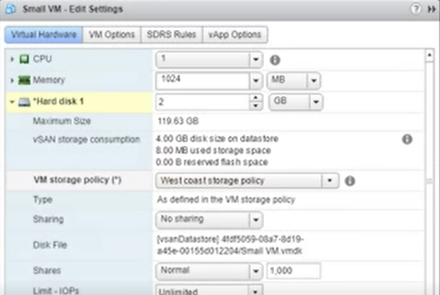

Verifying vm or hosts are compatible with policy

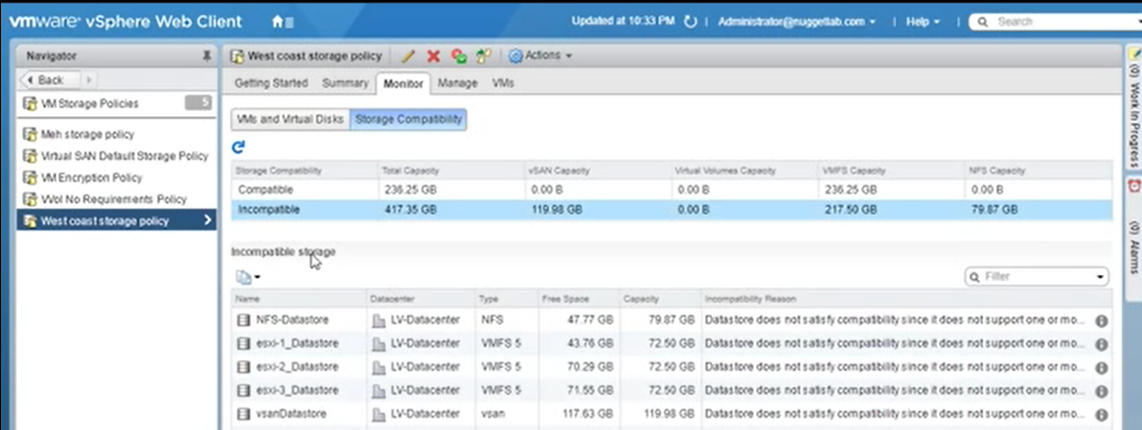

vSAN Fault Domains

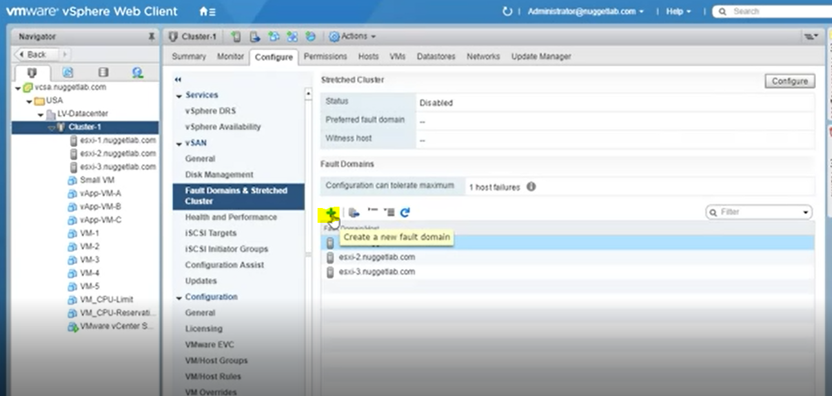

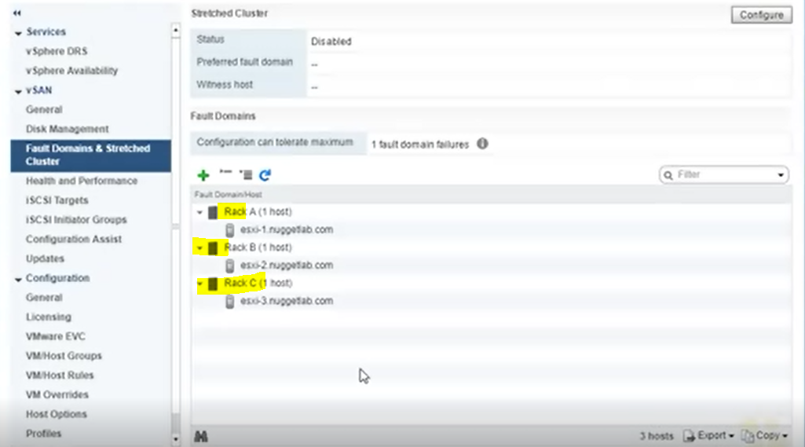

Storage I/O Control

I/O prioritization for VMs

Enabled on datastore that does not have multiple extent

Enterprise plus

Monitors and throttles VMs only when latency exceeds the set threshold

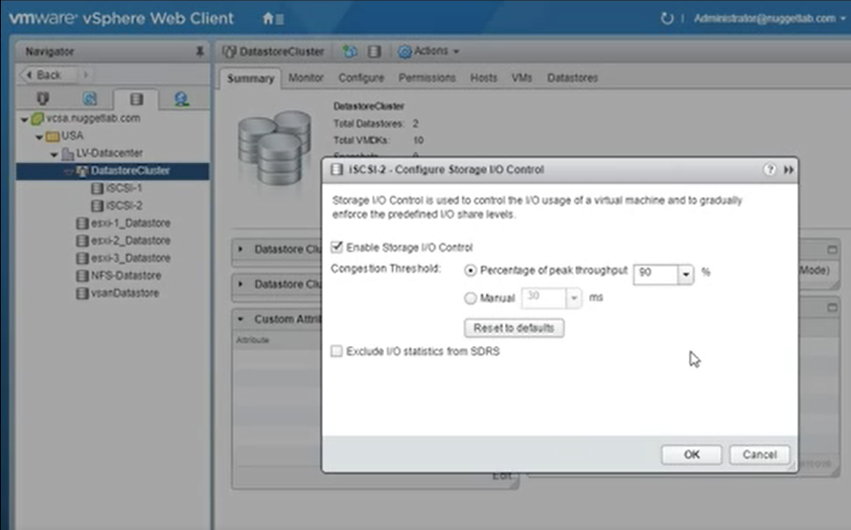

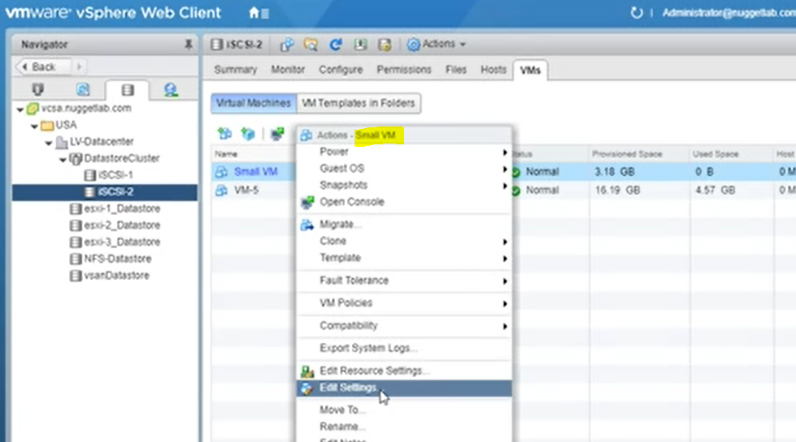

Contention durumunda storage share’e göre I/O verilir

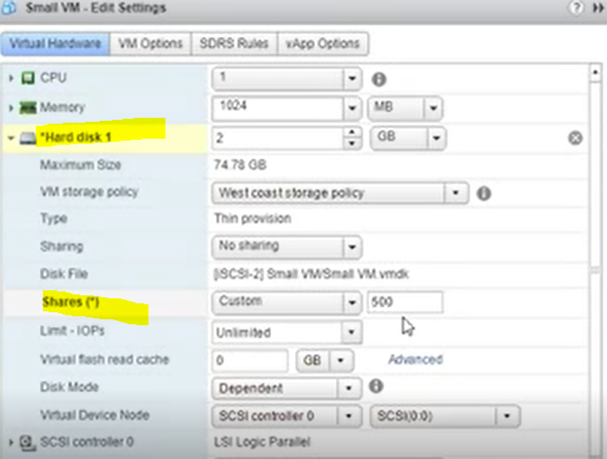

**ESXİ HOST PROFILES**

configure a “reference host” and then use that as a baseline to configure the other hosts

Enterprise Plus license are needed

Check for compliance for some specific settings

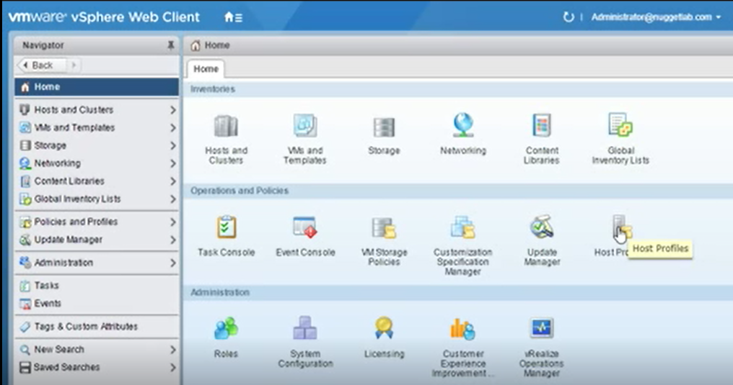

Select host and Exract host profile

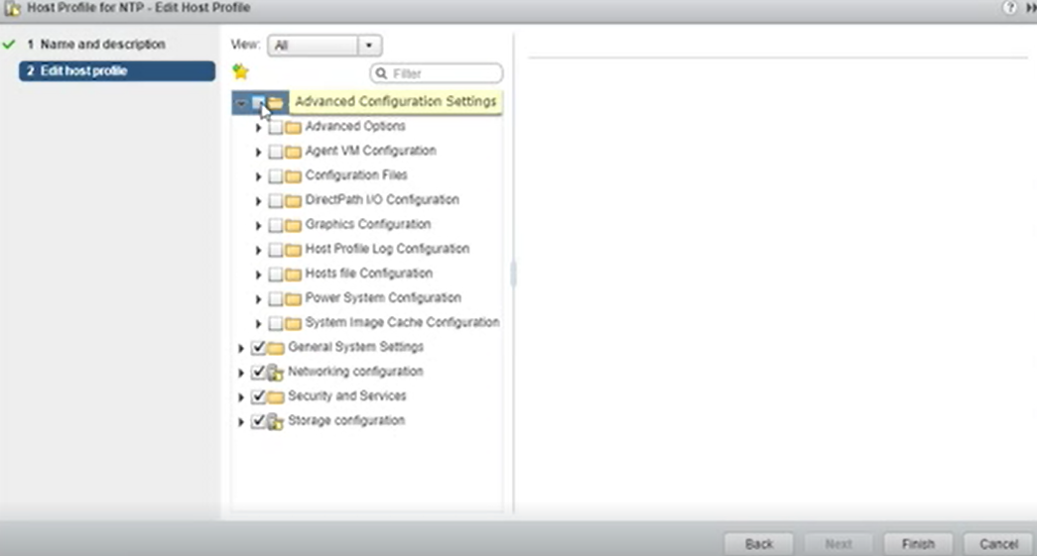

define which host or cluster will use that profile (from this screen also possible to Export host profile to .vpf file)

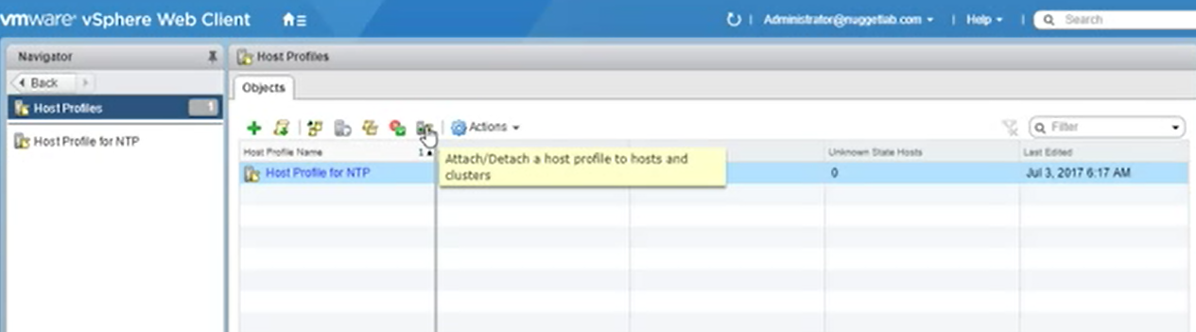

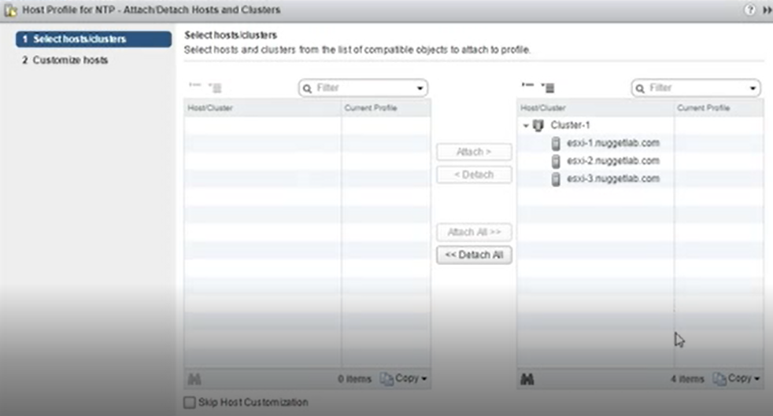

Run host profile and Check compliance status

Host compliance checking is always done in Host and Cluster view

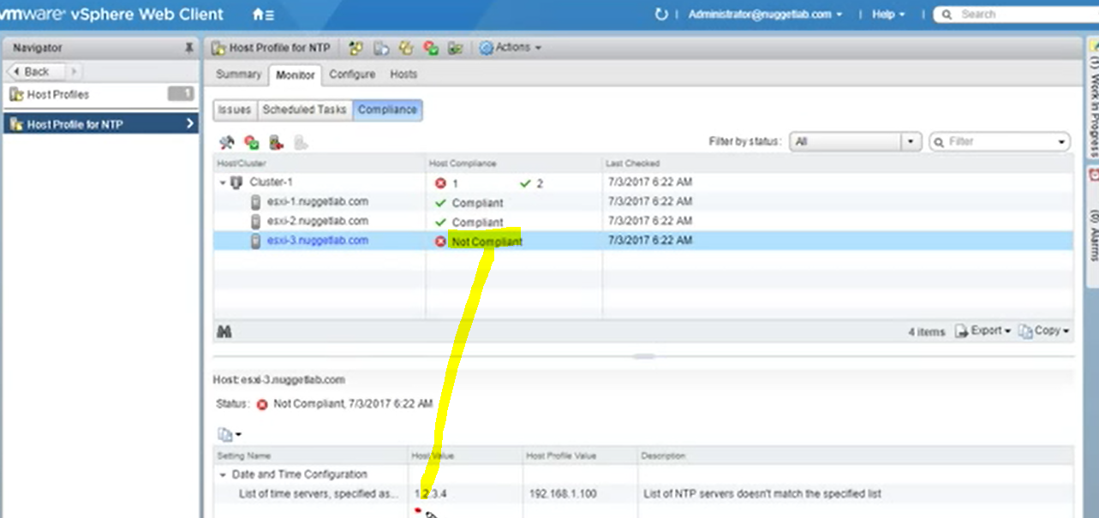

Compliance results: Compliant, non-compliant, unknown

Remediate

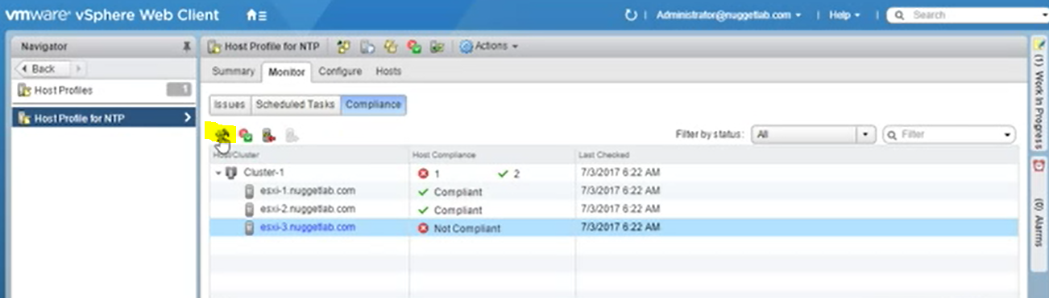

**Vcenter UPDATE MANAGER (VUM)**

İncluded within vcenter server appliance

Can be on same server as vCenter

Supports for esxi host,VMs and virtual appliance

Uses DRS when it applies patches to hosts not to down VMs

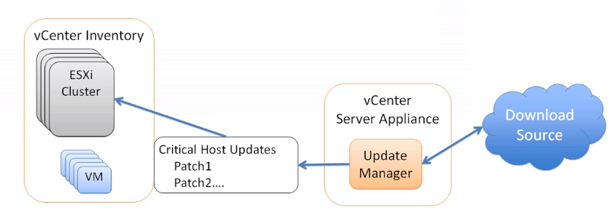

Patching esxi hosts

esxcli software vib install –d

İnstalling VUM

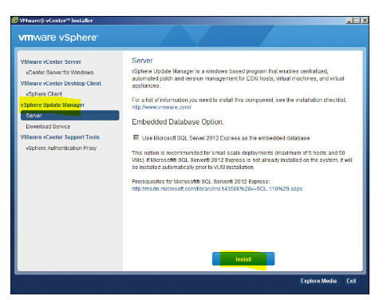

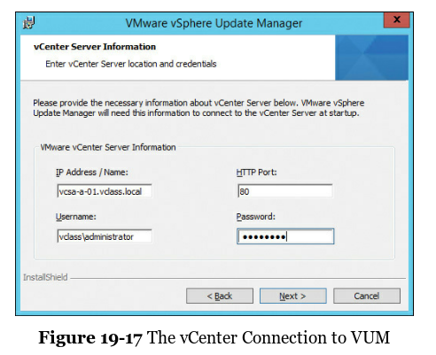

Vsphere Client>>install update manager plugin

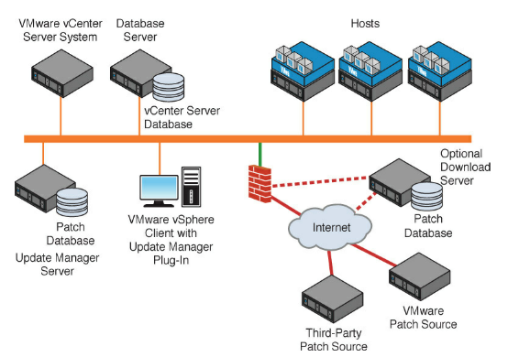

from VCSA (it checks upgraded .iso)

Upgrade one esxi host from one version to another

3rd party software install/upgrade on host

Update vm tools

Create Baseline >> group of patches downloaded

Baseline types>>

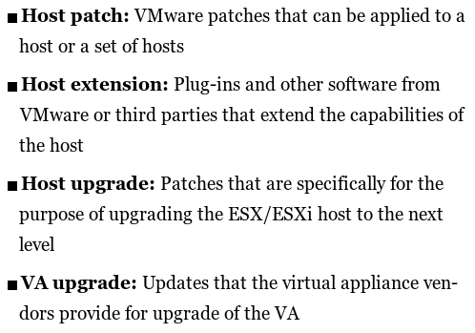

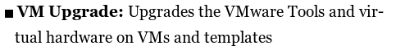

Patch download options> from Web Client

Apply remediation

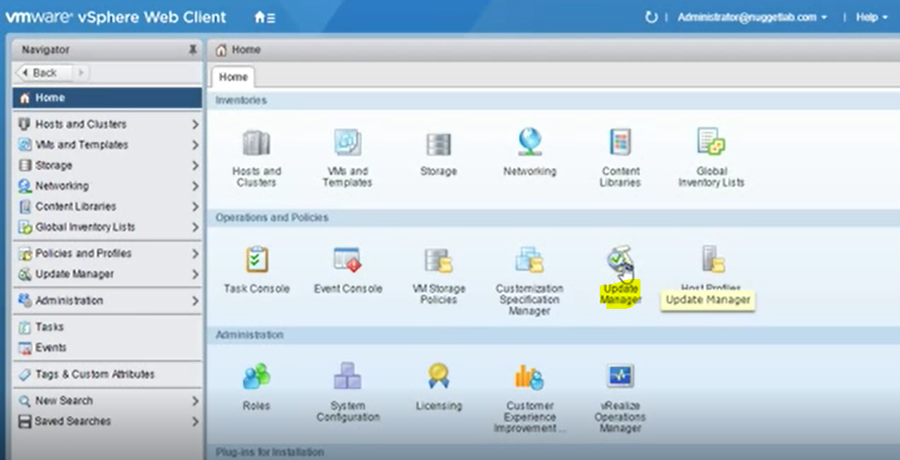

Create baseline

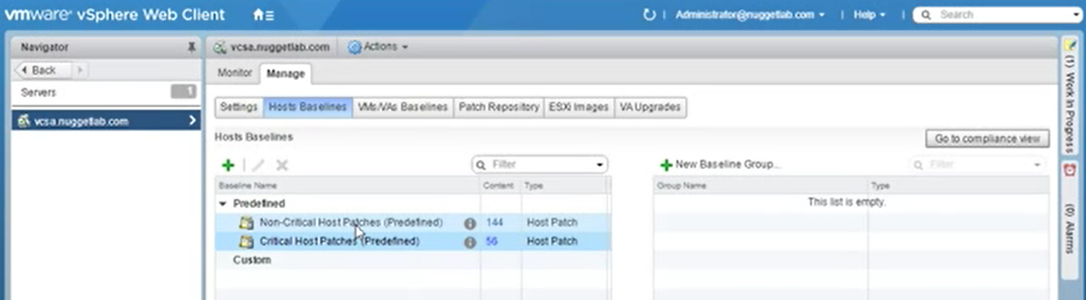

**Baseline type**> patch,extension,upgrade



**Patch options**>fixed,dynamic

Vendor,severity,category

Exclude patch to exclude

Associte hosts with baseline

Cluster or host level>update manager> attach baseline

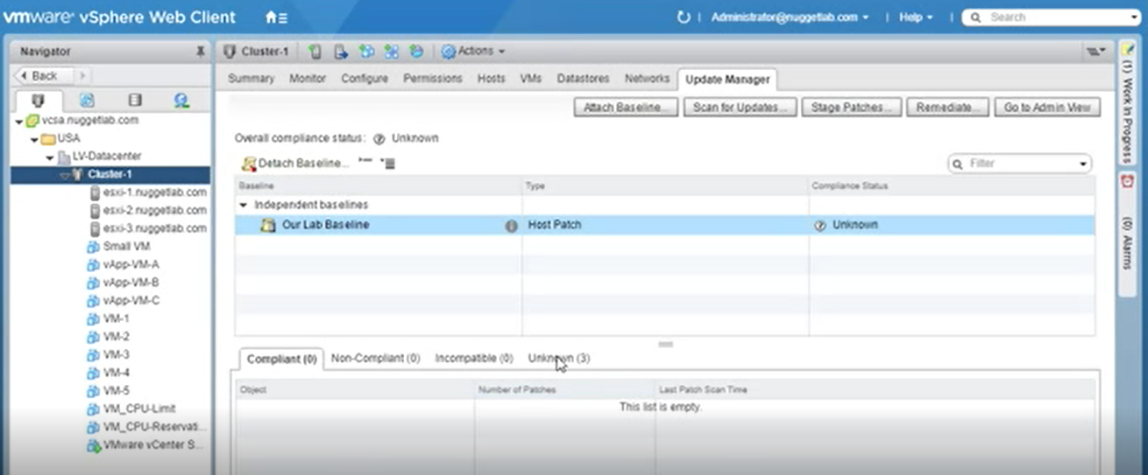

Run baseline

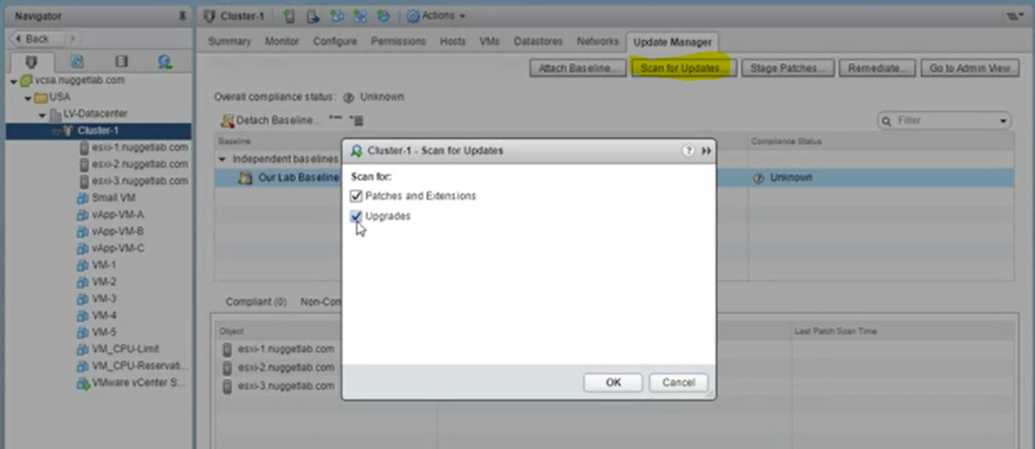

Remediate hosts which are not compliant

**AUTODEPLOY**

DHCP > pxe boot enabled on new esxi host

Uses management network

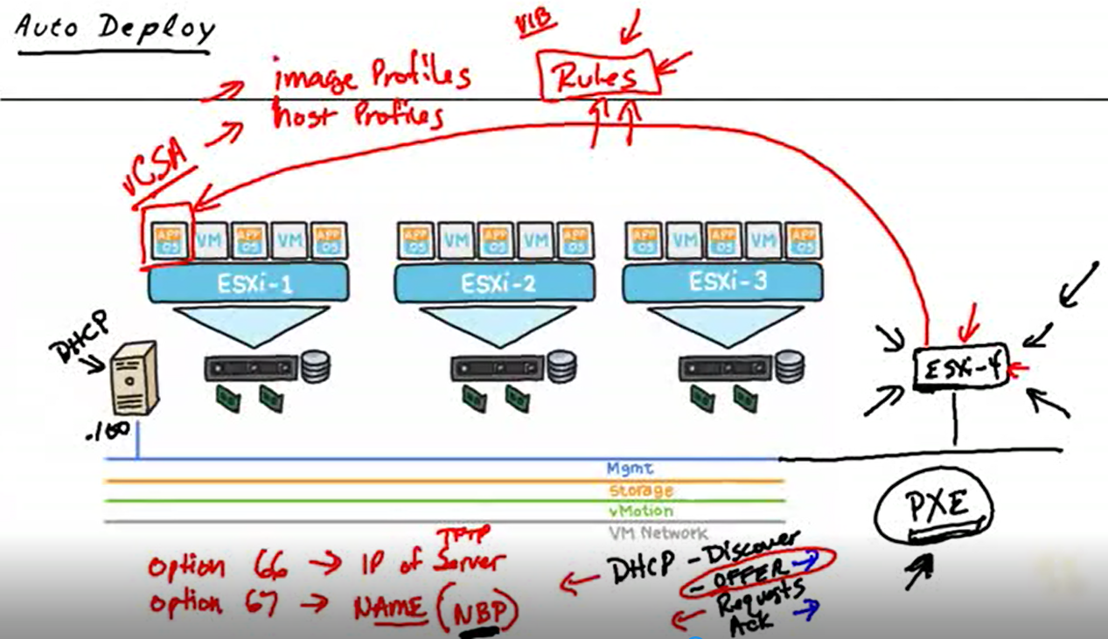

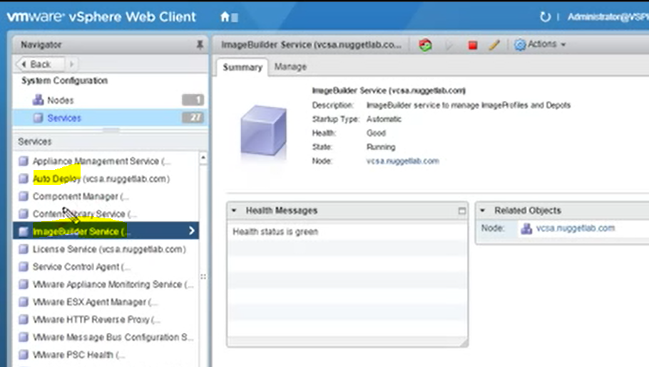

Service startup type automatic

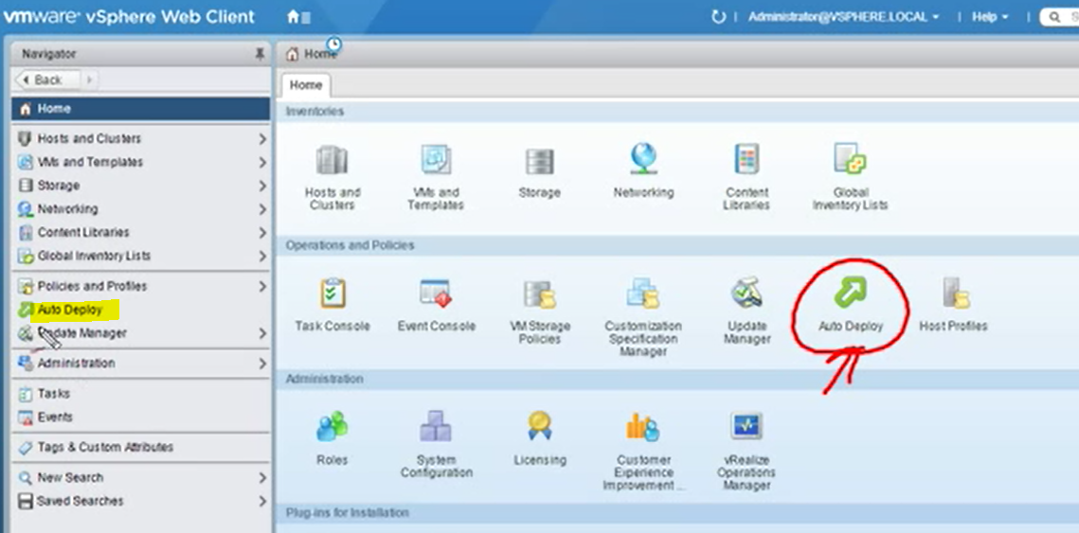

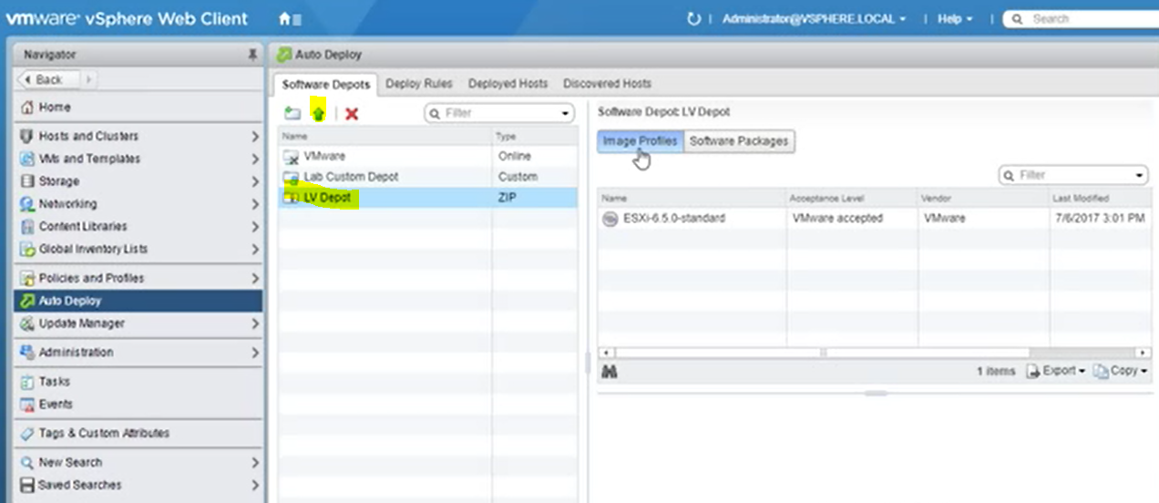add online depot

Or import depot

Create deploy rule

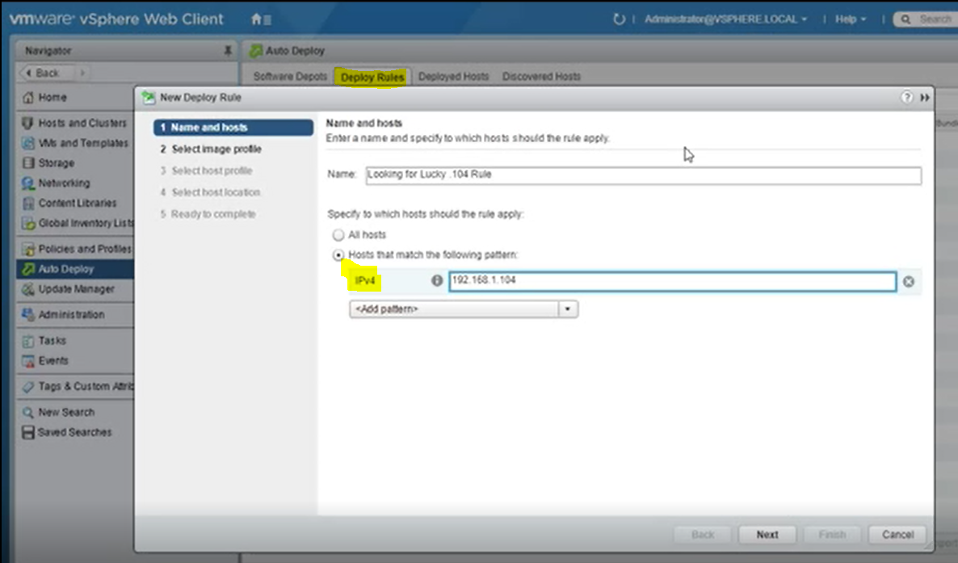

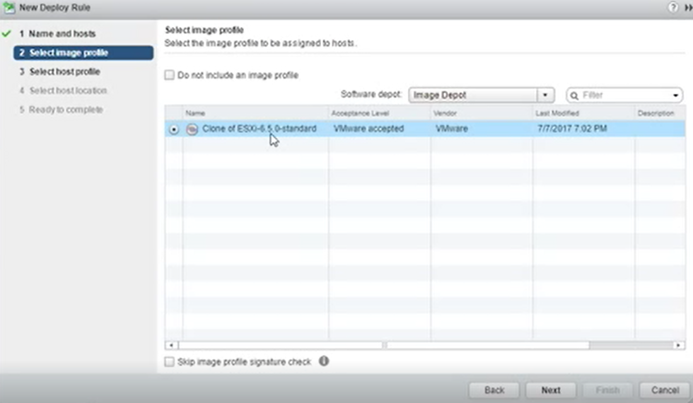

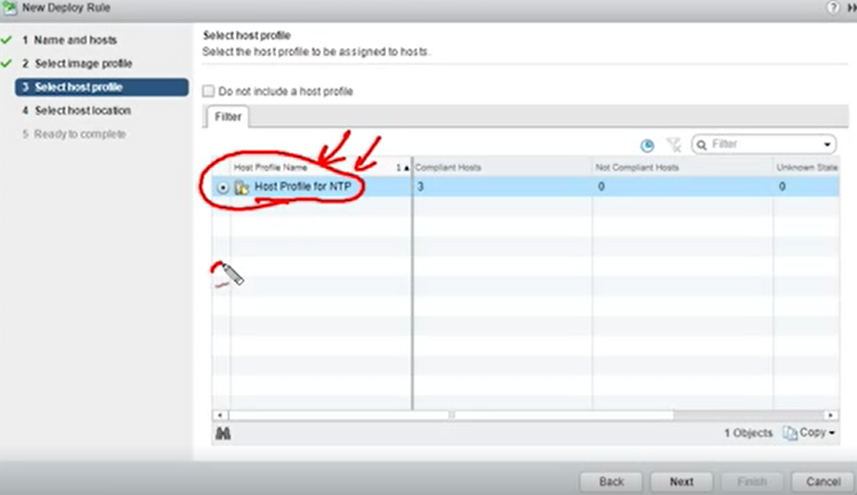

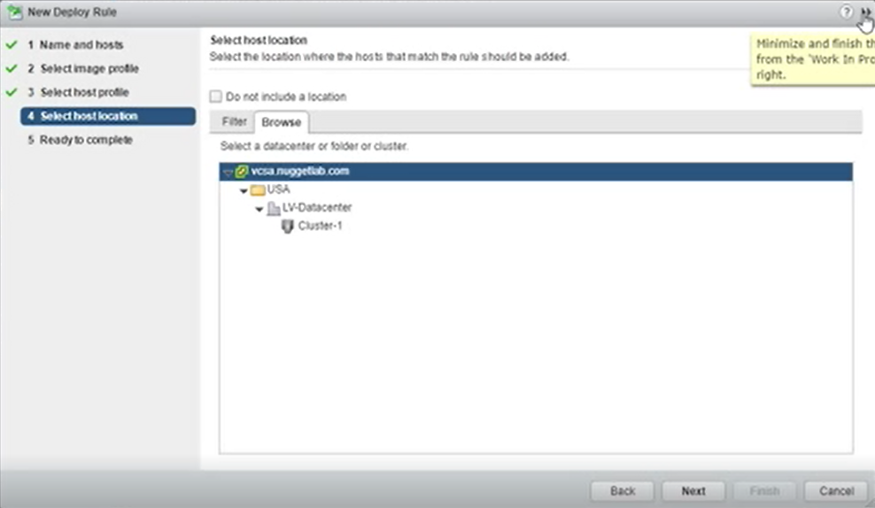

Dhcp settings

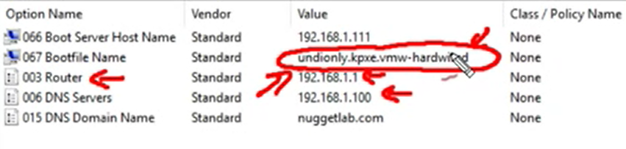

Dns settings (new host esxi4)

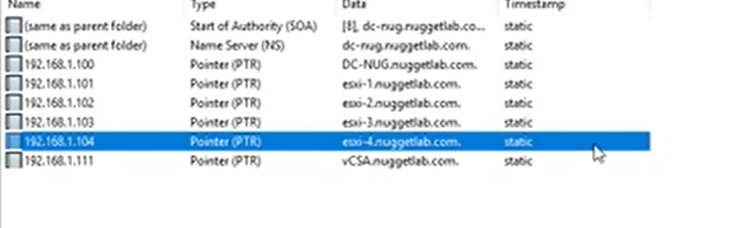

Activate rule

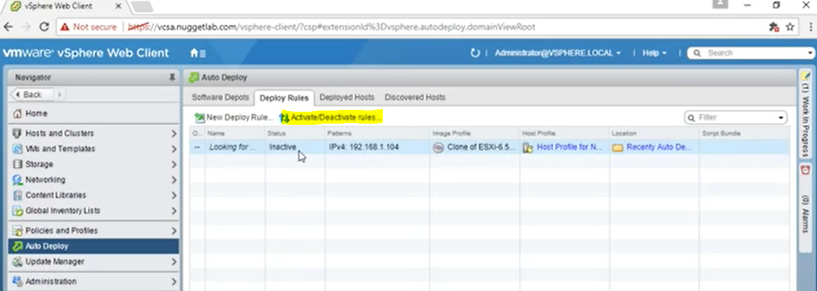

**ESXI LOCKDOWN**

Restricting access to esxi hosts

Block everything except Vcenter connection to hosts

Connection methods to hosts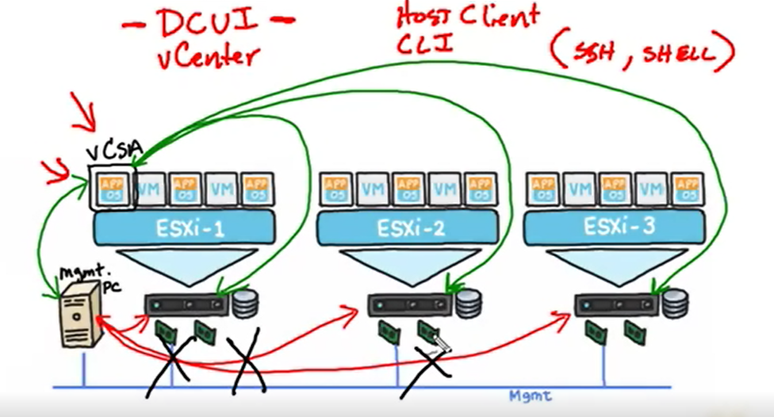

Viewing settings

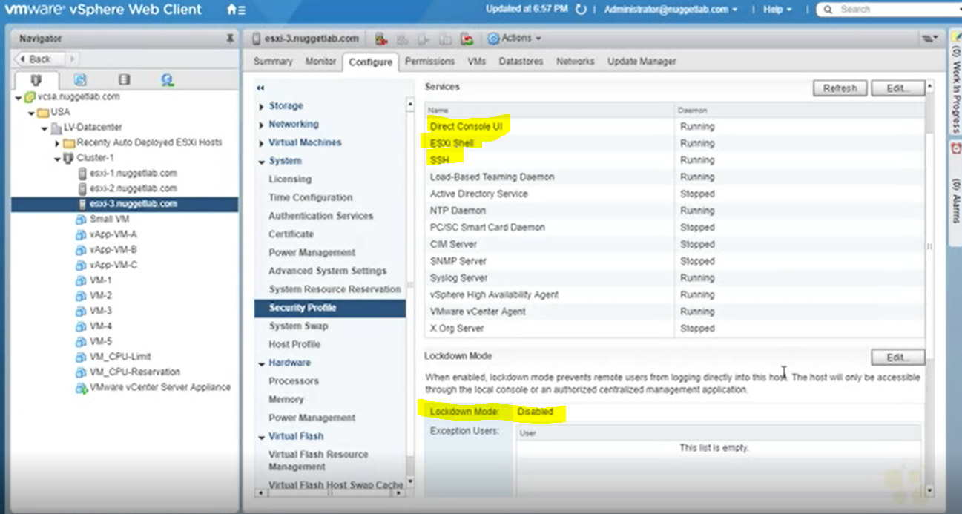

Lockdown options

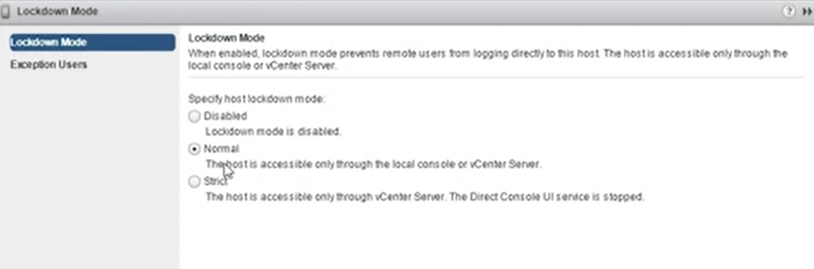

Normal and strict mode blocks SSH connection to hosts >> access denied message

Normal and strict mode blocks Host client connection to host >> access denied message

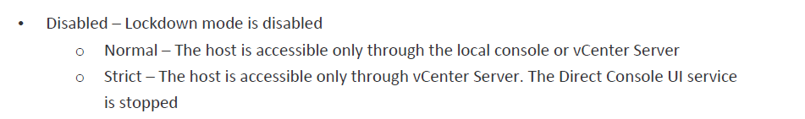

Exception users (can access esxi shell and SSH in strict lockdown) >> administrators and DCUI.Access

DCUI access settings

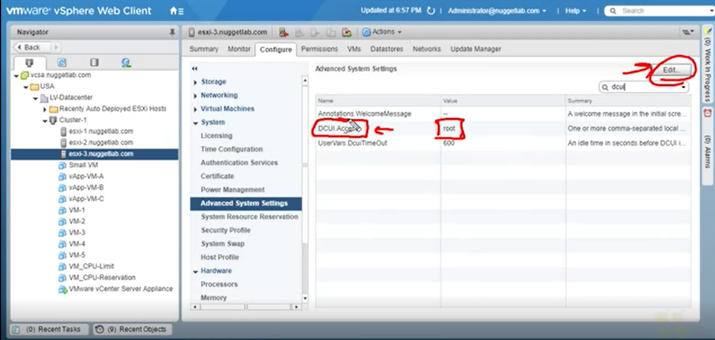

**vCSA and Certificates**

enterprise CA

SSL on vCSA

View from vcsa

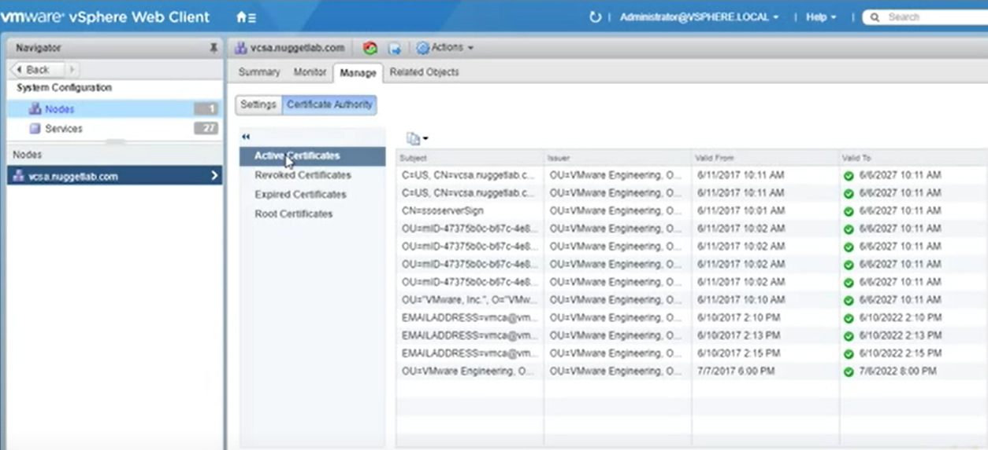

View from host

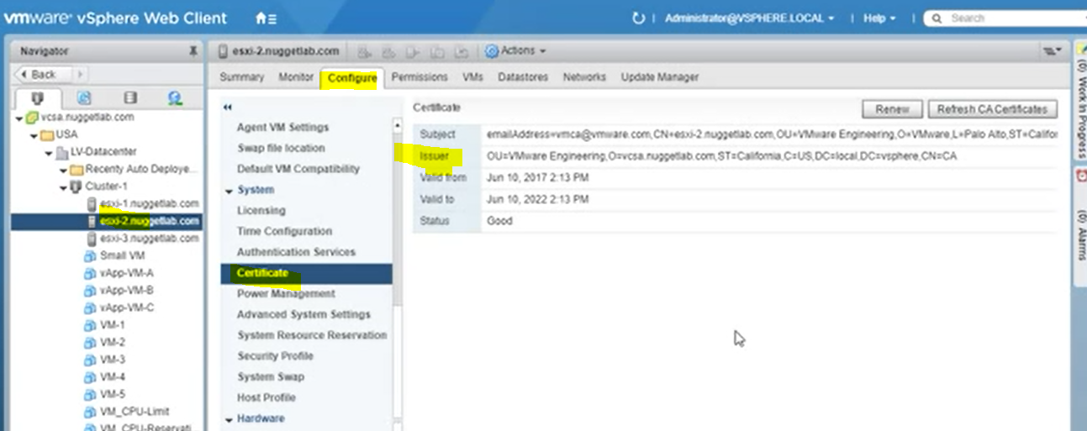

Generate certificate request on esxi host

And use it in CA

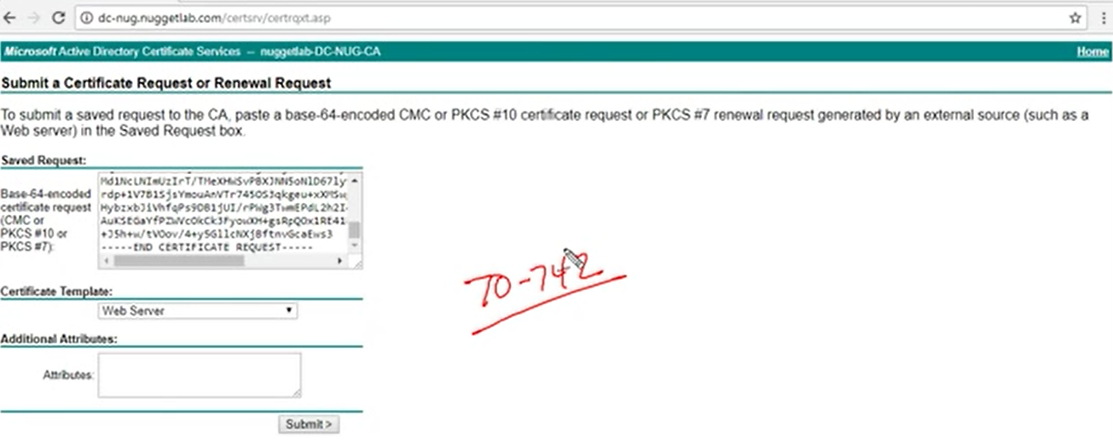

.cer uzantılı dosya olusturulup vcsa’a kopyalanır

vCenter Converter

move machines from physical environment to virtual environment

agent runs on physical machine

**Storage Multipath**

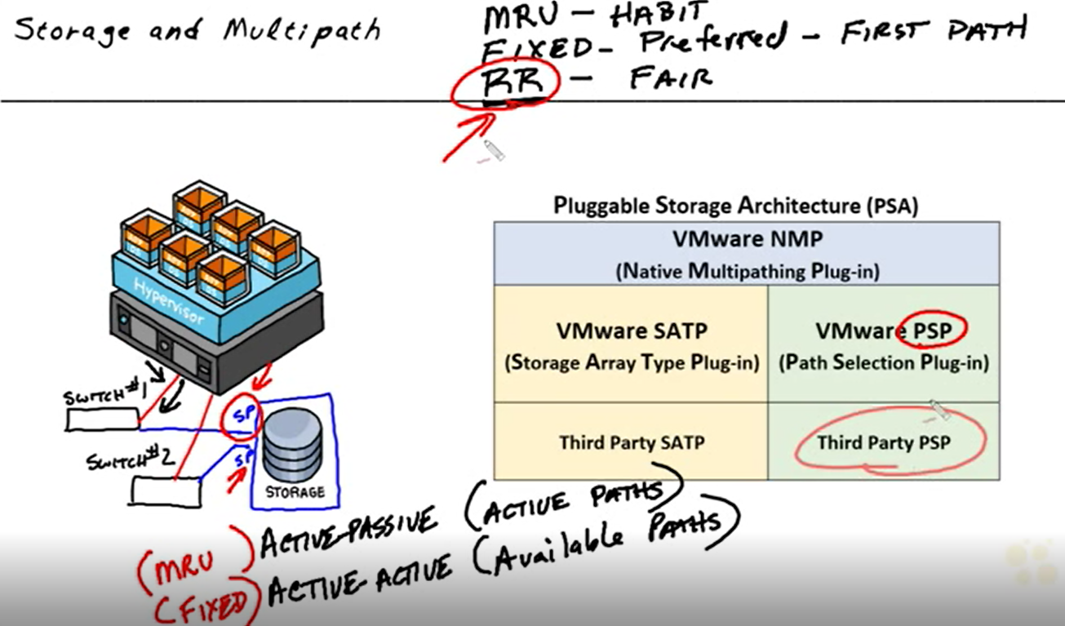

Viewing paths of host to storage

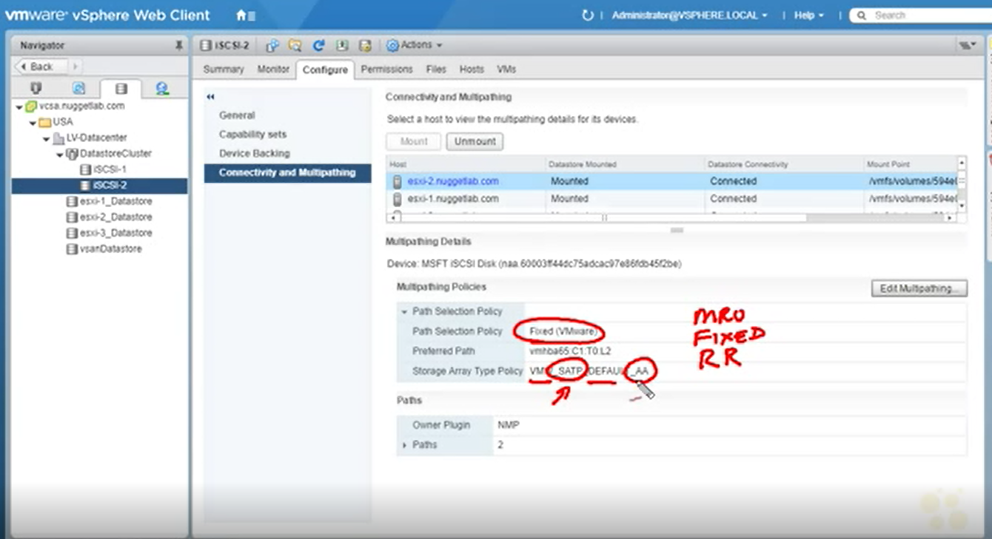

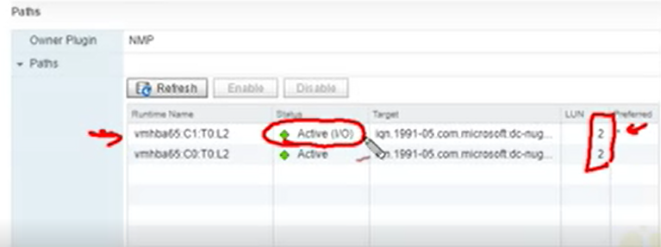

Edit multipathing> change multipath policy

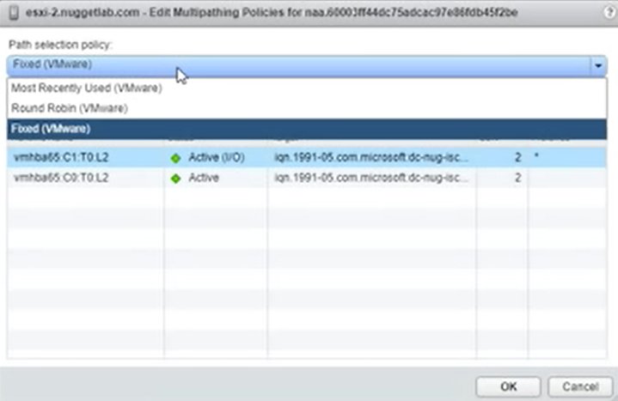

**vCenter High Availability**

Requirements

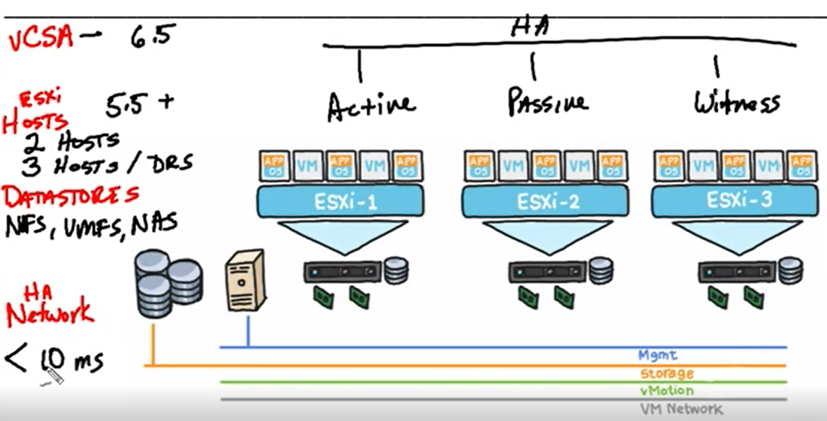

Topology

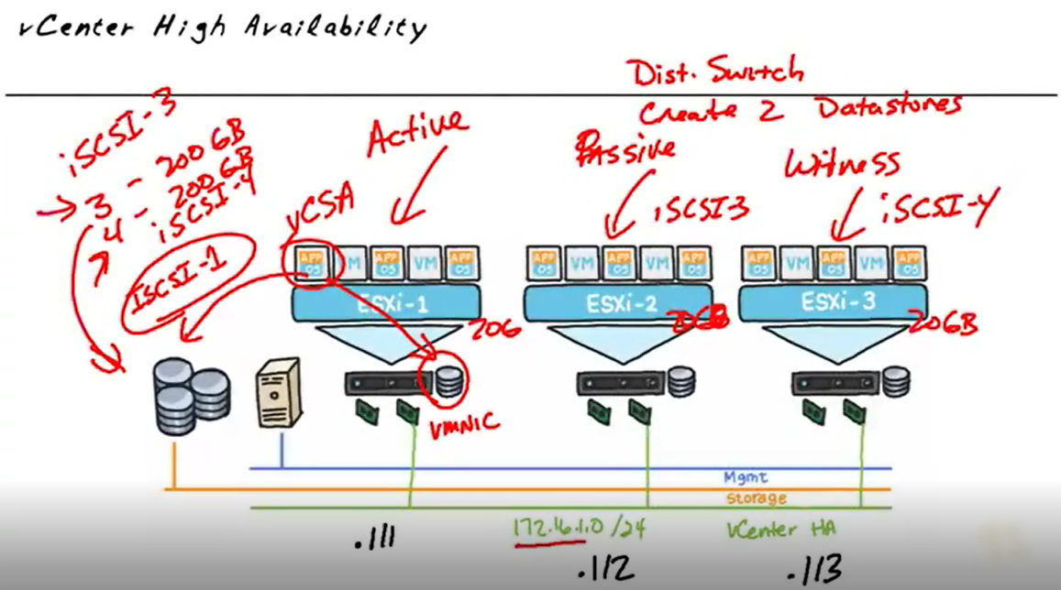

**Update ESXi and Virtual Machines**

Update requirements for esxi hosts

Methods

* Update Manager (recommended)

Create baseline (with iso) + attach baseline to hosts+ scan +get compliance info+ remediate

* Interactive upgrade from installation media
* Auto Deploy
* Esxcli (on maintenance mode of host)

Esxcli –server=esxhostname software vib list –rebooting-image

(list vibs and profiles that are installed on host and will be active after next host reboot)

Esxcli software vib update –d <path of installation media>

* Script upgrade

(power on host, on boot process shift+O

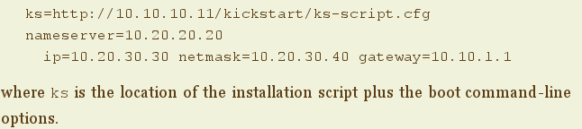

Script location: ftp server, http server, nfs server, usb

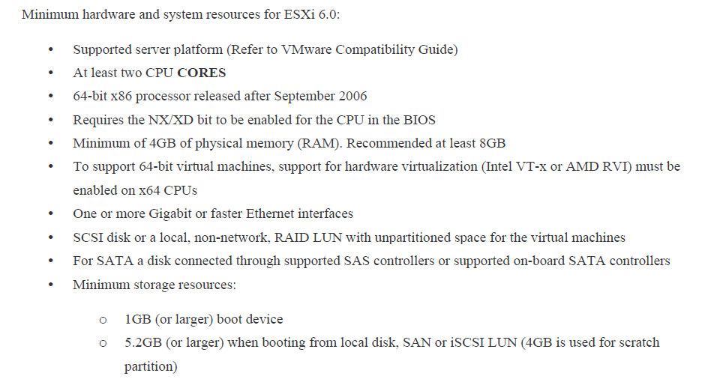

Upgrade distributed switch to 6.0



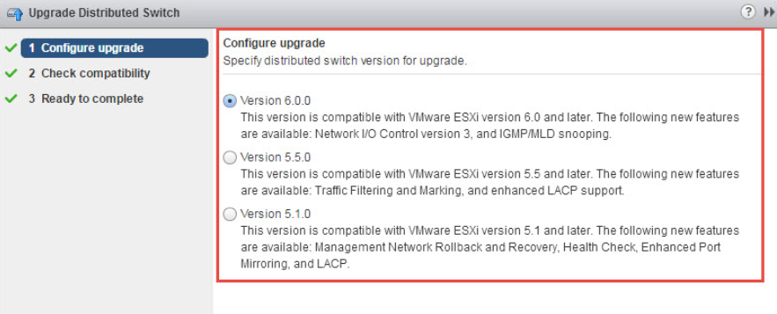

Upgrade Virtual Machine Hardware

Via

* Vsphere update manager
* Vsphere web client
* Back up or snapshot of VM
* Upgrade to latest version of VMware Tools
* Verify all vmdk files available are available to Esxi host
* Verify virtual machine is stored on datastore

Upgrade VMware tools

via

* Vsphere web client
* Vmware Update Manager

On VM level



VM hardware versions compatibility

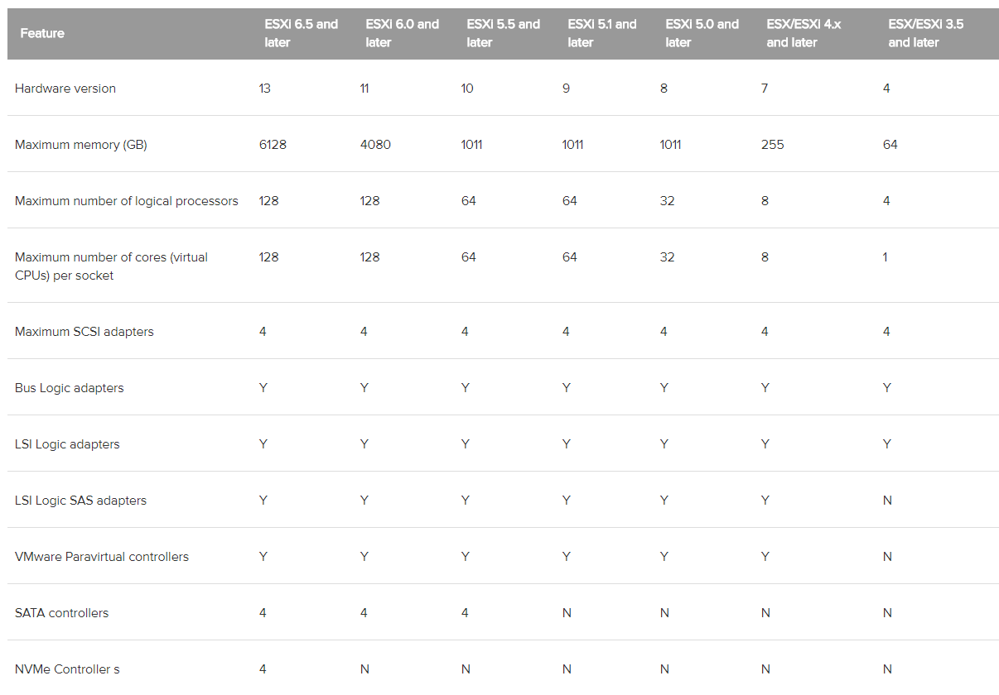

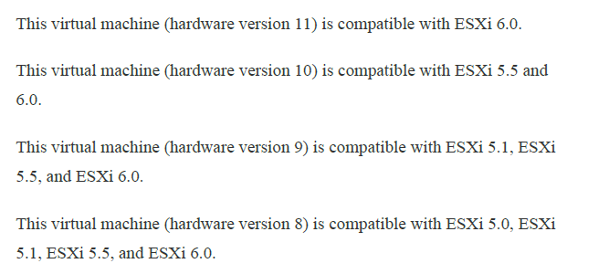

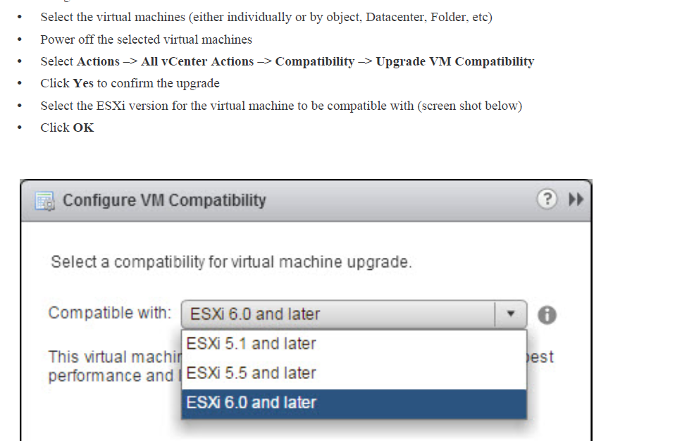

vCenter Upgrade

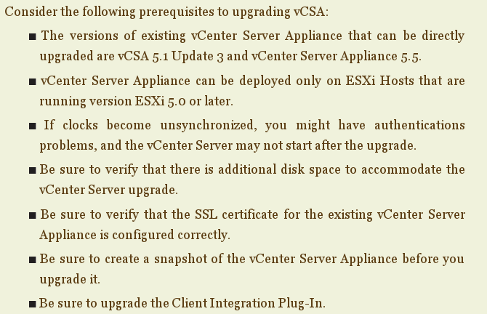

**Vcenter Logging Options**

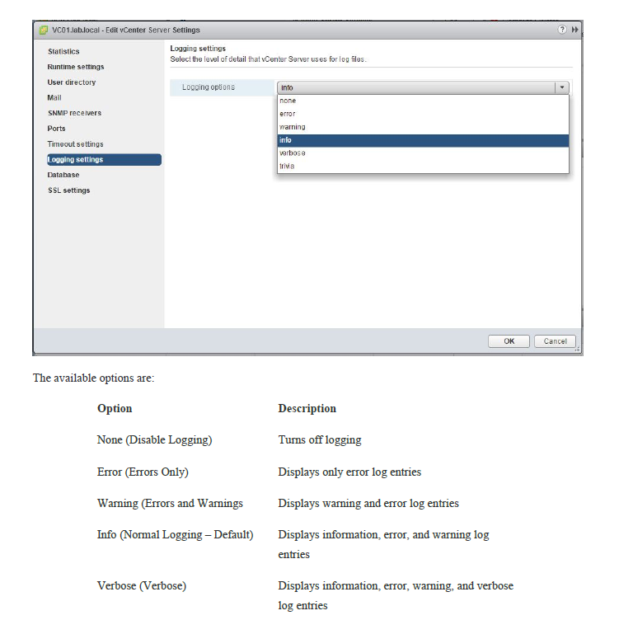

**Host Power Management Policies**

High Performance, Balanced, Low Power

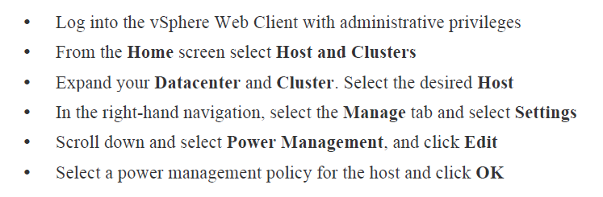

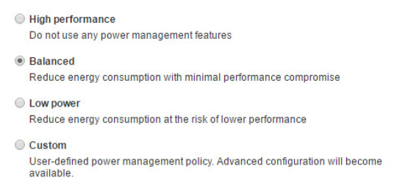

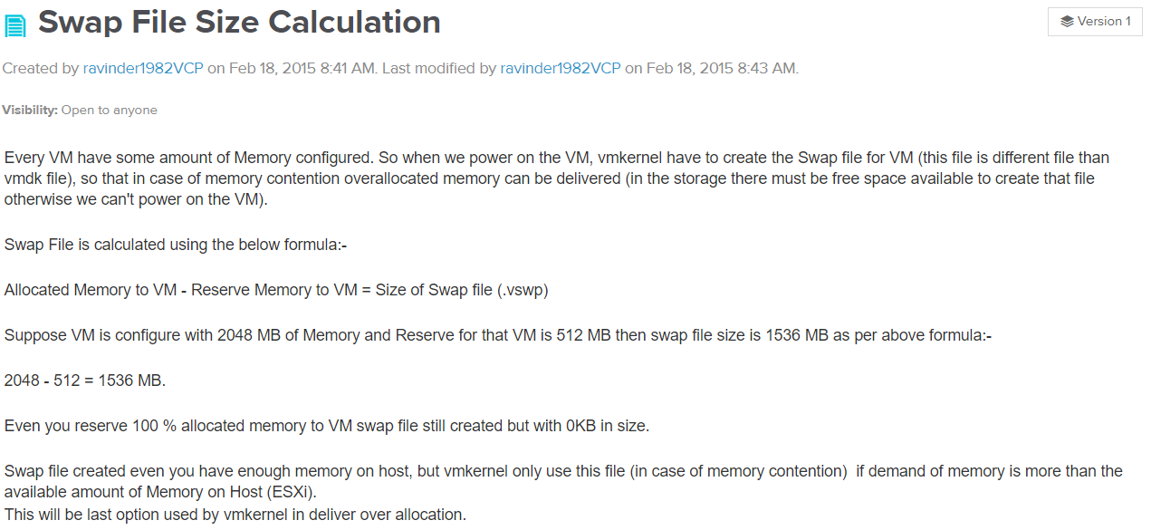

**MAXIMUMS**

**vm**

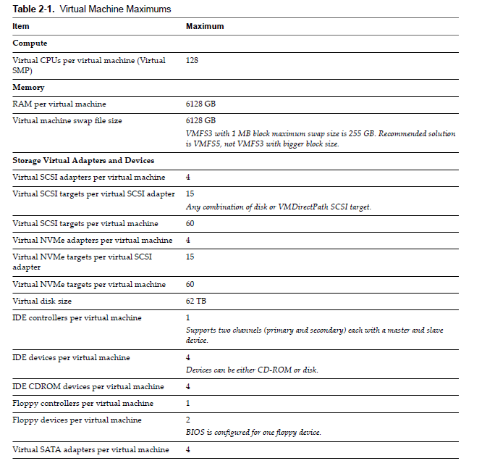

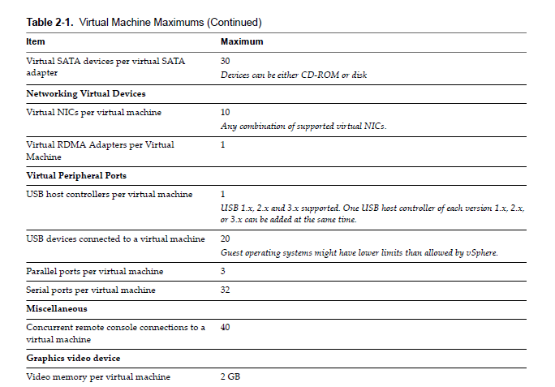

**HOST**

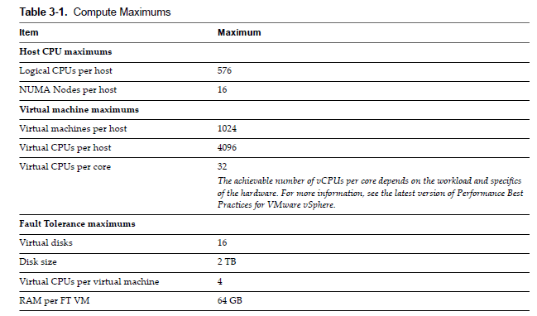

vRealize

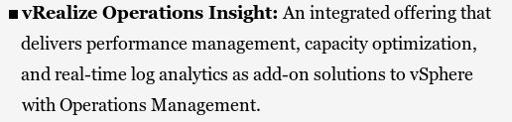

Administrative, analytics and database server are active components of vRealize operations.

**LICENSING**

Vcenter and esxihost

Vsphere Web Client>Home>Administration>Licensing>select vcenter/host>assign license

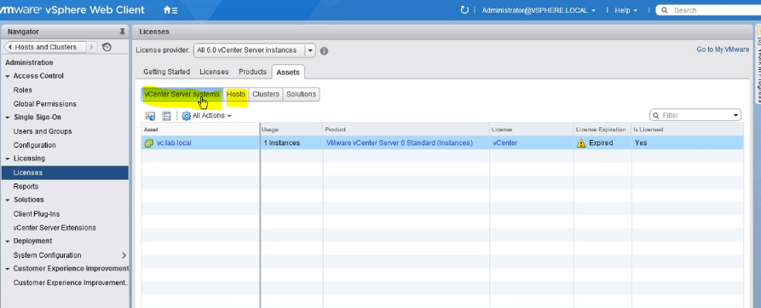

**VMWARE TOOLS**

Provided drivers and their features

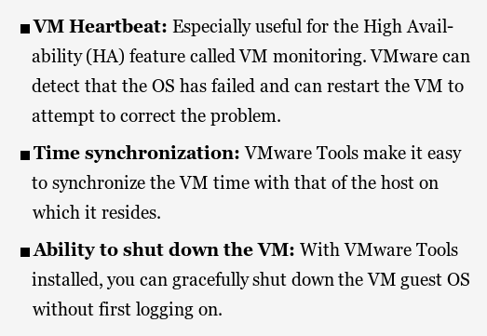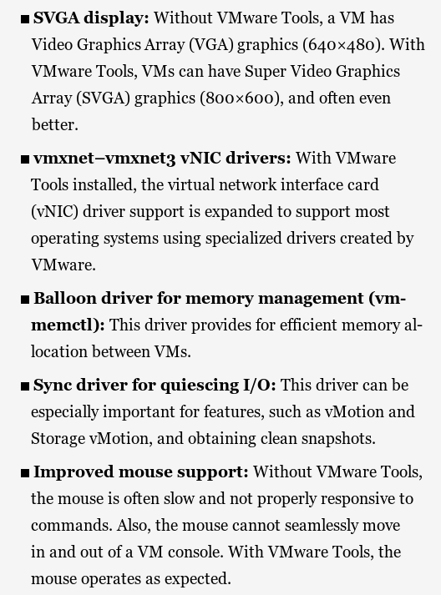

possible problems for installation

* Guest antivirus blocks
* Vmware installation media is corrupt
* Incorrect OS was selected in virtual machine options

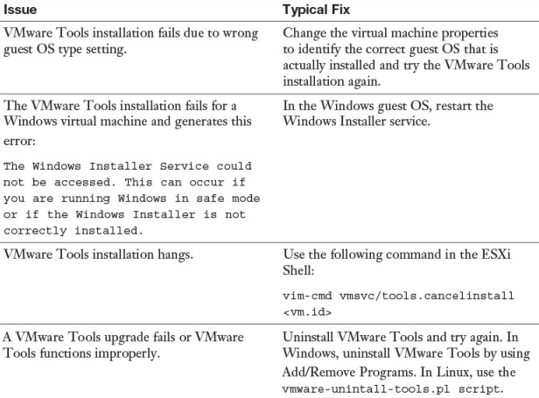

**VM COMPONENT PROTECTION**

Host has lost connectivity to the storage that it was providing the VM

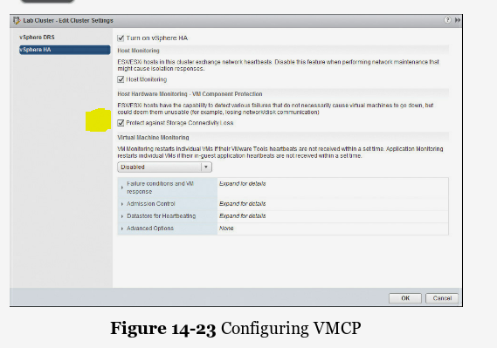

Permanent device loss>> issue events, power off and restart VMs

All paths down>> issue events, power off restart vm(conservative/aggressive)

**VSPHERE REPLICATION**

No extra charging for all editions

Managed by vsphere web client

Deploying vsphere replication

Host and Clusters> Deploy OVF template

Browse for ovf file and load it for installation

https://Your-VR-Appliance-Address:5480.

Lookup service address

Save and restart service

Configure Replication

both source and target must have a vSphere data center and the necessary resources to support VMs.

VM>Configure Replication

Recovery Point Objective>how up to date the VM will stay on an ongoing basis

**TROUBLESHOOTING**

VM can not start>> check resource pool reservation> check available resource left for that VM

Possible solution> change reservation type from fixed to dynamic(from pool), remove reservation (from VM)

Dynamic reservation> if there is not enough resources, pool get resources from parent

vApp can not start> not enough resource to start vms in that vApp

solution> modify(decrease) reservations of vms in vapp, increase reservation vapp, resource on vapp is expendable

VM network connectivity> check network cards, check distributed switch, port groups

High Availability Admission control problem> how many host failures can be tolerated 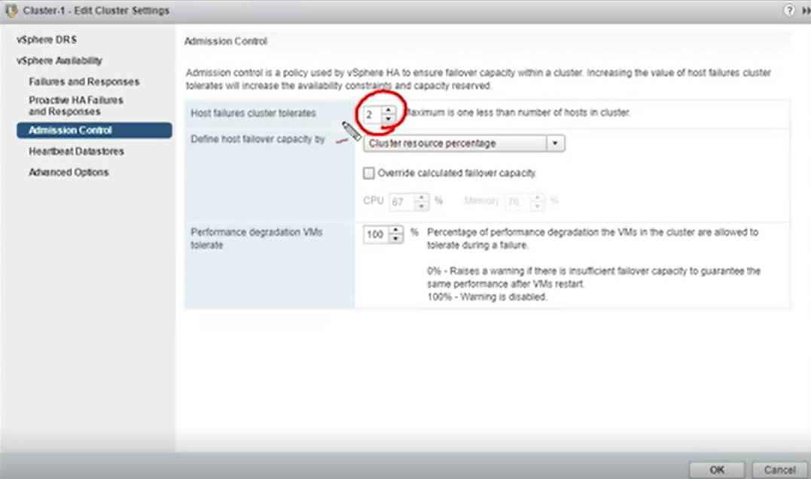

Fault tolerance problem> amount of CPU resource available in the parent resource pool is insufficient for operation (reservation limit on 1st host will be saved on 2nd host in fault tolerance)

Possible solution> modify limit on primary, vmotion move secondary vm to another host

Host

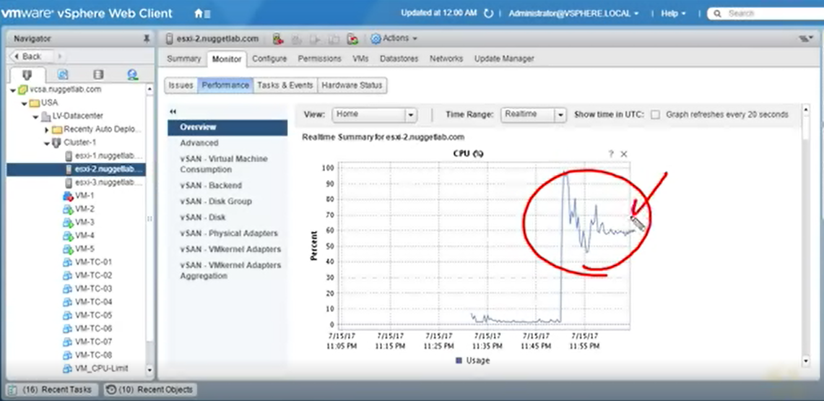

**VM Troubleshooting**

Start failures

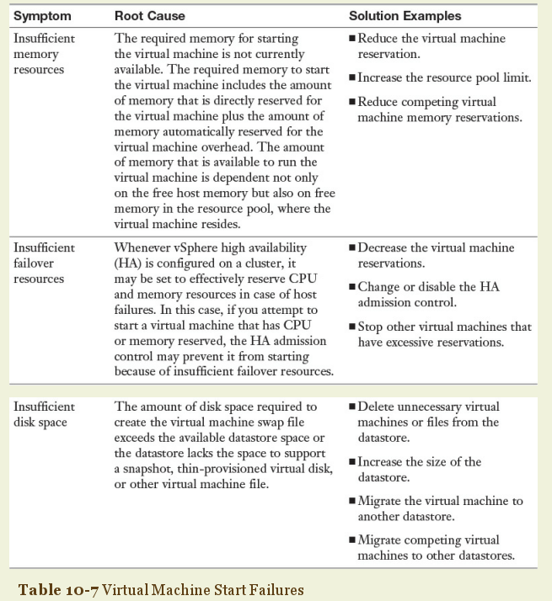

Memory overhead> disable Accelerate 3D Graphics

3D Graphics> fault tolerance and HA does not work

**Esxi troubleshooting**

Enable TSM-SSH from Web Client

Retrieve Host Logs>> from DCUI (view system logs) or Web Client (select host>monitor>log browser>retrieve now)

Host agent> The host agents on your hosts synchronize with vCenter and allow you to access the ESXi hosts directly with the vSphere Client or to access them through a vSphere Client logged on to a vCenter Server.

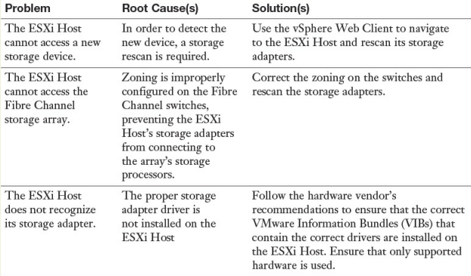

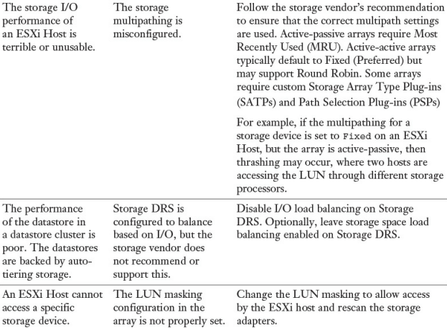

Types of logs from DCUI

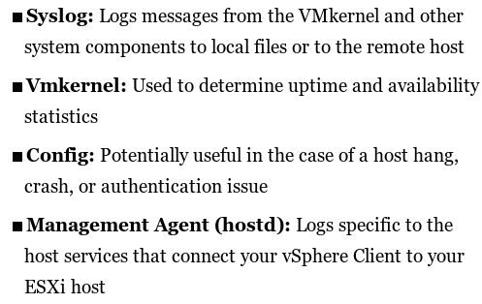

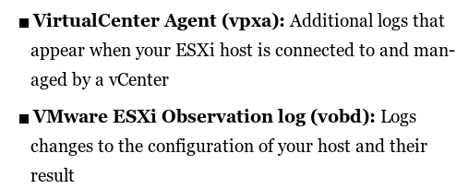

Vcenter troubleshooting

Logfiles> c:\ProgramData\VMware\vCenterServer\logs

Plugin> C: \Program Files\VMware\Infrastructure\VirtualCenter Server\extensions.

Corresponding services on Windows>>VMware Virtual Center Server

Vcenter services

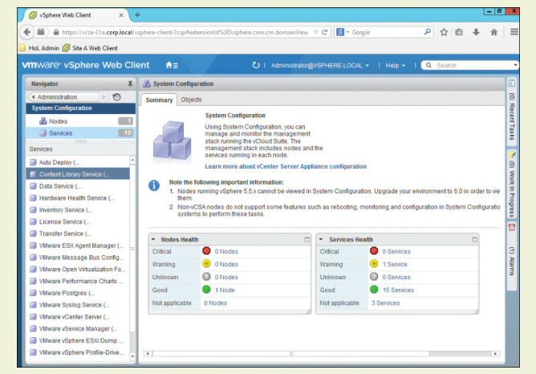

Database > vmware postgres

Monitoring sessions

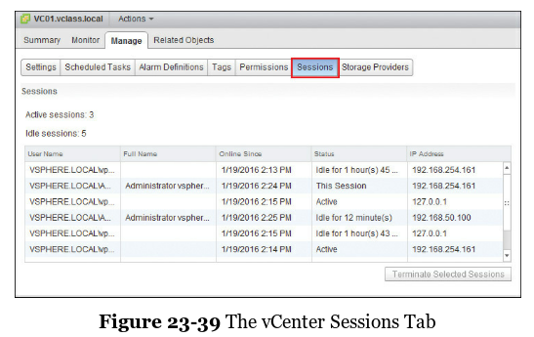

Vcenter’a giren kullanıcıları gösterir

Esxi host Exporting diagnostic information

Vsphere Client>File> Export> Export System Logs

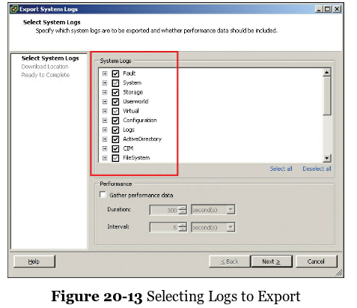

vCenter Exporting diagnostic information

Vsphere Web Client> vcenter server> monitor>System logs>export system logs

Choose host>chose type of log>generate log bundle

**VM Troubleshooting**

Excessive reservations cause slow host performance

Path thrashing is most likely to occur on active-passive arrays. It’s caused by two hosts attempting to access the same LUN through different storage processors.

include VMware Tools as part of your template.

.vmx file and selecting to Register VM>> if VM is not visible

Boot errors> choose proper iscsi controller, check boot order of disks (force BIOS setup)

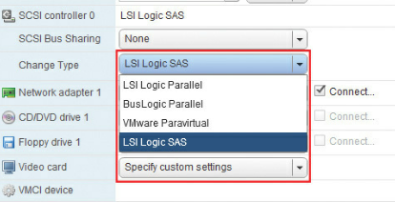

Alarm choices>> reset to green (alarm will trigger again), acknowledge(Your credentials are recorded and you have taken the responsibility to fix the issue, All actions associated with the alarm will be disabled)

Directory Settings for vCenter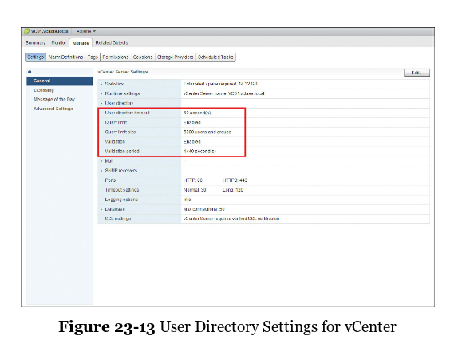

**User directory timeout**: This is the timeout interval in seconds for connecting to your Active Directory server. The default is 60 seconds,

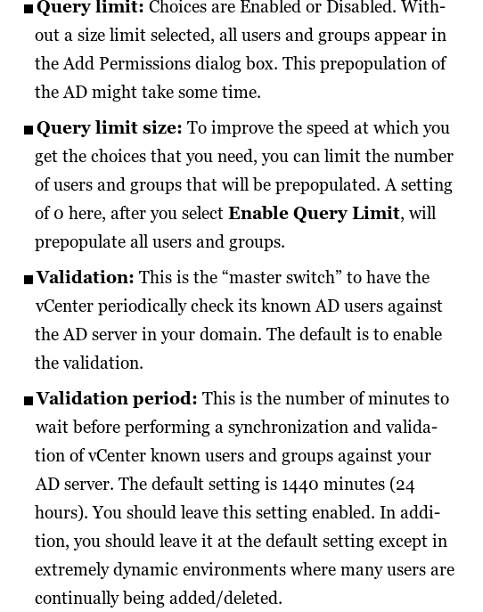

Creating scheduled tasks

VM>Manage>ScheduledTasks>Schedule New Task>PowerON>Scheduling options

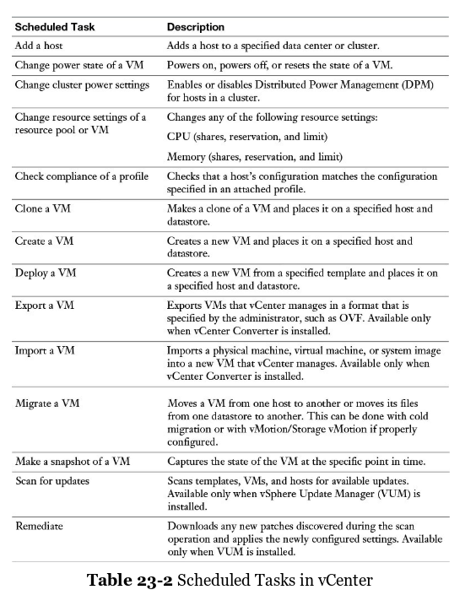

Logging options

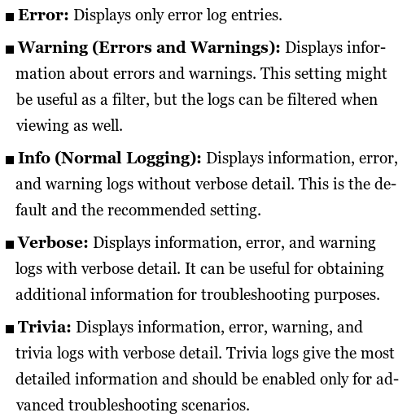

vRealize Operations Manager(vROP)

A tool that gives you information about your environment that you can use to decide when to make changes

collects performance data from each object at every level of your virtual environment.

vROPs is distributed as a virtual appliance that you can import and deploy with your vCenter Server system.

A single vROPs can connect to one or multiple vCenter Server instances.

Deployment

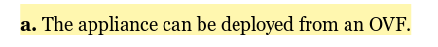

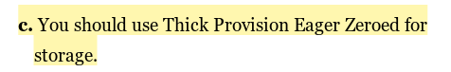

**INFLATE THIN PROVISIONED DISK**

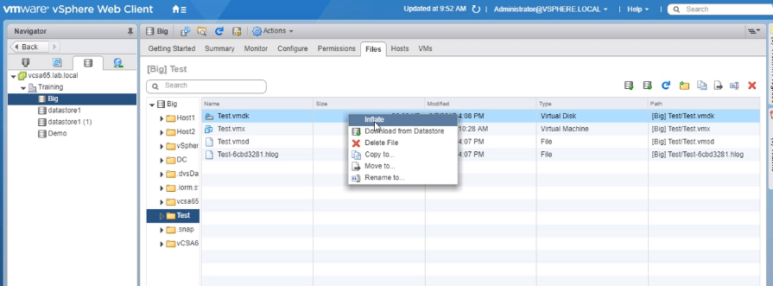

Thin disk to thick disk

VM VMX FILE CONFIGURATION

Power down virtual machine

* Disabling connecting Devices

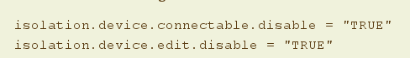

* Logging

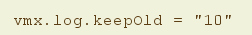

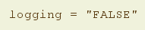

* VmX file size change

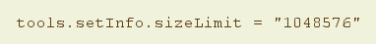

MISC ESXCLI

Esxcli network firewall

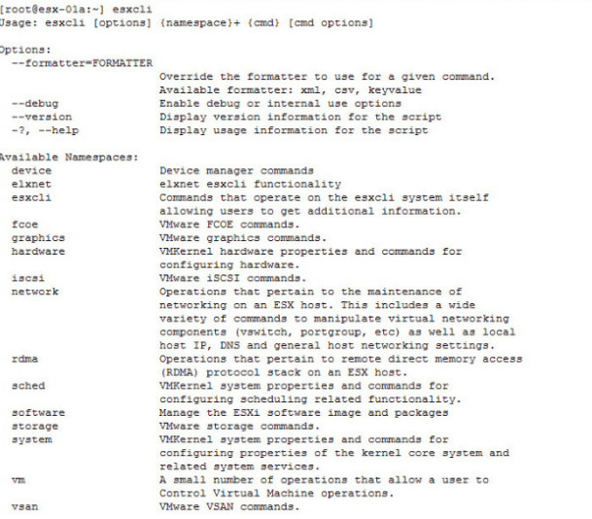

vFlash Cache

introduced in vsphere 5.5 (enterprise plus)

read caching of VM I/O requests

esx has locally attached ssd (on storage of esx> add virtual flash resource capacity)

vm hw version 10 or above

assign vFlash Resources to VMDKs

hosts use virtual flash pool for .vswp during memory contention

AutoDeploy

Enterprise Plus Licensing

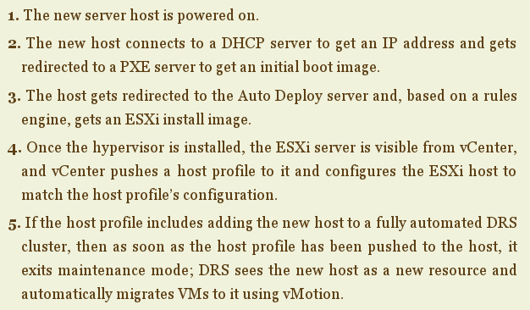

Autodeploy rules are based on asset, domain, gateway IP, hostname, IPV4, IPV6, mac address, model, oem string, serial number, UUID, Vendor

Components

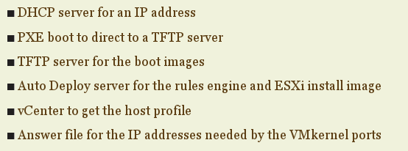

Autodeploy server=VCSA

PowerCLI to use Image Builder

Steps

1. Download software depots-driver and software bundles from vmware and other vendors
2. Import software depots into image builder
3. Create image profile (add all vmware and 3rd party vendor software)
4. Add remove vibs
5. Save image profile to finalize iso or zip